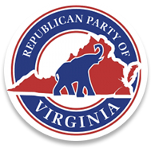

Augusta County Republican Committee

OFFICIAL CALL

Executive Committee Meeting

I, Dave Bourne, Chairman of the Augusta County Republican Committee, do hereby call for an Executive Committee meeting of the Augusta County Republican Committee to be held on November 17, 2020, at 6:00 PM, Augusta County Government Center, 18 Government Center Lane, Verona, Virginia, 24482, or alternate time, date, and location if needed.

.

**AGENDA FOR EXECUTIVE COMMITTEE MEETING**

1. Call to Order
2. Invocation
3. Pledge of Allegiance
4. Republican Creed
5. Quorum Declaration and Proxies
6. Treasurer’s Report
7. Officer / Committee Reports
8. Old Business
9. New Business
   1. Open discussion on the November 2020 Elections.
   2. Looking forward into Elections 2121.
10. Adjournment