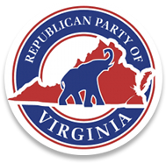

I, Dave Bourne, Chairman of the Augusta County Republican Committee, do hereby call for our monthly unit meeting to be held on Tuesday, November 16, 2021, 7:00 PM, at Common Ground, 15 Angela Court, Fishersville, VA 22939, or alternate time, date, and location if needed.

The agenda will be as follows:

- Welcome & Call to Order.
- Invocation.
- Pledge of Allegiance.
4. Reading of the Republican Creed.
5. Adoption of Agenda.
6. Proxy Report.
7. Quorum Declaration.
8. Approval of New Members and Reinstatement of Membership.
9. Unfinished Business
10. New Business
- Election performance evaluation / suggestions (please complete the survey that was emailed).
11. The transaction of such other business as may properly come before the Committee.
12. For the good of the committee.
13. Adjournment.

