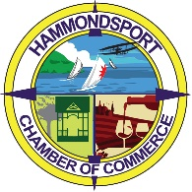Christmas in the Park 2025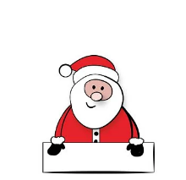Sponsorship Form
Hammondsport Chamber of Commerce
PO Box 539 Hammondsport, NY 14840 I 607-569-2989 I info@hammondsport.org
Christmas in the Park returns on December 13th from 4:00-7:00 pm with local entertainment and family friendly attractions.
This year’s event will feature:
Horse drawn wagon rides,
Local musicians,
Food and Craft vendors,
Keuka Lake Players Free Christmas Production,
Christmas Parade through town,
And of course, …
The Hammondsport Fire Department will bring Santa to Pulteney Park to see the children in the Visitor Center, where they will tell Santa their secrets!
The Chamber will market this event through social media, radio and print advertisement as well as heavily through our website and email newsletter that reaches over 2500 people.
If you would like to be a sponsor of the event, please fill out the information below and send it back to us by mail or email (and we will invoice).
Sponsor Name: ____________________________________________________
Address: _________________________________________________________
Phone: ___________________Email: _________________________________
Sponsorship Levels:
$300.00 _______ Business name prominently printed on banner, digital marketing and acknowledged on day of event as major sponsor, individual signage in the park, business name mentioned on all radio advertisements and headliner in our social media platforms
$175.00 _______ Business name included on all print materials (posters distributed throughout the region), business name included in social media posts and on vinyl banner in front of chamber
We appreciate any support you can give this event. We ask that sponsorship forms are returned to the chamber office by November 22nd so we can start the marketing campaign of the event.
If the event needs to cancel due to NYS regulations, your sponsorship will be refunded.

