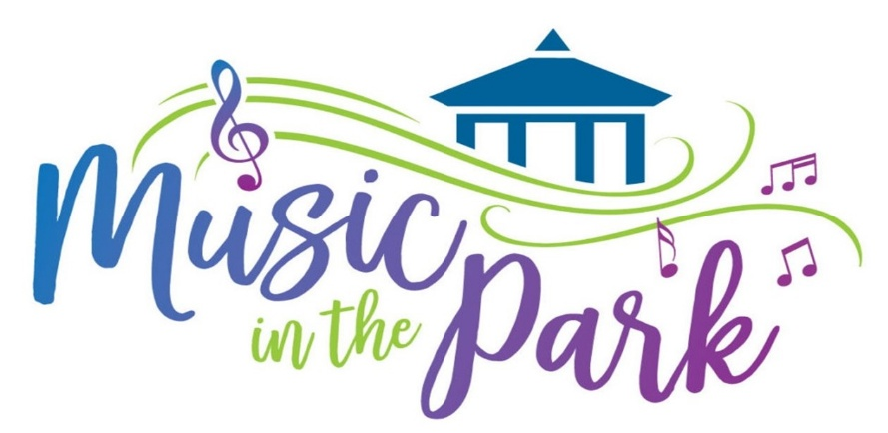
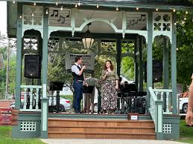

Thursdays from 6pm-8pm
July 9th through September 3rd
9 Weeks of Great Music and Sponorship

2026 Sponsorship Application
Don’t Miss Out on being part of the Hottest Part of the 2026 Summer Season! Music in the Park draws people into Hammondsport, which includes our residents, surrounding community members and those that are traveling to see the Finger Lakes. This weekly event supports our community and all our businesses. We look forward to your participation as a Sponsor and being a part of our fun family.
Benefits as a Sponsor of Music in the Park.
Marketing your Business on the Chamber Website
Weekly Marketing on the Chambers Facebook Page
Your Business listed on the Banner outside the Visitors Center
Your Business listed by the Gazebo in the park for the 2026 season.

Please make your check for $175.00 made payable to The Hammondsport Chamber of Commerce or if you would like to pay with Credit Card stop into the Chamber Office to pay with Christina Morgan, Chamber Office Director.
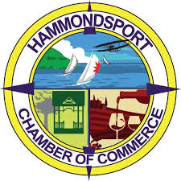
Business Name/ Individual: ____________________________________
Best Phone Number: __________________________________________
Billing Address: _______________________________________________

