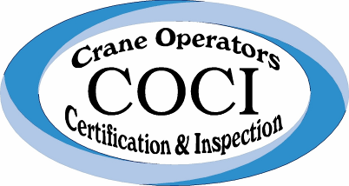

NCCCO- Accredited Examiner
2018 COCI Re-Certification Class Dates

Location: 2114 Industrial Park Rd
Lincolnton, NC 28092
704-735-2707
admin@cociinc.com

Class / Exam Dates (Th-Fri 8-5pm) | Application Deadline Dates For Class
April 26-27, 2018 NC28240 | April 12, 2018
May 17-18, 2018 NC28242 | May 3, 2018
June 7-8, 2018 NC31364 | May 23, 2018
July 12-13, 2018 NC31365 | June 28, 2018
August 23-24, 2018 NC31366 | August 9, 2018
September 13-14, 2018 NC31367 | August 30, 2018
October 4-5, 2018 NC31369 | September 20, 2018
November 15-16, 2018 NC31370 | November 1, 2018
December 6-7, 2018 NC31371 | November 20, 2018

Application submission instructions:
(You can fax, email or submit applications online)
1. Email applications by the class deadline date to admin@cociinc.com
2. Fax applications by the class deadline date to 704-735-3691
3. Contact Stephanie for online registration at 704-735-2707
* Do NOT submit applications to the address, fax or email on the application. All applications must be sent to COCI not to NCCCO if you are testing at our site.
* Please remember to have a candidate signature and a credit card signature on all applications before submitting.
If you are ONLY testing and not attending a class, the exams are given on Fridays of the class week starting at 8am. Submit applications by the deadline dates above.

