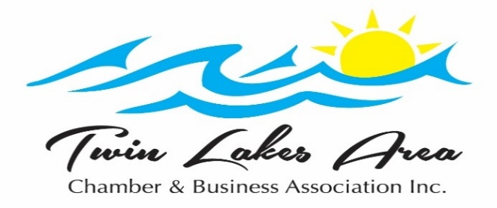

349 E. Main St. PO Box 64

Twin Lakes, WI 53181

262-877-2220

***Dear 2023 Prospective Chamber Member,***

We hope that you will consider becoming a part of the ***Twin Lakes Area Chamber &*** ***Business Association, Inc.***  Our association is a valuable *advertising, educational and* *networking* tool for your business.

We constantly strive to find new and better ways to serve our members. With your membership, you can display business cards and brochures at the chamber office, get referrals and opportunities to attend networking events. You will receive discounts on advertising in our guidebook, for membership events and booths at events. At our quarterly, membership meetings, we have guest speakers who cover topics that are of interest to businesses, along with Member Meeting Mixers, or other activities. A membership meeting is a terrific opportunity for networking with other local businesses. You can host a Business After 5 Event or Mixer at your place of business. Contact the Chamber for details.

The chamber sponsors several events throughout the year. We kick off our events with Business in the Park & Car Show on May 20th. Our summertime events, Rock the Lake on June 17th and Libertyfest, with a parade and fireworks, on July 1st, will bring the fun to Twin Lakes. Looking to fall, our Golf Outing is scheduled for September 13th. The Annual Awards Dinner will remain in November, on the 16th, to avoid conflicts with the many other holiday parties. To close out the year, we will present the annual village tree lighting to kick off Trees on Parade and Holiday Shopping on December 1st and 2nd. Our popular Elf Scavenger Hunt is on December 8th. These events provide you with opportunities for sponsorship, networking, business referrals, contacts and much more. The events that our members support bring in income that helps to cover Chamber expenses so that we can keep membership dues as low as possible.

As a Chamber Member, you also have opportunities to attend Multi-Chamber Networking Events. Remember, not only is your business a member of the Chamber but all of your employees are as well. Bringing your employees to a Chamber function is a learning experience and a great way to say thank you. Your employees are always welcome to participate as volunteers, event committee members, or as officers and board members. We encourage your employees to be on the Friday Facts Newsletter emails to keep them up-to-date on Chamber and local events and membership meeting invitations.

The Twin Lakes Area Chamber & Business Association Foundation awards several annual scholarships to Wilmot High School Seniors and other area high school seniors who are the children or grandchildren of Twin Lakes Chamber members.

Please take some time and look over what we have to offer. We would like to invite you to be our guest at a quarterly meeting to give you a glimpse of why it pays to be a member of the ***Twin Lakes Area Chamber & Business Association, Inc***. Thank you for considering a membership. We look forward to working with you.

Sincerely,

Marilyn Trongeau, Executive Director

Ann Lundberg, Assistant