The Board and Chief Rodriquez have concluded that enough progress has been made in controlling the pandemic that we now feel it is safe, while still maintaining CDC recommended safety protocols, to reopen the station and to resume holding in person meetings. We began that process with the May 15, 2021, board meeting, and will continue until further notice.
- Call to Order. The meeting was called to order in the main equipment bay of the fire station by Chairman Tom Cummiskey at 10:00 am.
- Pledge of Allegiance. Chairman Cummiskey led the gathering in the pledge of allegiance.
- Roll Call of Fire Board Members. In addition to Chairman Cummiskey, Clerk John Hennessey, Treasurer Pete Batschelet, Member Dennis Massion and Member Israel Torres were in attendance at the fire station. Also in attendance were Chief Dave Rodriquez and newly appointed Communications Specialist/Public Information Officer John Nelson. Admin. Assistant Julie Mattila was excused.
- Chairman's Welcome and Activity Report. Chairman Cummiskey welcomed all to the meeting, especially John Nelson, who will be making several presentations to the board. He noted our major focus will be on the proposed budget which must be approved by the board prior to presentation to the public at the May board meeting. Following a 30-day comment period by the public, final budget approval, with any changes, will be approved by the at the June board meeting prior to submittal to the County Board of Supervisors.
- Call to the Public/Audience Comments. There were no comments.
- Review and Approve the Minutes for the March 19, 2022, Regular Board Meeting. Member Massion made a motion to approve the minutes as presented. Treasurer Batschelet seconded, and the motion passed unanimously.
- Review and Approve the Financial Statements for March 2022. Treasurer Batschelet reviewed the General Fund financial report for the previous month and provided a brief summary report. We are 75.0% through the year. In relation to our published Not-To-Exceed (NTE) budget, YTD revenue is at 75.1% while YTD expenses are at 72.0%. The end of the month cash balance was $404,379.93. The projected year end cash balance is $405,096.93. We expect to receive one more round of tax receipts from the county. We are in good shape financially. Treasurer Batschelet made a motion to approve the financial reports as presented. Member Massion seconded, and the motion passed unanimously.

In accordance with the statutory requirements of A.R.S. 48-807, by virtue of accepting the entire detailed financial report the Board certified that:
  - The District has reconciled all balance sheet accounts for the preceding fiscal month, and the Board has reviewed them.
  - The District has produced a financial report for the preceding fiscal month, including a register of all checks, warrants, and deposits; a statement of the District’s financial activities; and a statement of the District’s net assets.
  - The District has produced a cash flow projection report for the current fiscal year and said report has been updated to include the actual revenues and expenditures for the preceding fiscal month.
  - The Governing Board has reviewed the financial reports, the updated cash flow projection report, and all month end fund statements and reports of the preceding month, including any reports provided by the County Treasurer and each of the financial institutions in which the District maintains an account.
  - The District is in compliance pursuant to A.R.S. 48-807 (N) & (O) and no reports indicate an adverse impact on the ongoing operations or liquidity of the District.

- Business. Note: In order to accommodate a schedule conflict by PIO Nelson, we addressed agenda items 8n) and 8h) first, in that order, following which PIO Nelson was excused from the meeting. The meeting minutes, however, are presented in the original order.
  - Status update re: Finance Committee Meeting. Treasurer Batschelet reported the Finance Committee (himself, Chief Rodriquez, Chairman Cummiskey and Clerk Hennessey) met April 6th to review the proposed budget developed during the recently completed STRAP Update process. The primary topic was Chief Rodriquez’s salary and how to reallocate the lump sum ASRS line item in the STRAP Budget. The result was a balanced budget, which will be covered in detail in agenda item 8d). It includes the recommended Chief’s salary, which is addressed in agenda item 8b).
  - Discussion and possible action re: Change to Chief’s salary. Chairman Cummiskey presented the recommended Chief Salary to be included in the proposed 2022-2023 budget and the 2023-2024 projected budget. See attached.
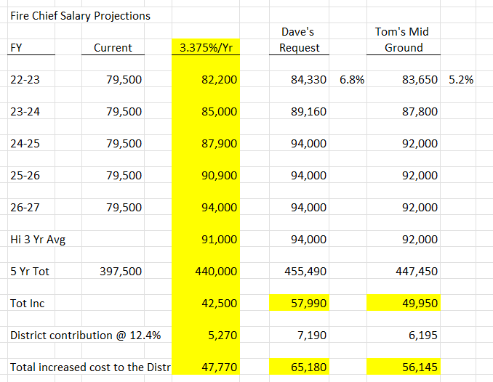
The following comments were made re: the recommended salary.
- Chief’s salary has remained unchanged for 15 years.
- With Chief’s stated intent to retire in 5 years we need to adjust the Chief’s salary to be in a range compatible with that of neighboring districts so as to be more attractive to that of a prospective chief, recognizing that the compensation package for a new Chief will include other factors not reflected in Chief Rodriquez’s salary. The proposed salary adjustments will put us in a position to offer a compensation package commensurate with the stated factors.
- We explored several options and settled on the middle ground approach (right-most column).
- Industry benchmark salary increases that we are aware of are in the 5% YOY range. As can be seen, our recommendation is in the 5.2% range.
- Member Torres reported Coconino County has stated its position is to make aggressive First Responder salary increases in the 12% range, further reinforcing the recommended increases in Chief’s salary as being reasonable. Note: we are awaiting independent confirmation on the numbers.
- The proposed salary structure will be revisited should the Fire District Safety Act be passed by the voters in November.
Chairman Cummiskey made a motion to approve the recommended middle ground salary structure for Chief Rodriquez. Member Massion seconded, and the motion passed unanimously.
  - Discussion and possible action re: Change to timing of Chief’s contract. Chairman Cummiskey noted Chief’s contract end date does not line up with our fiscal year (contract ends on October 31st versus fiscal year end of June 30th.) For budgetary purposes, an alignment with our fiscal year makes sense. Chairman Cummiskey made a motion to change the end date of Chief’s new contract to be June 30th. Treasurer Batschelet seconded, and the motion passed unanimously. Chairman Cummiskey took the action to prepare a new two-year contract beginning July 1, 2022, and ending June 30, 2024, with the appropriate salary language per agenda item 8b). In addition, he will prepare an updated Performance Assessment so that its timing aligns with the new contract.
  - Discussion and possible action re: Board review of 2022-23 budget. Treasurer Batschelet led a detailed review of the budget/spreadsheet per agenda item 8a). Following board approval, he will present the proposed budget to the public in May, with final board approval in June. Key points from the discussion:
    - The Mil rate for the FY2022-2023 budget year is $3.375, up from $3.25 for the prior years, and for the FY2023-2024 projection year, the Mil rate is $3.50, remaining flat thereafter.
    - The FDAT rate has been reduced from 20% to 18% based on guidance from the County Treasurer.
    - We have chosen to be conservative with EMS income since there are many unknown variables at this time.
    - We have included grant income as appropriate.
    - We have included a healthy contingency line item.
    - Salaries have been increased based on Chief’s input for ODS/POC and admin personnel and per agenda item 8b).
    - We do not have the final insurance costs; however, we feel the numbers are close.
    - In general, we have factored in 3.5% for inflation.
    - We have included an expense line item for newly created PIO function.
    - Many of the expense line items continue to increase and are treated accordingly. Propane, e.g., has gone up 120% YTD. Larson waste has gone up 4%.
    - We have included funding to support our Master Plan activities.

At this point Chief introduced a major expense item increase that must be accommodated. The item, which he had just been advised of, is for Workers’ Comp Insurance. Securis, our provider, advised us the increase, from $20,875 to $46,786 annually is required to cover COVID and presumptive cancer deaths for first responders, an unfunded mandate. Our previous insurer decided to exit the business because of the increase liability and uncertainty. We have no choice at this time but to increase the budget to cover the added cost. We agreed to reduce funds for Other Capital, Chart of Accounts line item 8003, from the previously presented budget, and move the difference to Chart of Accounts Line Item, 5053, Workers’ Comp Insurance, resulting once again in a balanced budget. Treasurer Batschelet agreed to redo the spreadsheet and email it to all board members and Chief. With that understanding, Treasurer Batschelet made a motion to approve the amended budget. Member Massion seconded, and the motion passed unanimously.

Several action items were then discussed as to how to go about addressing the financial burden paced on fire districts, recognizing the cancer coverage is real and needed:

    - Member Torres noted there is a significant budget surplus at the state level that could possibly be used to address the problem.
    - Chief Rodriquez and Member Torres agreed to press AFDA/John Flynn to bring this before the entire AFDA board. All board members agreed to sign a letter addressed to AFDA urging action.
    - Member Torres, as Chairman of the Governmental Advocacy Committee, agreed to contact Judy Begay, our County Supervisor requesting the Board of Supervisors to explore our options. It is our understanding that COVID monies are being allocated based on COVID reported deaths. We need to make sure we are represented in this allocation since COVID deaths are one of the reasons for the rise in costs.
    - Chief agreed to contact our local AFDA representative (Chief Antionides) to explore ideas for resolution.
  - Status update re: Repairs to the Annex and timeline for lease to Sheriff’s Office. Work is nearing completion on the storm related repair work. Chief has advised Deputy McKeever to be prepared to move in in May.
  - Status update re: Water Tender Replacement. Chief reported the build effort is 60% complete. Chief will be delivering radios and antennas to be installed. The unit will be delivered with the turret nozzle installed. Total cost breakdown:
Total Cost $69,000
Trade-In (T1211) $8,000
Down Payment $20,000 (District funds, already expensed)
Balance Upon Delivery $41,000 (District funds plus Auxiliary donation)
Note: The Auxiliary, at the district’s request, has agreed to solicit donations to help pay for the cost of the Turret Nozzle to offset the balance upon delivery, thereby reducing the district funds required. See agenda item 8g).

  - Status update re: 2022 Funds request to the Auxiliary. Chairman Cummiskey reported the letter has been sent to the Auxiliary requesting they use their efforts to provide funds to cover, to the greatest extent possible, the cost of the turret nozzle. They have agreed to the request.
  - Status update re: Grant activities. Communications Specialist/PIO John Nelson provided an update on the State Forestry Grant. Relevant comments:
    - John presented a graphic representation of past and current grant lot clearing initiatives.
The bulk of lot clearing has occurred on the north side properties.

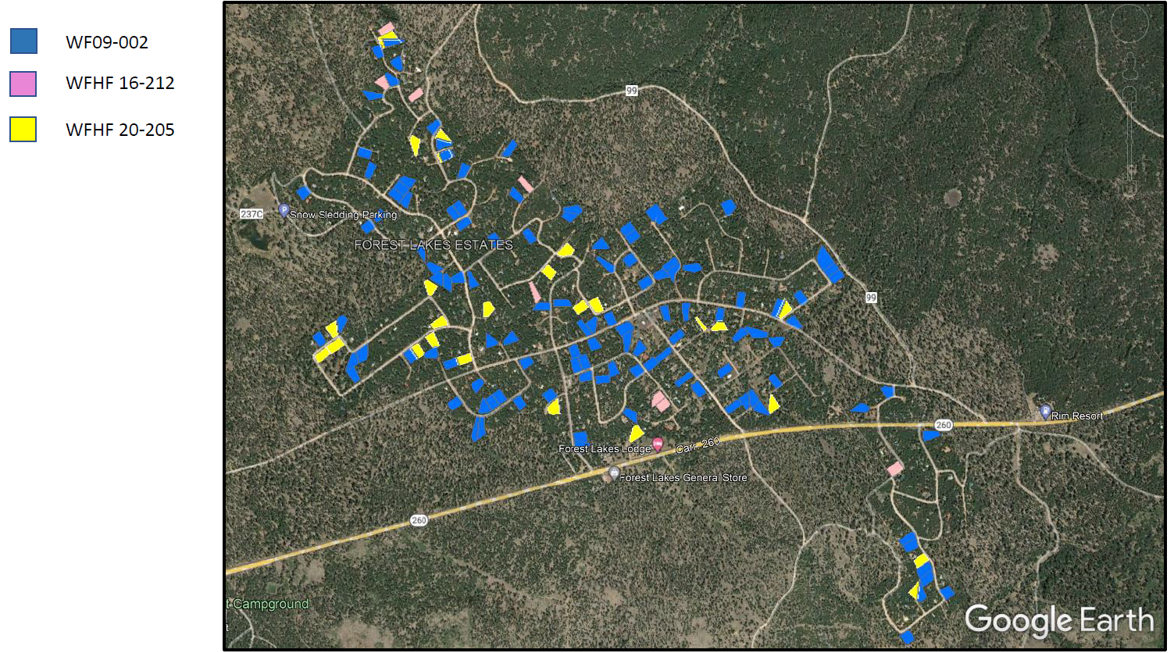
    - The existing grant (WFHF 20-205) is going well.
    - Only two contractors are available to do lot clearing.
    - A grant application request for the Healthy Forest Initiative (same objectives, new name) is being pursued.
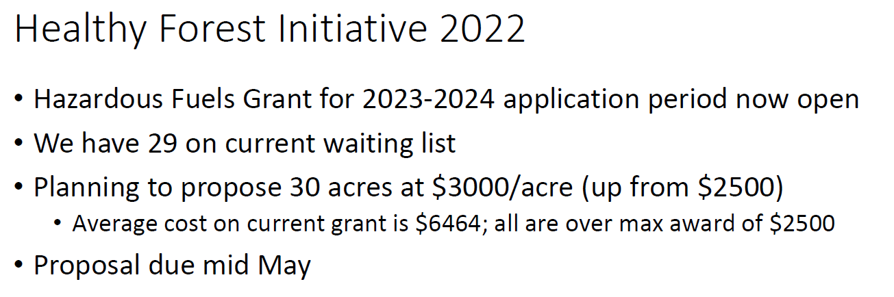
    - Forest Lakes has been designated a high priority for grant awards.
    - All administrative costs for these grants are paid for by the grant.
  - Status update re: Governmental Advocacy Committee. Chairman Torres reported budget discussions continue at the state level. The Fire District Safety Act legislation continues to work itself through the various committees. Chairman Torres will advise if we need to send letters in support of the legislation.
  - Status update re: Master Planning Committee Activities. Chief reported electrical work for the Tuff Sheds and the Blue Garage has started now that soil conditions are favorable. He is pursuing a beautification effort involving the installation of railroad ties along the southern border of the property. Treasurer Batschelet advised he may have a source for acquiring railroad ties at a discount. Contouring work will be required as part of the design effort.
  - Discussion and possible action re: Review and approval of Policy 0002 – Fire Board and Chief Policy. Policies, Procedures and Bylaws Chairman Massion reviewed the subject policy that included minor updates to paragraphs 27 and 28. It was decided to keep the title Public Information Officer in lieu of Communications Specialist because that designation is used routinely throughout the Arizona Revised Statutes, to which our policies reference. He also included a modification to the description to the role of the Auxiliary to agree with the wording used in the Auxiliary’s Bylaws. Chairman Massion made a motion to approve the Policy 0002 as presented. Treasurer Batschelet seconded, and the motion passed unanimously,
  - Status update re: Heart Monitor Purchase. Chief reported we do not yet have an updated delivery date promise from Stryker. We have no realistic alternative but to wait. There is no reasonable work-around.
  - Status update re: Exploration of Certificates of Participation or other refinancing. Chairman Cummiskey summarized the report prepared by Stifel at his request to determine: 1) if a COP is a viable option for FLFD; 2) if a rebid of our existing LPA was advantageous; and 3) if we might restructure the existing LPA to include the cost of a new fire engine.
    - Option 1. Based on an analysis of FLFD, a COP is not a viable alternative. We do not meet the threshold borrowing amount.
    - Option 2. Zion Bank does not refinance its own LPAs. Stifel proposed to go out to the marketplace to competitively bid refinancing our existing contract. Based on the current LPA, we owe $508K at a current interest rate of 3.07%. Stifel estimates the rate will adjust to 3.58% in 2027. Bottom line: refinancing our existing LPA with STIFEL would result in a NPV savings of -$10,046, which, given it is 15-year time period, was not deemed significant enough to pursue.
    - Option 3. Refinance existing $508K debt plus add $700K for selected capital improvements would result in an annual debt service of over $100K, which is unaffordable.

Bottom line recommendation: Stay with our current arrangement with Zion’s Bank.

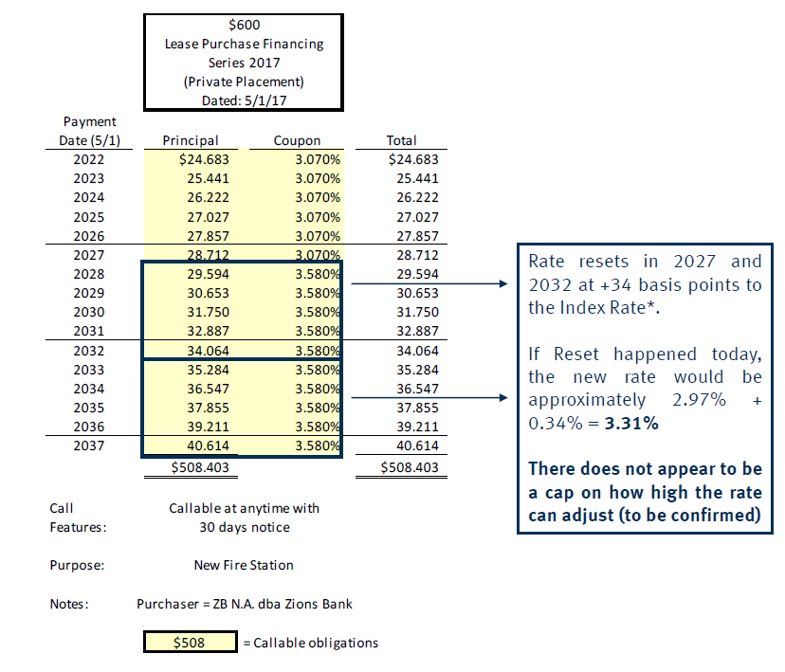
Existing LPA With Zion Bank with Estimated Reset in 2027 (Future Reference.)

  - Status update re: PIO Presentation. Member Torres introduced the topic, the source of which was discussions at the recent AFDA Conference. He thanked Chief and John Nelson for leading the effort that produced the presentation we are about to view.

John Nelson then proceeded with the prepared briefing. The basic objective is to improve communications. The information has to be professional, authoritative, accurate and timely and include topics other than directly fire related, but of interest to the community (social events such as open houses, red flag warnings, …) The first order of business was to select a communications model. It was determined the best model for Forest Lakes was a one-way exchange of information (based on our staffing limitations.) The fire district would push information out to the public. It was also decided the information content would be broader than what the traditional Public Information Officer would address. The strategy would incorporate our web page and social media apps such as Twitter and Facebook. There would be close coordination with information disseminated from FLOA. There would be alternative means of information delivery for those of us who choose not to use social media. There should be some means to allow resident originated notices. There is no FLFD Hotline. In the event of an evacuation order, by statute Law Enforcement is in charge, with FLFD being in a support role. The information model chosen is shown below:
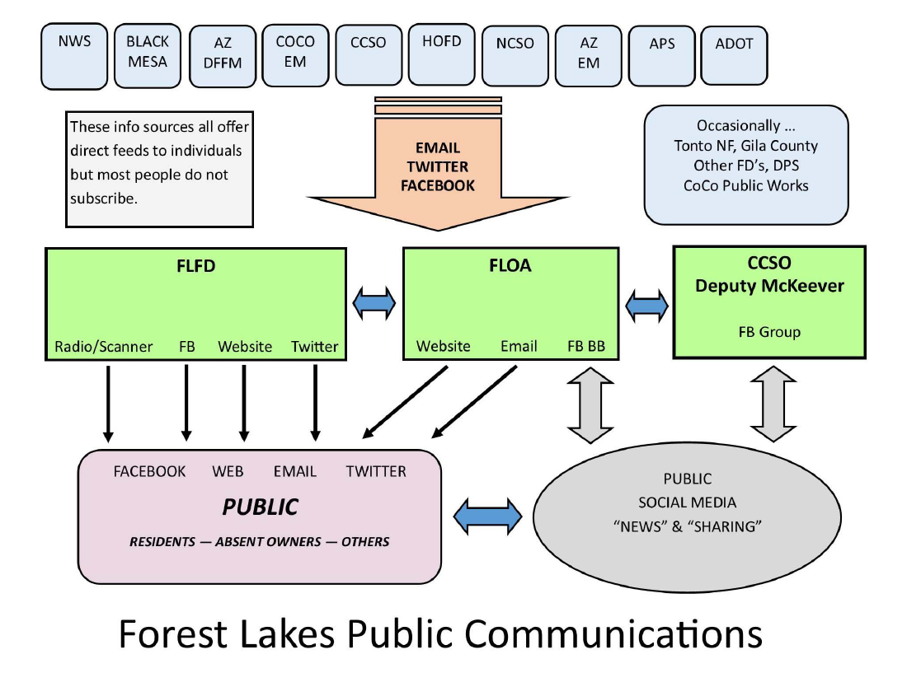
The proposed Action Plan to accomplish Improved Communications, as agreed upon, is shown below:

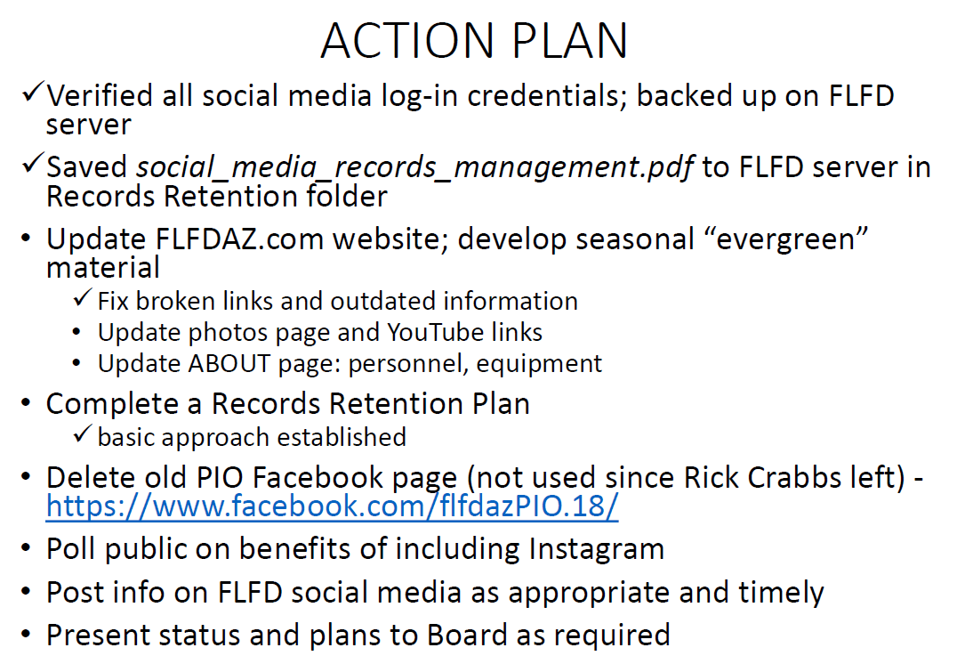
In closing, John, in his role as Communications Specialist, said a scanner is a fail-safe option we all should have. When all else fails, a scanner delivers information. Scanners are VHF, Receive Only and are fairly inexpensive (~$100.) He is willing to assist any resident who needs help acquiring and setting up a unit.

John took an action to report back to the board at the June meeting.

- Fire Chief’s Report. Chief displayed a report from the NOAA/NWS Flagstaff Office. In summary:
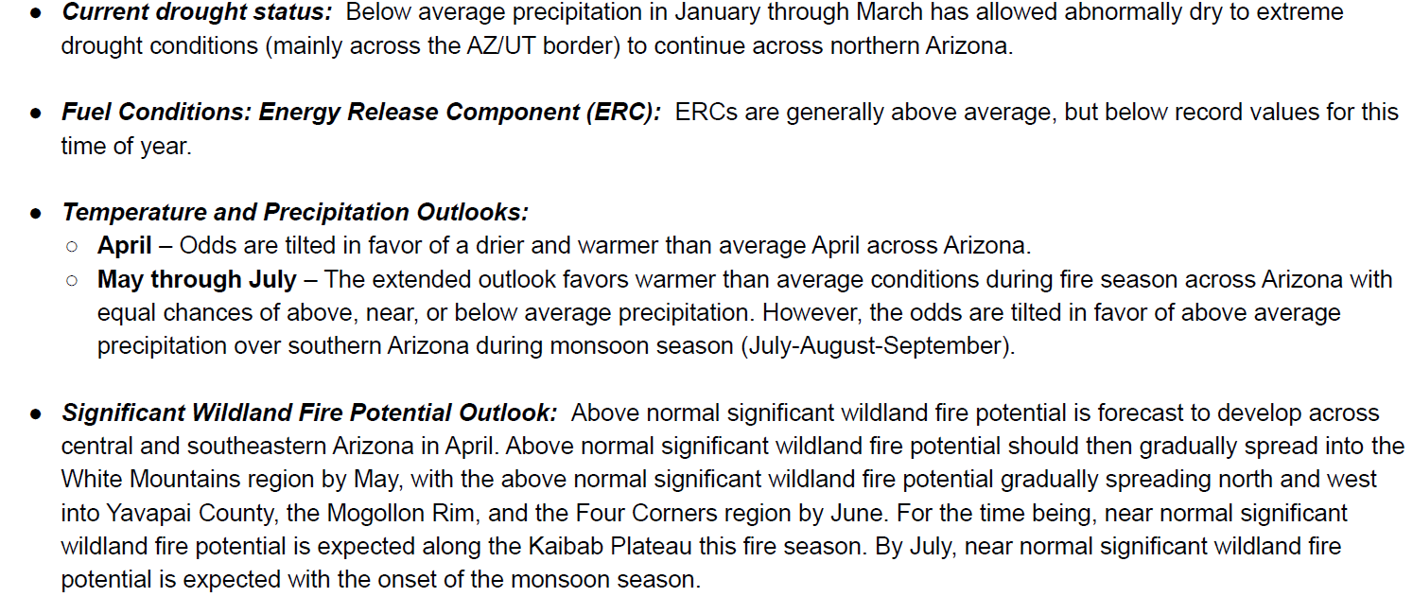

He noted we have already had two small fires near Forest Lakes and that fires outside our state lines impact us by drawing away resources. We will try to direct Healthy Forest Initiative grant monies toward the south side where fire danger is highest (see agenda item 8h). Previous forest service fire treatment/mitigation plans along the south side boundary that were put on hold due to COVID will be revisited. The Black Mesa district is short staffed however, so this may take some time to address. Because of the dry conditions the Forest Service may implement forest closures sooner rather than later. Our monsoon season is expected to be wetter than normal. Our new ambulance billing company, AAB, will take over our billing starting July 1st. FLDWID is hosting a meeting in Forest Lakes with our county assessor, treasurer, and other related departments at 12 noon on May 19th. FLFD and FLOA will participate as well. Julie will send out an invite to board members and staff. The GWTS will begin normal hours in May.
- Call to the Public/Audience Comments. There were no comments.
- Fire Board Comments.

Clerk Hennessey advised he has filed a Notice of Election on behalf of the fire district with the County Elections department for the November 8, 2022, General Election stating that three board member seats will up for election: Tom Cummiskey, Dennis Massion and Pete Batschelet. Their terms all expire November 30, 2022. He will be in contact with our attorney, Bill Whittington, seeking guidance on how to comply with legal requirements regarding the election process. For the record, terms for the remaining two board members, Israel Torres, and John Hennessey, expire November 30, 2024. Chairman Cummiskey reminded us that if we only have three applicants for the three positions the County Board of Supervisors can declare the positions filled and remove the issue from the ballot. Pete stated his intention to run again. Chief has advised two residents have expressed interest to him in pursuing the openings.

Chairman Cummiskey advised he is leaving for extended vacation travel, beginning April 21^{st,} and returning May 19th. He will be available by email and cell phone.

- Adjournment. There being no further business before the board, the meeting was adjourned at 12:13 pm.
Note: In order to promote openness and transparency, all materials presented at the board meeting are available to be viewed on the FLFD Web Site: flfdaz.com and following the web site prompts; or by going directly to the URL, flfdaz.com/board-meeting-minutes.
Approved by the Forest Lakes Fire Board on May 21st, 2022

John Hennessy ______________________________

