Precision Sports Therapy

Setting Up Your Vehicle
July 22, 2021

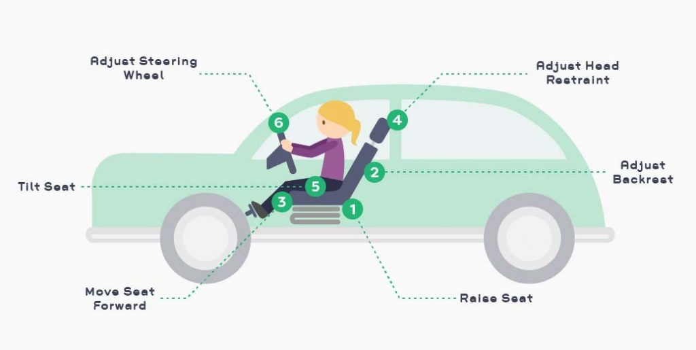

A Guide To Comfortable and Healthy Driving
Setting up your vehicle properly can prevent you from experiencing unnecessary pain or soreness. There are many different aspects that can contribute to proper positioning, including the seat, headrest, steering wheel, and mirrors. Driving can cause pain in the shoulders, neck, hips, arms, or anywhere else that is static for a long duration while driving. Try these tips to set up your car properly and check out the neck and shoulder educational videos on our website for some stretches and exercises you can try.

Mirror Positioning
- Position your side mirrors to minimize hunching your back and neck rotations
- Adjust the rearview mirror with good posture to promote staying in a good position throughout your driving

Rest and Relaxation
- Plan to stop for a rest at least once every two hours during long car rides so that you can move around and stretch
- These rests will allow your muscles to relax, as well as preventing yourself from remaining static for extended periods

Posture and Backrest Positioning
- Your hips and shoulders should remain against the backrest
- Your head should be balanced over your shoulders
- The lumbar support should comfortably support you across the small of your back to help you sit up tall
- Your backrest should be slightly reclined, but support you in an upright position

Steering Wheel
- Pull the steering wheel close enough to avoid reaching forwards (if car allows)
- The height of the steering wheel is proper when your forearms face each other if held properly
- Release the wheel at red lights to reduce your time with static grip

Seat Positioning and Tilt
- Seat should be positioned so that you can reach the pedals with your knees slightly bent and without sliding your hips forwards on the seat
- Your heel should remain on the floor when depressing the pedals
- Your knees and hips should be aligned with the horizontal positioning of the seat
- There should be no uncomfortable pressure on the backs of your legs

Headrest Positioning
- Your neck should be supported with your head balanced over your shoulders
- The headrest should not be pushing your head forwards

