# Setting Up Your Workspace

A Guide to Working Comfortably and Healthily

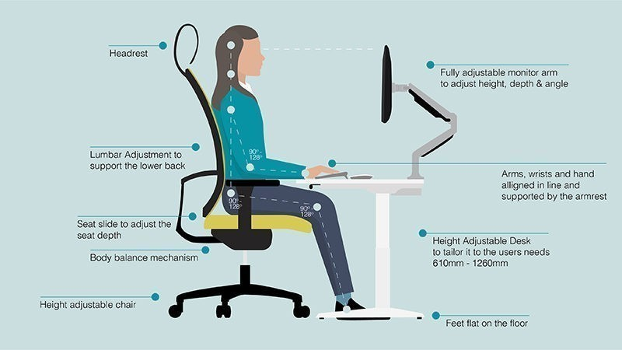

Although we wish we didn’t need to spend so much time at a computer or in the office, it is becoming a modern-day reality. This can lead to stiff and sore muscles due to poor posture and remaining static for long portions of the day. However, a combination of movement and a proper workplace setup can combine to reduce the negative effects on your body.

horizontal lineChair:

Hips and shoulders should be anchored against the backrest. Your hips should also be slightly higher than your knees. Sit all the way back in the chair with your thighs evenly spaced. To reduce reaching, slide your chair towards your workspace.

Work Surface:

Any frequently referenced documents should sit on an angled document holder directly in front of or beside your monitor. Your workstation should be positioned perpendicular to any windows, or adjust the blinds, to reduce glare.

Input Devices:

When using a laptop use a separate keyboard and mouse. Also, try to match your elbow height with your keyboard and mouse height. 

Monitors:

Try to set up your monitors to minimize neck rotation and align the top of the screen at or slightly below eye level. To raise a laptop so the screen is at the right height you can use books, boxes, or a stand. Distance your monitor about arm’s length away or closer if needed for better vision. Take screen breaks every 20 minutes for about 20 seconds and look in the distance about 20 feet away.

Armrests:

Your arm rests should be positioned so that your shoulders are relaxed, and your arms sit relaxed at your sides. Your arms should also sit close to the mouse and your elbows should be at a 90-degree angle.

Feet Supported:

Your feet should sit flat on the floor or footrest to provide a stable base that can take pressure off the backs of your legs. Your knees should be slightly bent.

horizontal line

# Microbreaks and Stretches

## Release Tension: Activate Shoulders:

## Forearm stretches (2 x 10s) Shoulder Rolls (10 x)

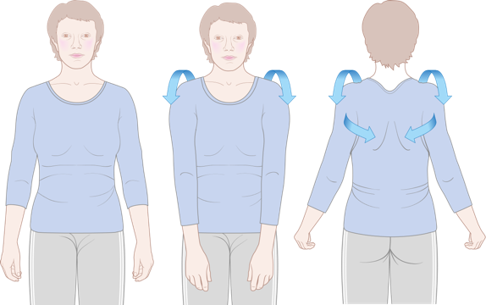

Release Tight Hips: Engage Core:

Seated Figure Four (2 x 20s) Standing Disc Unload (5 x 3s)

