Rectortown United Methodist Church
January 11th, 2026 10:00 a.m.
Baptism Sunday

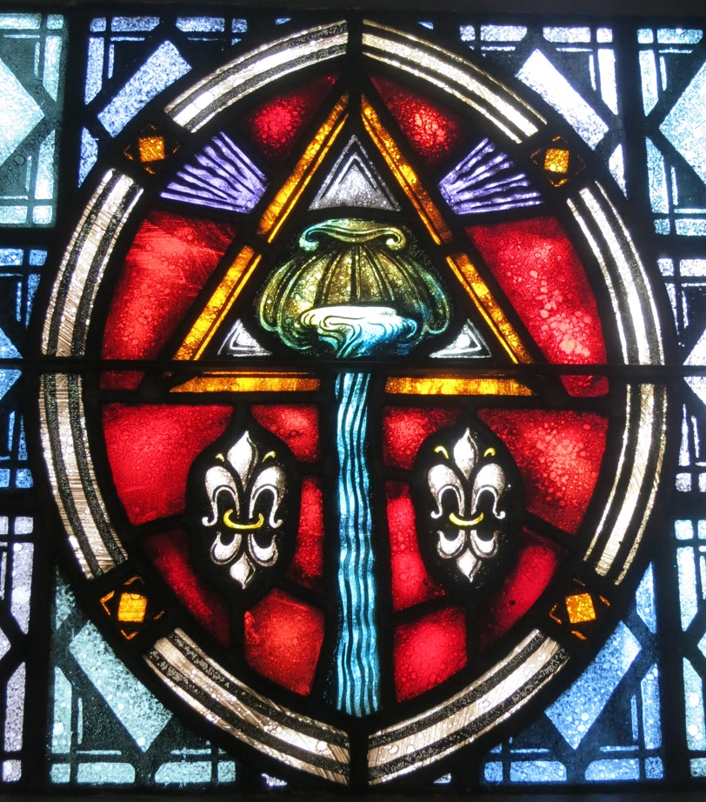

Pastor: Eduardo Carrillo
3049 Rectortown Road, Marshall, VA 20115
Pastor’s Cell Phone: (703) 967-4361
Pastor’s E-mail: pastor@rectortownumc.org
Music Director: Karen Chase
Ministers: every member of the congregation
Welcome to Rectortown UMC!

“This is the day that the Lord has made;
let us rejoice and be glad in it.” Psalm 118:24 NRSV

* Please Stand As You Are Able and Comfortable
PRELUDE - let us quiet our minds and hearts.
WELCOME, ANNOUNCEMENTS and CELEBRATIONS

GATHERING
*BRINGING IN THE LIGHT OF CHRIST

*CALL to WORSHIP
Leader: We come to the water
People: to celebrate God’s goodness!
Leader: We come to the water
People: to celebrate God’s love!
Leader: We come to the water to remember
People: that we are beloved, cherished, and
forgiven!

*OPENING PRAYER
Holy God, we thank you today for the gift of baptism and how it unites us as one by the Holy Spirit. We thank you that before we do anything, you claim us as beloved, surround us in community, and nurture us to be your people. As we celebrate the meaning of baptism today, we ask once again for your cleansing love to wash over us. Help us to remember that we all belong to the body of Christ; we each have a special role in your family; and we are sent out into the world to do good and resist evil in your name. Amen.
* HYMN
“How Great Thou Art” UMH 77

PROCLAMATION
YOUNG DISCIPLES’ MESSAGE

*PRAYER for ILLUMINATION UMH 393
Spirit of the living God, fall afresh on me.
Spirit of the living God, fall afresh on me.
Melt me, mold me, fill me, use me.
Spirit of the living God, fall afresh on me.

OLD TESTAMENT READING
Isaiah 43: 1 – 7

*NEW TESTAMENT READING
Mark 1: 4 – 12
This is the word of God for the people of God.
Thanks be to God.

SERMON “Baptism”

RESPONSE
*RESPONDING HYMN
“Spirit Song” UMH 347

*AFFIRMATION OF FAITH UMH 881
Apostles’ Creed (Traditional Version)

SHARING OUR JOYS and CONCERNS

PASTORAL PRAYER & LORD’S PRAYER

GIVING OUR GIFTS and TITHES
Offertory:
Doxology UMH 94
“Praise God from Whom All Blessings Flow”
Offertory Prayer

*CLOSING HYMN
“Breathe on Me, Breath of God” UMH 420

SENDING FORTH
*BENEDICTION

* POSTLUDE
* Please stand as you are able and comfortable.
This worship service has ended, and now your service begins.
As you leave church today, you are entering the mission field.

PRAYERS FOR THE CHURCH AND FOR THE WORLD:
For Family and Friends:
Russ & Ethel Muter  Gillian Payne  Ernestine Hall  Sandra  Hall Family  Donna Olson  Joan Newsome | John McGuinn & Sydney  Kathleen Rhodes  Rick Willis  Don Williams  Austin  Dennis
For the Family of those who grieve for:
Larry Underwood
Henry Skinker
Robbie Ferris

For the Church and For the World:

For those in need of healing, and their caretakers.
For first responders, the military, and their families.
For God’s People, The Church, and the World.
Prayers for national, state, and local leaders; and for our Nation.

If you know someone you would like to add to our prayer list, please forward your request to the church office by email at: secretaryrumc@gmail.com, or by calling (540) 364-1066.

RUMC CELEBRATIONS

Birthdays
None
Anniversaries
None

UPCOMING MEETINGS AND EVENTS

Admin Council
Thursday, February 5th at 7 pm. Zoom & In Person

Trustees Meeting
Tuesday, January 13th at 6 pm.
Zoom & In Person

Fig Leaf
Friday, January 16th at 10 am. Zoom & In Person

Worship Meeting
Wednesday, January 28th at 10 am. Zoom & In Person

Rectortown United Methodist Church
  - Location: 3049 Rectortown Road, Rectortown, VA
Mailing Address: PO Box 301, Rectortown, VA 20140
Email: secretary@rectortownumc.org
Phone: (540)364.1066

