**Rectortown United Methodist Church**

May 4th, 2025 10:00 a.m.

*3rd Sunday of Easter/ Communion*

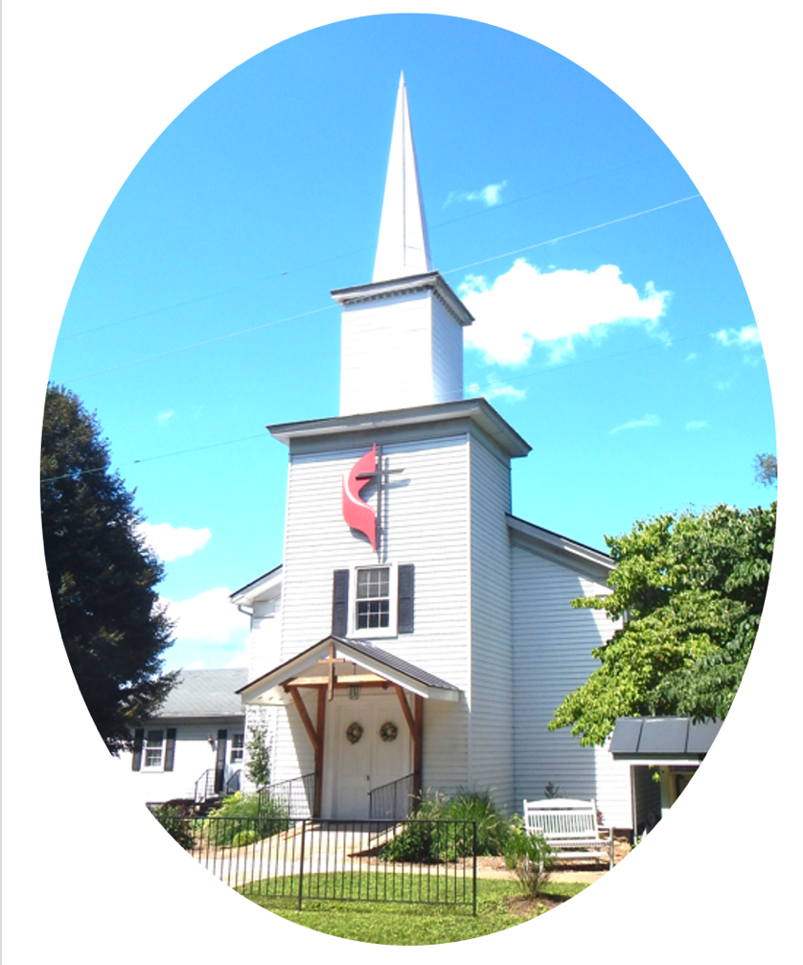

***Pastor****: TaeWon Kang*

*3049 Rectortown Road, Marshall, VA* 20115

*Pastor’s Cell Phone:* (470) 728 - 9060  
*Pastor’s E-mail:* pastortaewonkang@gmail.com

***Music Director****:* Karen Chase

***Ministers****: every member of the congregation*

Welcome to Rectortown UMC!

*“You are looking for Jesus the Nazarene, who was crucified. He has risen!”*

Mark 16:6 NIV

**\*** *Please Stand As You Are Able and Comfortable*

**PRELUDE** - *let us quiet our minds and hearts.*

**WELCOME, ANNOUNCEMENTS and CELEBRATIONS**

**\*BRINGING IN THE LIGHT OF CHRIST**

**\*CALL to WORSHIP**

Leader: Christ asked Peter if he loved him.  
**People: Peter affirmed three times his love**

**of the Lord.**Leader: Christ asks us if we love him.  
**People: We affirm our love of the Lord in our**

**worship**Leader: Christ calls us to demonstrate our love in

service.  
**People: Lord, help us to witness to your love**

**in the ways in which we care for**

**others. AMEN**

**\*OPENING PRAYER**

**God of power and might, let your love shine on us and through us to others. Take the blindness from our eyes and our hearts. Give us the joy of knowing, loving, worshiping, and serving you in all that we say, think, and do. In Jesus’ Name, we pray. Amen.**

**\* HYMN** “All Hail the Power of Jesus’ Name”

UMH 154 (Verse1,3,&6)

**YOUNG DISCIPLES’ MESSAGE**

**\*PRAYER for ILLUMINATION** UMH 393

**Spirit of the living God, fall afresh on me.**

**Spirit of the living God, fall afresh on me.**

**Melt me, mold me, fill me, use me.**

**Spirit of the living God, fall afresh on me.**

**EPISTLE READING**

Revelations 5:11 - 14

This is the word of God for the people of God.

**Thanks be to God.**

**RESPONSIVE READING** Psalm 30 UMH 762

**\*GOSPEL READING** John 21: 1 - 19

**\*** Gloria Patri –“Glory Be to the Father” UMH 70

**SERMON**

“The Resurrected Jesus’ Calling”

**\*RESPONDING HYMN**

“More Love to Thee, O Christ” UMH 453

**INVITATION, CONFESSION, AND PARDON**

**INVITATION (UMH 12)**

Christ our Lord invites to his table all who

love him,

Who earnestly repent of their sin

And seek to live in peace with one another.

Therefore, let us confess our sin before God

and one another.

**CONFESSION (UMH 12)**

**Merciful God,**

**We confess that we have not loved you**

**with our whole heart.**

**We have failed to be an obedient church.**

**We have not done your will,**

**We have broken your law,**

**We have rebelled against your love,**

**We have not loved our neighbors,**

**And we have not heard the cry of the**

**needy.**

**Forgive us, we pray.**

**Free us for joyful obedience,**

**Through Jesus Christ our Lord. Amen.**

**PARDON (UMH 12)**

Hear the good news:

Christ died for us while we were yet sinners;

That proves God’s love toward us.

In the name of Jesus Christ, you are forgiven!

**PASSING OF THE PEACE**

**SHARING OUR JOYS and CONCERNS**

**PASTORAL PRAYER**

**GIVING OUR GIFTS and TITHES**

Offertory:

Doxology UMH 94  
 “Praise God from Whom All Blessings Flow”

Offertory Prayer

**GREAT THANKSGIVING** UMH 13

**LORD’S PRAYER, BREAKING THE BREAD, AND GIVING THE BREAD AND CUP** UMH 14

**\*PRAYER AFTER COMMUNION** UMH 11

***Eternal God, we give you thanks for this holy mystery in which you have given yourself to us. Grant that we may go into the world in the strength of your Spirit, to give ourselves for others, in the name of Jesus Christ our Lord, Amen.***

**\*CLOSING HYMN**

“Jesu, Jesu” UMH 432

**\*BENEDICTION**

**\* POSTLUDE**

* *Please stand as you are able and comfortable.*

|  |
| --- |
| ***This worship service has ended, and now your service begins.***  ***As you leave church today, you are entering the mission field.*** |

***PRAYERS FOR THE CHURCH AND FOR THE WORLD:***

|  |  |
| --- | --- |
| **For Family and Friends:** | |
| Linda Brown  Jim Caylen  Towny Lunsford  Christine Felts & Mother  Paula Polston | Russ & Ethel Muter  Joann Garrett  Vickie Duff  The Reed Family  Tommy Ann |
| **For the Family of those who grieve for:**  Laura Skirka  Judy Bailey  Winnie | |
|  |  |

**For the Church and For the World:**

For those in need of healing, and their caretakers.

For first responders, the military, and their families.

For God’s People, The Church, and the World.

Prayers for national, state, and local leaders; and for our Nation.

**If you know someone you would like to add to our prayer list, please forward your request to the church office by email at: secretaryrumc@gmail.com, or by calling (540) 364-1066.**

**RUMC CELEBRATIONS**

|  |  |
| --- | --- |
| **Birthdays** | |
| Gilliam Pearson – May 6th | Danielle Martin – May 7th |
| Olivia Walker – May 7th | Ren Walker – May 11th |
| Richard Rector – May 11th | |
| **Anniversaries** | |
| None | |

**UPCOMING MEETINGS AND EVENTS**

**Mother’s Day, May 11th**

**Please bring a picture of a significant woman in your life for the altar.**

**Admin Council**

Thursday, **June 5th at 7pm**. In person and zoom.

**Trustees Meeting**

Tuesday, May 13th at 6pm. In person and zoom.

**Worship Meeting**

Monday, May 12th at 6pm. Zoom and in person.

**RSVP for Homecoming**

Please RSVP to the secretary by May 12th!

**Fig Leaf**

Tuesday, May 20th at 10am. Zoom and in person.

**Rectortown United Methodist Church**

Location: 3049 Rectortown Road, Rectortown, VA

Mailing Address: PO Box 301, Rectortown, VA 20140

Email: secretary@rectortownumc.org

Phone: (540)364.1066