Rectortown United Methodist Church
November 12th, 2023 10:00 a.m.
Twenty-Fourth Sunday

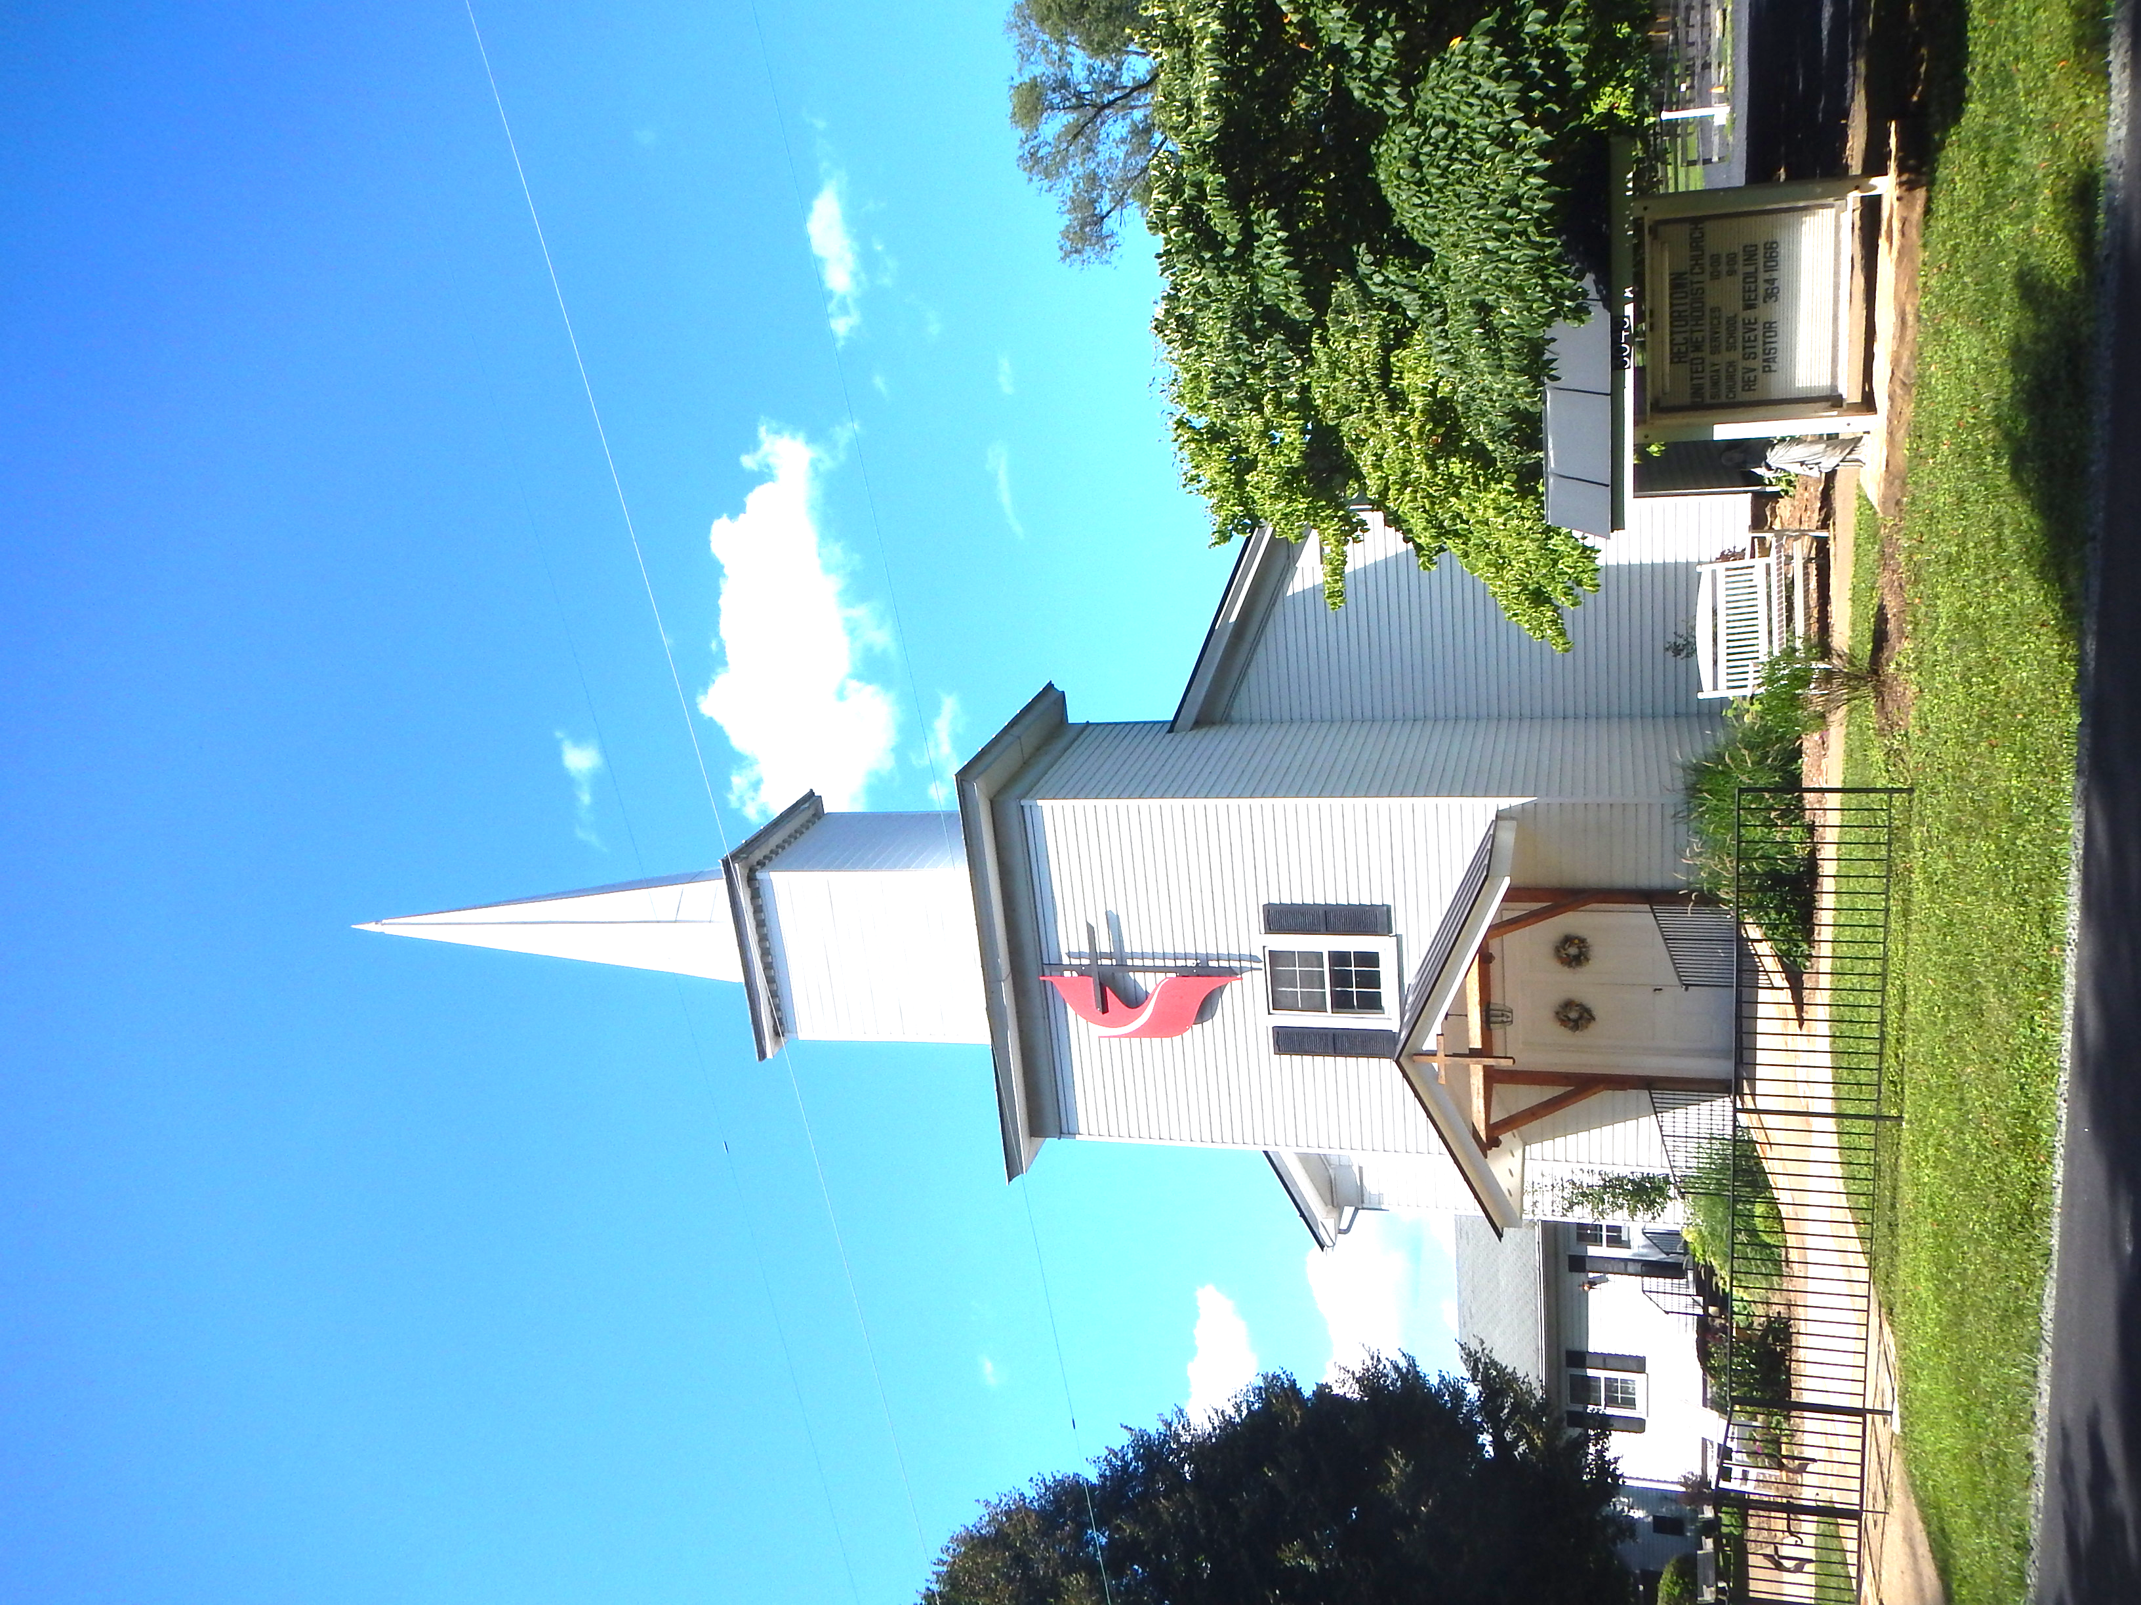

Pastor: Rev. Jonathan Jennings Lamb
3049 Rectortown Road, Marshall, VA 20115
Pastor’s Cell Phone: (540) 742-1535
Pastor’s E-mail: jonathanlamb@vaumc.org
Music Director: Karen Chase
Ministers: every member of the congregation
Welcome to Rectortown UMC!

No matter where you have been or where you have failed to be – what you have said or what you have failed to say - what you have done or what you have failed to do - whom you have loved or whom you have failed to love - you are welcome here.

* Please Stand As You Are Able and Comfortable

PRELUDE - let us quiet our minds, hearts, and spirits as we begin to focus on the presence of God as we become aware of the Light of Christ in our midst.

ENTRANCE

WELCOME, ANNOUNCEMENTS and CELEBRATIONS

BRINGING IN the LIGHT of CHRIST “Lamb of Glory”

CALL TO WORSHIP (from umcdiscipleship.org)

Leader: God is great, and greatly to be praised!
People: We thank you, God, for families and friends. We
thank you for the warmth of kitchens, quilts, and
good neighbors.
Leader: God, how great is your name throughout the earth!
People: We thank you, God, for newborn kittens and
faithful dogs, for pine trees and sunlight and crisp, clean air.
Leader: Blessed be God, the rock of our salvation!
People: We thank you, God, for the sound of laughter
and the touch of love, for brand new mornings
and for dreams held close.
Leader: Let us come into God’s presence with
thanksgiving; let us make a joyful noise with songs
of praise. Come! Let us worship God.

* FIRST HYMN “Blessed Assurance” UMH 369

OPENING PRAYER (From umdiscpleship.org )

Creator God, who claims us as your own, we bring our full selves to worship today.
Our happiness and our sorrow, our singing and our crying, our strengths, and our failures—
We carry it all. Teach us to trust that your faithfulness endures in all the seasons and circumstances of our lives. Help us to know that all that we are is bound to you and teach us to rest on your steadfast love as the source of our gratitude and joy as we, your sheep, follow you wherever you lead. Amen.

YOUNG DISCIPLES’ MESSAGE “Parable of the Ten Bridesmaids”

VETERANS’ RECOGNITION

THE PASSING OF THE PEACE

PROCLAMATION AND RESPONSE

PRAYER for ILLUMINATION From Caldwell Presbyterian

God of mercy, you promised never to break your covenant with us. Amid all the changing
words of our generation, speak your eternal Word that does not change. Then may we
respond to your gracious promises with faithful and obedient lives; through our Lord Jesus
Christ. Amen.

FIRST SCRIPTURE LESSON
Scripture: Matthew 28:16-20

This is the word of God for the people of God.
Thanks be to God.

RESPONSIVE READING
Psalm 76:1-12 UMH 797

SECOND SCRIPTURE LESSON
Scripture: John 15:15-17

* Gloria Patri – “Glory Be to the Father” UMH 70

MESSAGE “The State of the Cooperative Parish”

RESPONSE: PRAYER FOR OPERATION CHRISTMAS CHILD BOXES

* SECOND HYMN “Seek Ye First” UMH 405

AFFIRMATION OF FAITH UMH 882

SHARING OUR JOYS and CONCERNS

PASTORAL PRAYER

GIVING OUR GIFTS and TITHES
Offertory: “Offertory on Maitland”
* Doxology UMH 94
“Praise God from Whom All Blessings Flow”
Offertory Prayer
THANKSGIVING
THE LORD’S PRAYER UMH 895
SENDING FORTH
*HYMN “Guide My Feet” TFWS 2208
BENEDICTION
* SENDING FORTH
“Go Ye, Go Ye Into The World” TFWS 2239
* Please stand as you are able and comfortable.
This worship service has ended, and now your
service begins.
As you leave church today, you are entering the mission field.

Questions for Reflection

“How can we live into our mission as a church today?”

PRAYERS FOR THE CHURCH AND FOR THE WORLD:
For Family and Friends:
Linda Brown  Jim Caylen  First Grader at CTE School  Paula Poston  Towny Lunsford | Millie Mailwauki  Bill Newlin  Alice Pleasants  Jim Richbourg  Steve and Cecilia Trimble  Lowell Daniels
For the Family of those who grieve for:
Bev Delano  Kraig Kelican  Robin Payne | Ruth Rosenberg-Manne  Sal Torelli  Mark Trabucchi
For the Church and For the World:

For those in need of healing, and those caring for them.
For first responders, and the military, and their families.
For God’s People, The Church, and the World.
Prayers for national, state, and local leaders; and for our Nation.

If you know someone you would like to add to our prayer list, please forward your request to the church office by email at: secretaryrumc@gmail.com, or by calling (540) 364-1066.

RUMC CELEBRATIONS

Birthdays
Diane Harrington – November 13th | Tara Wegdam – November 14th
Anniversaries
None

UPCOMING MEETINGS and EVENTS
Charge Conference
November 12th at 2 pm at Leesburg UMC

Pastor Vacation
November 20th to 24th

Thanksgiving Break
Offices Closed
November 22nd to 24th

Ornament Making/ Tree Decorating
November 25th at 9am

Community Christmas Tree Lighting
November 26th at 6pm
Fellowship at 5:30pm


Rectortown United Methodist Church
Location: 3049 Rectortown Road, Rectortown, VA
Mailing Address: PO Box 301, Rectortown, VA 20140
Email: secretaryrumc@gmail.com Phone: (540) 364-1066

