**Rectortown United Methodist Church**

May 18th, 2025 10:00 a.m.

*5th Sunday of Easter/ Heritage Sunday*

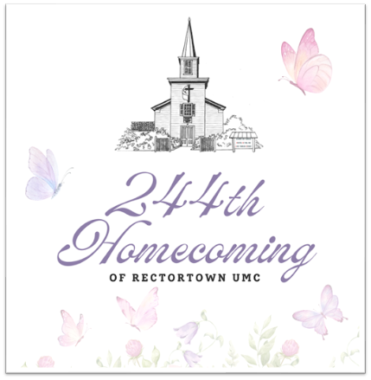

***Pastor****: TaeWon Kang*

*3049 Rectortown Road, Marshall, VA* 20115

*Pastor’s Cell Phone:* (470) 728 - 9060  
*Pastor’s E-mail:* pastortaewonkang@gmail.com

***Music Director****:* Karen Chase

***Ministers****: every member of the congregation*

Welcome to Rectortown UMC!

*“You are looking for Jesus the Nazarene, who was crucified. He has risen!”*

Mark 16:6 NIV

**\*** *Please Stand As You Are Able and Comfortable*

**PRELUDE** - *let us quiet our minds and hearts.*

**WELCOME, ANNOUNCEMENTS and CELEBRATIONS**

**\*BRINGING IN THE LIGHT OF CHRIST**

**\*CALL to WORSHIP**

Leader: Jesus reminded the disciples  
**People: Love one another as I have loved**

**you.**Leader: Jesus taught and witnessed to God’s love  
**People: Love one another as I have loved**

**you.**Leader: Jesus encourages us to love each other

with tenderness, compassion, and hope.  
**People: Let us love one another as Christ**

**loved us. AMEN.**

**\*OPENING PRAYER**

**Gracious and Loving God, we are grateful that you have called us together this day, drawing us from darkness to the glory of your light. May our spirits rejoice at the good news you have for us today. Open our hearts to your healing love, for we ask this in Christ’s Name. AMEN.**

**\* HYMN** “Blessed Assurance” UMH 369

**YOUNG DISCIPLES’ MESSAGE**

**\*PRAYER for ILLUMINATION** UMH 393

**Spirit of the living God, fall afresh on me.**

**Spirit of the living God, fall afresh on me.**

**Melt me, mold me, fill me, use me.**

**Spirit of the living God, fall afresh on me.**

**EPISTLE READING**

Revelations 21: 1 - 6

This is the word of God for the people of God.

**Thanks be to God.**

**RESPONSIVE READING** Psalm 148 UMH 861

**\*GOSPEL READING** John 13: 31 - 35

**\*** Gloria Patri –“Glory Be to the Father” UMH 70

**SERMON** “Love, Love, Love”

**\*RESPONDING HYMN**

“Make Us One” TFWS 2224

**\*Affirmation of Faith** UMH 881

Apostles’ Creed (Traditional Version)

**SHARING OUR JOYS and CONCERNS**

**PASTORAL PRAYER & LORD’S PRAYER**

**GIVING OUR GIFTS and TITHES**

Offertory:

Doxology UMH 94  
 “Praise God from Whom All Blessings Flow”

Offertory Prayer

**\*CLOSING HYMN**

“How Great Thou Art” UMH 77

**\*BENEDICTION**

**\* POSTLUDE**

* *Please stand as you are able and comfortable.*

|  |
| --- |
| ***This worship service has ended, and now your service begins.***  ***As you leave church today, you are entering the mission field.*** |

***PRAYERS FOR THE CHURCH AND FOR THE WORLD:***

|  |  |
| --- | --- |
| **For Family and Friends:** | |
| Linda Brown  Jim Caylen  Towny Lunsford  Christine Felts & Mother  Paula Polston | Russ & Ethel Muter  Joann Garrett  Vickie Duff  The Reed Family  Tommy Ann |
| **For the Family of those who grieve for:**  Laura Skirka  Judy Bailey  Winnie | |
|  |  |

**For the Church and For the World:**

For those in need of healing, and their caretakers.

For first responders, the military, and their families.

For God’s People, The Church, and the World.

Prayers for national, state, and local leaders; and for our Nation.

**If you know someone you would like to add to our prayer list, please forward your request to the church office by email at: secretaryrumc@gmail.com, or by calling (540) 364-1066.**

**RUMC CELEBRATIONS**

|  |  |
| --- | --- |
| **Birthdays** | |
| Gary Garrett – May 19th | Rebecca Pearson – May 19th |
| Kenneth Nalls – May 21st | Jody Warfield – May 22nd |
| Kayla Ryder – May 24th | |
| **Anniversaries** | |
| Amy & Joe Riggio – May 19th  Russ & Ethel Muter – May 25th | |

**UPCOMING MEETINGS AND EVENTS**

**Admin Council**

Thursday, **June 5th at 7pm**. In person and zoom.

**Trustees Meeting**

Tuesday, June 10th at 6pm. In person and zoom.

**Worship Meeting**

Monday, June 9th at 6pm. Zoom and in person.

**Fig Leaf**

Tuesday, June 17th at 10am. Zoom and in person.

**Memorial Day**

Monday, May 26th. Office is closed.

**Rectortown United Methodist Church**

Location: 3049 Rectortown Road, Rectortown, VA

Mailing Address: PO Box 301, Rectortown, VA 20140

Email: secretary@rectortownumc.org

Phone: (540)364.1066