**Rectortown United Methodist Church**

August 31st, 2025 10:00 a.m.

*12th Sunday after Pentecost/ Labor Day Weekend*

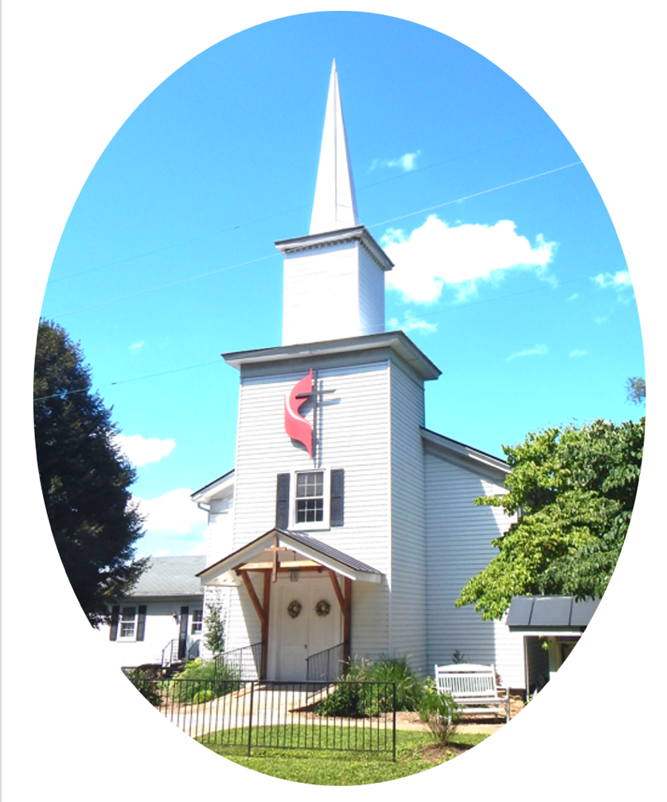

***Pastor****: Eduardo Carrillo*

*3049 Rectortown Road, Marshall, VA* 20115

*Pastor’s Cell Phone:* (703) 967-4361  
*Pastor’s E-mail:* pastor@rectortownumc.org

***Music Director****:* Karen Chase

***Ministers****: every member of the congregation*

Welcome to Rectortown UMC!

*“This is the day that the Lord has made;  
    let us rejoice and be glad in it.”* Psalm 118:24 NRSV

**\*** *Please Stand As You Are Able and Comfortable*

**PRELUDE** - *let us quiet our minds and hearts.*

**WELCOME, ANNOUNCEMENTS and CELEBRATIONS**

***GATHERING***

**\*BRINGING IN THE LIGHT OF CHRIST**

**\*CALL to WORSHIP**

Leader: Come, all who are weary from the ways

of the world.  
**People: We come to find rest and renewal in**

**God’s presence.**  
Leader: Come, all who long for a deeper way of

living.  
**People: We come with open hearts, ready to**

**receive.**  
Leader: Let us worship with humility, joy, and

gratitude.  
**People: Let us worship the One who**

**welcomes all.**

**\*OPENING PRAYER**

**God of grace, we come into your presence not because we have earned it, but because you have invited us. As we gather at your feet, teach us how to walk in humility and to extend hospitality to others. Fill this time with your Spirit, and shape us for your kingdom work. Amen.**

**\* HYMN**

“When Morning Gilds the Skies” UMH 185

***PROCLAMATION***

**YOUNG DISCIPLES’ MESSAGE**

**\*PRAYER for ILLUMINATION** UMH 393

**Spirit of the living God, fall afresh on me.**

**Spirit of the living God, fall afresh on me.**

**Melt me, mold me, fill me, use me.**

**Spirit of the living God, fall afresh on me.**

**OLD TESTAMENT READING**

Jeremiah 2: 4 – 13

**\*NEW TESTAMENT READING**

Luke 14: 1, 7 – 14

This is the word of God for the people of God.

**Thanks be to God.**

**SERMON**  “Take the Lower Seat”

***RESPONSE***

**\*RESPONDING HYMN**

“Together We Serve” TFWS 2175

**\*AFFIRMATION OF FAITH** UMH 881

Apostles’ Creed (Traditional Version)

**SHARING OUR JOYS and CONCERNS**

**PASTORAL PRAYER & LORD’S PRAYER**

**GIVING OUR GIFTS and TITHES**

Offertory:

Doxology UMH 94  
 “Praise God from Whom All Blessings Flow”

Offertory Prayer

**\*CLOSING HYMN**

“Precious Name” UMH 536

***SENDING FORTH***

**\*BENEDICTION**

**\* POSTLUDE**

* *Please stand as you are able and comfortable.*

|  |
| --- |
| ***This worship service has ended, and now your service begins.***  ***As you leave church today, you are entering the mission field.*** |

***PRAYERS FOR THE CHURCH AND FOR THE WORLD:***

|  |  |
| --- | --- |
| **For Family and Friends:** | |
| Russ & Ethel Muter  Nancy Glascock  Jeff Sisk | Priscilla Krick  John McGuinn & Sydney  Sandy Thomas  Patsy Williams |
| **For the Family of those who grieve for:**  Texas & New Mexico Flood Victims  Peggy Rose Goldsmith  Bobby Williams  Jerry Yowell | |
|  |  |

**For the Church and For the World:**

For those in need of healing, and their caretakers.

For first responders, the military, and their families.

For God’s People, The Church, and the World.

Prayers for national, state, and local leaders; and for our Nation.

**If you know someone you would like to add to our prayer list, please forward your request to the church office by email at: secretaryrumc@gmail.com, or by calling (540) 364-1066.**

**RUMC CELEBRATIONS**

|  |
| --- |
| **Birthdays** |
| Emma Symanski – September 2nd |
| **Anniversaries** |
| None |

**UPCOMING MEETINGS AND EVENTS**

**Admin Council**

Thursday, **September 4th at 7pm**. In person and zoom.

**Trustees Meeting**

Tuesday, **September 9th** at 6pm. In person and zoom.

**Worship Meeting**

**September 24th** at 10am, in person and zoom.

**Fig Leaf**

Tuesday, **September 16th** at 10am. Zoom and in person.

**New Secretary Hours**

Monday & Wednesday – 8:45am to 11:45am

Tuesday & Thursday – Off

Friday – 8:45am to 2:30pm

**Rectortown United Methodist Church**

Location: 3049 Rectortown Road, Rectortown, VA

Mailing Address: PO Box 301, Rectortown, VA 20140

Email: secretary@rectortownumc.org

Phone: (540)364.1066