**Rectortown United Methodist Church**

September 14th, 2025 10:00 a.m.

*14th Sunday after Pentecost*

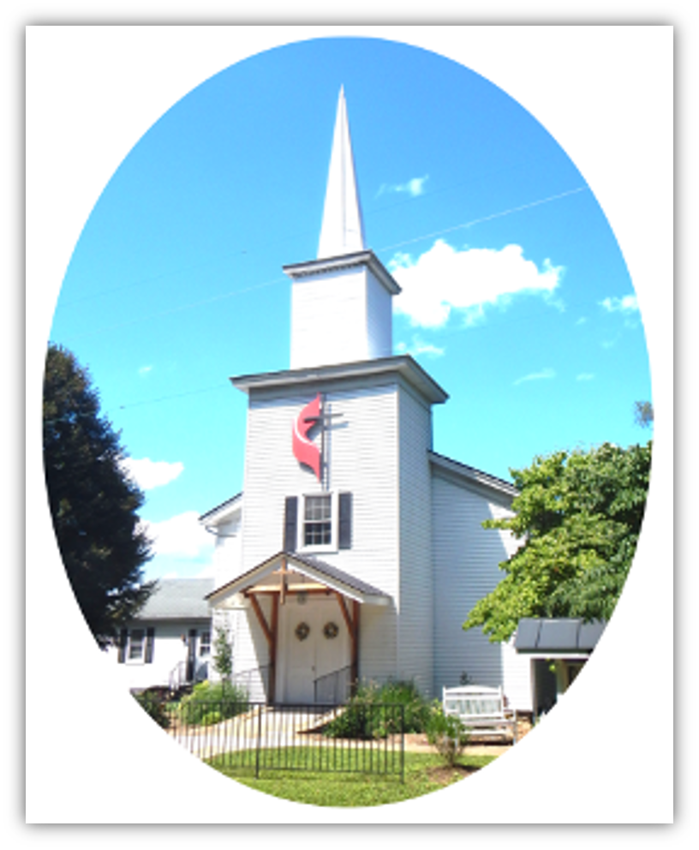

***Pastor****: Eduardo Carrillo*

*3049 Rectortown Road, Marshall, VA* 20115

*Pastor’s Cell Phone:* (703) 967-4361  
*Pastor’s E-mail:* pastor@rectortownumc.org

***Music Director****:* Karen Chase

***Ministers****: every member of the congregation*

Welcome to Rectortown UMC!

*“This is the day that the Lord has made;  
    let us rejoice and be glad in it.”* Psalm 118:24 NRSV

**\*** *Please Stand As You Are Able and Comfortable*

**PRELUDE** - *let us quiet our minds and hearts.*

**WELCOME, ANNOUNCEMENTS and CELEBRATIONS**

***GATHERING***

**\*BRINGING IN THE LIGHT OF CHRIST**

**\*CALL to WORSHIP**

Leader: Come, all who feel far from home.  
**People: God is searching, calling, rejoicing.**  
Leader: Come, all who carry regret or burden.  
**People: God's mercy finds us where we are.**  
Leader: Let every generation draw near.  
**People: With joy, we worship the One who never gives up.**

**\*OPENING PRAYER**

**Merciful God, when we lose our way, you do not lose sight of us. You pursue us with compassion and welcome us with joy. Today, we give thanks for those who have shown us your love across generations. Open our hearts now to be found again by your grace. Amen.**

**\* HYMN**

“Praise, My Soul, the King of Heaven” UMH 66

***PROCLAMATION***

**YOUNG DISCIPLES’ MESSAGE**

**\*PRAYER for ILLUMINATION** UMH 393

**Spirit of the living God, fall afresh on me.**

**Spirit of the living God, fall afresh on me.**

**Melt me, mold me, fill me, use me.**

**Spirit of the living God, fall afresh on me.**

**OLD TESTAMENT READING**

Jeremiah 4: 11 – 12, 22 – 28

**\*NEW TESTAMENT READING**

Luke 15: 1 – 10

This is the word of God for the people of God.

**Thanks be to God.**

**SERMON**  “The God Who Searches”

***RESPONSE***

**\*RESPONDING HYMN**

“It’s Me, It’s Me, O Lord” UMH 352

**\*AFFIRMATION OF FAITH** UMH 881

Apostles’ Creed (Traditional Version)

**SHARING OUR JOYS and CONCERNS**

**PASTORAL PRAYER & LORD’S PRAYER**

**GIVING OUR GIFTS and TITHES**

Offertory:

Doxology UMH 94  
 “Praise God from Whom All Blessings Flow”

Offertory Prayer

**\*CLOSING HYMN**

“Softly and Tenderly Jesus Is Calling” UMH 348

***SENDING FORTH***

**\*BENEDICTION**

**\* POSTLUDE**

* *Please stand as you are able and comfortable.*

|  |
| --- |
| ***This worship service has ended, and now your service begins.***  ***As you leave church today, you are entering the mission field.*** |

***PRAYERS FOR THE CHURCH AND FOR THE WORLD:***

|  |  |
| --- | --- |
| **For Family and Friends:** | |
| Russ & Ethel Muter  Jeff Sisk  Larry Underwood | John McGuinn & Sydney  Patsy Williams |
| **For the Family of those who grieve for:** | |
|  |  |

**For the Church and For the World:**

For those in need of healing, and their caretakers.

For first responders, the military, and their families.

For God’s People, The Church, and the World.

Prayers for national, state, and local leaders; and for our Nation.

**If you know someone you would like to add to our prayer list, please forward your request to the church office by email at: secretaryrumc@gmail.com, or by calling (540) 364-1066.**

**RUMC CELEBRATIONS**

|  |
| --- |
| **Birthdays** |
| None |
| **Anniversaries** |
| None |

**UPCOMING MEETINGS AND EVENTS**

**Admin Council**

Thursday, **October 2nd at 7pm**. In person and zoom.

**Trustees Meeting**

Tuesday, **October 14th** at 6pm. In person and zoom.

**Worship Meeting**

**September 24th** at 10am, in person and zoom.

**Fig Leaf**

TBD

**Joint Cooperative Meeting**

Sunday, **September 21st** at 1:45 pm at Middleburg UMC or on zoom.

**Rectortown United Methodist Church**

Location: 3049 Rectortown Road, Rectortown, VA

Mailing Address: PO Box 301, Rectortown, VA 20140

Email: secretary@rectortownumc.org

Phone: (540)364.1066