Rectortown United Methodist Church
May 10th, 2026 10:00 a.m.
Sixth Sunday After Easter/ Mother’s Day


Pastor: Eduardo Carrillo
3049 Rectortown Road, Marshall, VA 20115
Pastor’s Cell Phone: (703) 967-4361
Pastor’s E-mail: eduardocarrillo@vaumc.org
Music Director: Karen Chase
Ministers: every member of the congregation
Welcome to Rectortown UMC!

“This is the day that the Lord has made;
let us rejoice and be glad in it.” Psalm 118:24 NRSV

* Please Stand As You Are Able and Comfortable
PRELUDE - let us quiet our minds and hearts.
WELCOME, ANNOUNCEMENTS and CELEBRATIONS
GATHERING
*BRINGING IN THE LIGHT OF CHRIST

*CALL to WORSHIP
Leader: The world searches for a God it cannot name, but we have been found by Him!
People: Praise our God, all peoples! Let the sound of His praise be heard!
Leader: He is not far from any one of us, He is here, He is near, He is alive!
People: God brought us through, and we are still here to praise Him!
Leader: He did not ignore our cry! He did not turn away! He is the God who is known!
All: We shout with joy, the Unknown God has made Himself known to us in Christ!

*OPENING PRAYER
God of every nation and every searching soul, we celebrate You today! You are not a God who hides, You are a God who comes. You walked among us, You died for us, You rose for us, and You live in us. Like the Psalmist, we come with our testimony, You have heard us, You have held us, You have never let us go. Forgive us when we stop listening, holding on, and trusting you. Fill us afresh with Your Spirit today. Let this worship ring out boldly, You are ours and we are Yours. Amen!

* HYMN
“For the Beauty of the Earth” UMH 92

PROCLAMATION
YOUNG DISCIPLES’ MESSAGE

*PRAYER for ILLUMINATION UMH 393
Spirit of the living God, fall afresh on me.
Spirit of the living God, fall afresh on me.
Melt me, mold me, fill me, use me.
Spirit of the living God, fall afresh on me.

FIRST READING
Psalm 66: 8 – 20

*SECOND READING
John 14: 15 – 21
This is the word of God for the people of God.
Thanks be to God.

SERMON “Love That Never Quits”
RESPONSE
*RESPONDING HYMN
“Swing Low, Sweet Chariot” UMH 703

*AFFIRMATION OF FAITH UMH 881
Apostles’ Creed (Traditional Version)

SHARING OUR JOYS and CONCERNS

PASTORAL PRAYER & LORD’S PRAYER

GIVING OUR GIFTS and TITHES
Offertory:
Doxology UMH 94
“Praise God from Whom All Blessings Flow”
Offertory Prayer

*CLOSING HYMN
“Because He Lives” UMH 364

SENDING FORTH
*BENEDICTION

* POSTLUDE
* Please stand as you are able and comfortable.
This worship service has ended, and now your service begins.
As you leave church today, you are entering the mission field.

PRAYERS FOR THE CHURCH AND FOR THE WORLD:
For Family and Friends:
Russ & Ethel Muter  Gillian Payne  Ernestine Hall  Hall Family  David Nalls | Kathleen Rhodes  Rick Willis  Austin  Ronald Scheuble
For the Family of those who grieve for:
Georgie Ann Grimes
Katherine
For the Church and For the World:

For those in need of healing, and their caretakers.
For first responders, the military, and their families.
For God’s People, The Church, and the World.
Prayers for national, state, and local leaders; and for our Nation.
If you know someone you would like to add to our prayer list, please forward your request to the church office by email at: secretary@rectortownumc.org or by calling (540) 364-1066.

RUMC CELEBRATIONS
Birthdays
Ren Walker – May 11th
Ben Wegdam – May 13th
Vicki Willis – May 16th

Anniversaries
Linda & Rudy Neish – May 13th
Abbey & Bill Klooster – May 13th

UPCOMING MEETINGS AND EVENTS
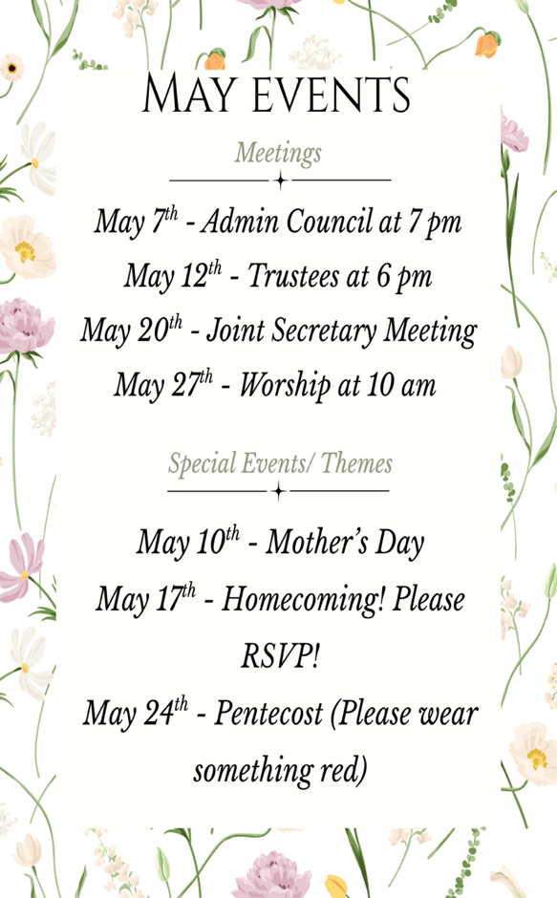

Mowing Season is Here!
Please help with the mowing fee of 90.00 by donating or mowing the grounds.

Rectortown United Methodist Church
  - Location: 3049 Rectortown Road, Rectortown, VA
Mailing Address: PO Box 301, Rectortown, VA 20140
Email: secretary@rectortownumc.org
Phone: (540)364.1066

