Rectortown United Methodist Church
August 9th, 2026 9:30 a.m.
Eleventh Sunday after Pentecost


Pastor: Eduardo Carrillo
3049 Rectortown Road, Marshall, VA 20115
Pastor’s Cell Phone: (703) 967-4361
Pastor’s E-mail: eduardocarrillo@vaumc.org
Music Accompanist: Cheryl Kowalczyk
Ministers: every member of the congregation
Welcome to Rectortown UMC!

“This is the day that the Lord has made;
let us rejoice and be glad in it.” Psalm 118:24 NRSV

* Please Stand As You Are Able and Comfortable
PRELUDE - let us quiet our minds and hearts.
WELCOME, ANNOUNCEMENTS and CELEBRATIONS
GATHERING
*BRINGING IN THE LIGHT OF CHRIST

*CALL to WORSHIP
Leader: When we are thrown into the pits of despair by the world around us,
People: The Lord hears our cries from the depths.
Leader: When we step out in faith and the waves threaten to pull us under,
People: The Lord stretches out His hand to catch us.
Leader: Do not fear the depth of the pit or the height of the storm.
People: For the God who delivered Joseph is the God who walks on water.
All: Come, let us worship the God of our rescue!

*OPENING PRAYER
Almighty God, your word reminds us today that no pit is too deep for your reach, and no storm is too wild for your command. We confess that when our circumstances get dark, we often feel abandoned, like Joseph in the cistern or the disciples tossed on the sea. Forgive our small faith. Quiet our frantic minds this morning. Stretch out your saving hand over our lives, lift us out of our anxieties, and place our feet on solid ground. We confess with our mouths and believe in our hearts that you are Lord over every storm. Amen.

* HYMN
“How Firm a Foundation” UMH 529

PROCLAMATION
YOUNG DISCIPLES’ MESSAGE

*PRAYER for ILLUMINATION UMH 393
Spirit of the living God, fall afresh on me.
Spirit of the living God, fall afresh on me.
Melt me, mold me, fill me, use me.
Spirit of the living God, fall afresh on me.

FIRST READING
Genesis 37: 1 – 4, 12 – 28
*SECOND READING
Matthew 14: 22 – 33
This is the word of God for the people of God.
Thanks be to God.

SERMON
“The Anatomy of a Rescue”

RESPONSE
*RESPONDING HYMN UMH 57
“O for a Thousand Tongues”

*AFFIRMATION OF FAITH UMH 881
Apostles’ Creed (Traditional Version)

GIVING OUR GIFTS and TITHES
Offertory:
Doxology UMH 94
“Praise God from Whom All Blessings Flow”
Offertory Prayer

SENDING FORTH
*CLOSING HYMN
“Precious Lord” UMH 474

SHARING OUR JOYS & CONCERNS
PASTORAL PRAYER & LORD’S PRAYER
*BENEDICTION & POSTLUDE
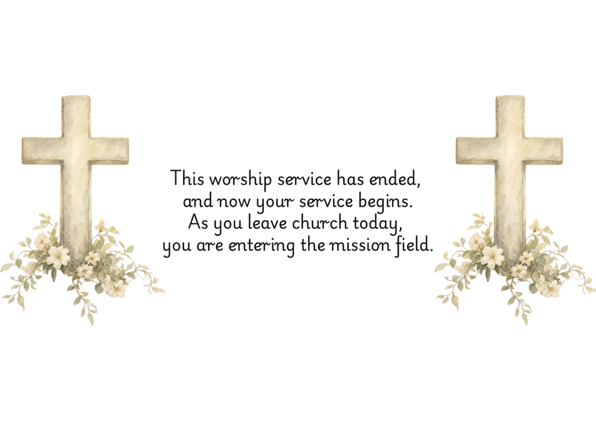

PRAYERS FOR THE CHURCH AND FOR THE WORLD:
For Family and Friends:
Russ & Ethel Muter  Gillian Payne  Billy Wines  Gloria Shelton  Neil Smiley  Gloria Shelton  Joan Newsome | Kathleen Rhodes  Rick Willis  Austin  Ronald Scheuble  Dennis Leohrs  Shirley Embrey
For the Family of those who grieve for:
Tommy Krick
Sandy Beckham
Butch Shelton
David Nalls
Ron May
For the Church and For the World:

For those in need of healing, and their caretakers. For first responders, the military, and their families. For God’s People, The Church, and the World. Prayers for national, state, and local leaders; and for our Nation.
If you know someone you would like to add to our prayer list, please forward your request to the church office by email at: secretary@rectortownumc.org or by calling (540) 364-1066.

RUMC CELEBRATIONS
Birthdays
Amy Riggio – 9th
Jimmy Willis – 9th
Carl Carter – 11th
Courtney Harrington – 11th

Anniversaries
None
UPCOMING MEETINGS AND EVENTS
Trustees Meeting
August 11th at 6pm. In person and zoom.

Rectortown United Methodist Church
  - Location: 3049 Rectortown Road, Rectortown, VA
Mailing Address: PO Box 301, Rectortown, VA 20140
Email: secretary@rectortownumc.org
Phone: (540)364.1066

