**Rectortown United Methodist Church**

July 20th, 2025 10:00 a.m.

*6th Sunday after Pentecost*

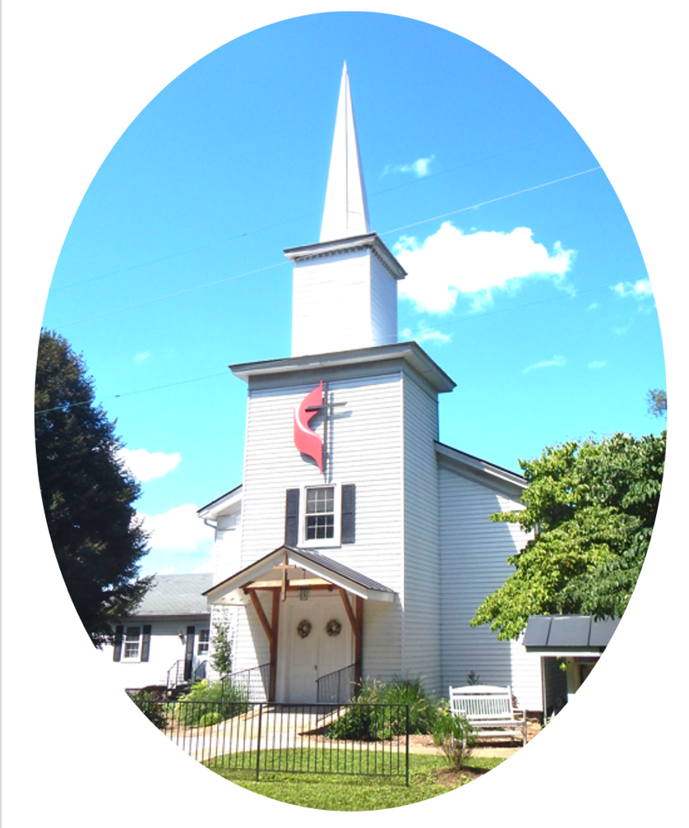

***Pastor****: Eduardo Carrillo*

*3049 Rectortown Road, Marshall, VA* 20115

*Pastor’s Cell Phone:* (703) 967-4361  
*Pastor’s E-mail:* pastor@rectortownumc.org

***Music Director****:* Karen Chase

***Ministers****: every member of the congregation*

Welcome to Rectortown UMC!

*“You are looking for Jesus the Nazarene, who was crucified. He has risen!”*

Mark 16:6 NIV

**\*** *Please Stand As You Are Able and Comfortable*

**PRELUDE** - *let us quiet our minds and hearts.*

**WELCOME, ANNOUNCEMENTS and CELEBRATIONS**

**\*BRINGING IN THE LIGHT OF CHRIST**

**\*CALL to WORSHIP**

Leader: Come in from the noise, the rush, the full

schedules and restless nights.

**People:** **We come to sit, to pause, to listen.**

Leader: God is not absent. God's Word is not

distant.

**People:** **In stillness and in truth, God**

**speaks.**

Leader: Let justice rise, let grace take root, Let

our worship awaken us again.

**All: We come, hungry for presence, ready to be changed.**

**\*OPENING PRAYER**

**Holy God, we enter this space carrying the weight of our weeks, some heavy with labor, some stretched by distraction, some dulled by routine, others bruised by injustice. But here we are, your people gathered not to perform, but to be present and transformed. We don’t want to miss what you’re saying.**

**We don’t want to outrun what you’re doing. So still us. Center us. Open us to your Word. Plant something eternal in us this hour, a seed of truth, a whisper of grace, a spark of holy urgency. In Jesus’ name we pray, Amen.**

**\* HYMN**

“The Church’s One Foundation” UMH 546

**YOUNG DISCIPLES’ MESSAGE**

**\*PRAYER for ILLUMINATION** UM Book of Worship

**Lord, open our hearts and minds by the power of your Holy Spirit, that as the Scriptures are read and your Word proclaimed, we may hear with joy what you say to us today. Amen.**

**OLD TESTAMENT READING**

Amos 8: 1 – 12

**\*NEW TESTAMENT READING**

Luke 10: 38 – 42

This is the word of God for the people of God.

**Thanks be to God.**

**SERMON**

“Occupied but Empty”

**\*RESPONDING HYMN**

“To God Be the Glory” UMH 98

**\*AFFIRMATION OF FAITH** UMH 881

Apostles’ Creed (Traditional Version)

**SHARING OUR JOYS and CONCERNS**

**PASTORAL PRAYER & LORD’S PRAYER**

**GIVING OUR GIFTS and TITHES**

Offertory:

Doxology UMH 94  
 “Praise God from Whom All Blessings Flow”

Offertory Prayer

**\*CLOSING HYMN**

“Victory in Jesus” UMH 370

**\*BENEDICTION**

**\* POSTLUDE**

* *Please stand as you are able and comfortable.*

|  |
| --- |
| ***This worship service has ended, and now your service begins.***  ***As you leave church today, you are entering the mission field.*** |

***PRAYERS FOR THE CHURCH AND FOR THE WORLD:***

|  |  |
| --- | --- |
| **For Family and Friends:** | |
| Russ & Ethel Muter  Peggy Rose Goldsmith  Nancy Glascock  Jeff Sisk  TommyAnn | Dusty, Warden in Texas  Priscilla Krick  John McGuinn & Sydney  Sandy Thomas |
| **For the Family of those who grieve for:**  Winnie  Anne Jackson  Texas & New Mexico Flood Victims | |
|  |  |

**For the Church and For the World:**

For those in need of healing, and their caretakers.

For first responders, the military, and their families.

For God’s People, The Church, and the World.

Prayers for national, state, and local leaders; and for our Nation.

**If you know someone you would like to add to our prayer list, please forward your request to the church office by email at: secretaryrumc@gmail.com, or by calling (540) 364-1066.**

**RUMC CELEBRATIONS**

|  |
| --- |
| **Birthdays** |
| None |
| **Anniversaries** |
| None |

**UPCOMING MEETINGS AND EVENTS**

**Admin Council**

Thursday, **August 7th at 7pm**. In person and zoom.

**Trustees Meeting**

Tuesday, **July 8th** at 6pm. In person and zoom.

**Worship Meeting**

Cancelled

**Fig Leaf**

Tuesday, **July 15th** at 10am. Zoom and in person.

**Back to School Supplies Needed!**

Please see the flyers or our website for supplies requested. Please consider donating!

**Offering Request**

Please consider donating towards purchasing fencing supplies for the parsonage.

**Rectortown United Methodist Church**

Location: 3049 Rectortown Road, Rectortown, VA

Mailing Address: PO Box 301, Rectortown, VA 20140

Email: secretary@rectortownumc.org

Phone: (540)364.1066