**Rectortown United Methodist Church**

August 24th, 2025 10:00 a.m.

*11th Sunday after Pentecost*

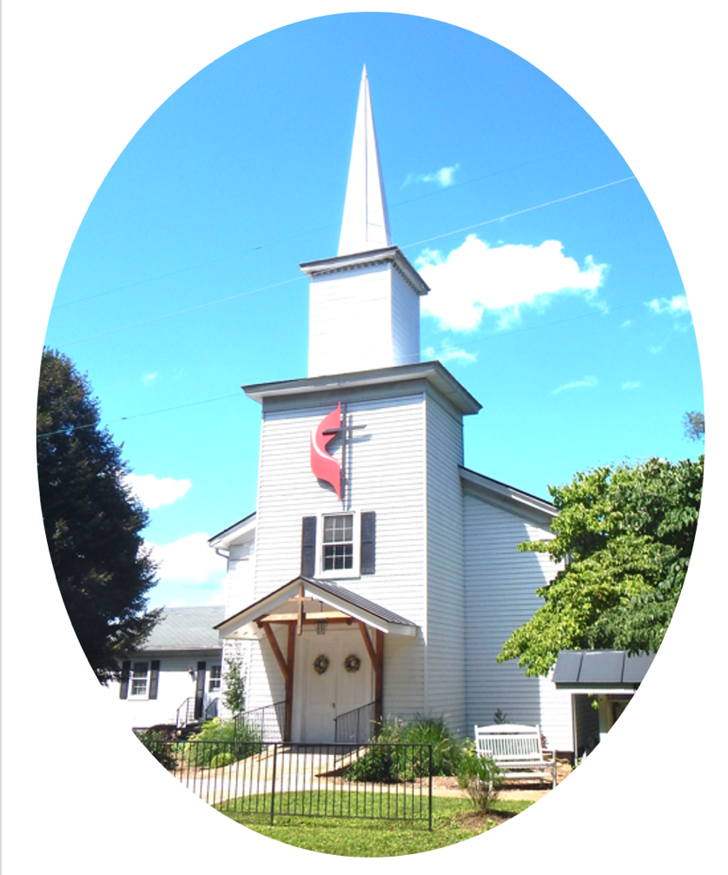

***Pastor****: Eduardo Carrillo*

*3049 Rectortown Road, Marshall, VA* 20115

*Pastor’s Cell Phone:* (703) 967-4361  
*Pastor’s E-mail:* pastor@rectortownumc.org

***Music Director****:* Karen Chase

***Ministers****: every member of the congregation*

Welcome to Rectortown UMC!

*“This is the day that the Lord has made;  
    let us rejoice and be glad in it.”* Psalm 118:24 NRSV

**\*** *Please Stand As You Are Able and Comfortable*

**PRELUDE** - *let us quiet our minds and hearts.*

**WELCOME, ANNOUNCEMENTS and CELEBRATIONS**

***GATHERING***

**\*BRINGING IN THE LIGHT OF CHRIST**

**\*CALL to WORSHIP**

Leader: Before we were formed, God knew us.  
**People: We were known and loved before**

**we were born.**  
Leader: God's voice still speaks, still sends, still

stirs.  
**People: We gather to listen, to respond, and**

**to worship.**  
Leader: Come, people of God, let us worship in

spirit and truth.  
**People: We are here, ready to be called and**

**sent.**

**\*OPENING PRAYER**

**God of calling and courage, you meet us in every stage of life. As we worship today, remind us that your purposes are not limited by age, ability, or fear. Speak to us in ways we can hear, and guide us in ways we can follow. In your name we pray, Amen.**

**\* HYMN**

“Lord of the Dance” UMH 261

***PROCLAMATION***

**YOUNG DISCIPLES’ MESSAGE**

**\*PRAYER for ILLUMINATION** UMH 393

**Spirit of the living God, fall afresh on me.**

**Spirit of the living God, fall afresh on me.**

**Melt me, mold me, fill me, use me.**

**Spirit of the living God, fall afresh on me.**

**OLD TESTAMENT READING**

Jeremiah 1: 4 – 10

**\*NEW TESTAMENT READING**

Luke 13: 10 – 17

This is the word of God for the people of God.

**Thanks be to God.**

**SERMON**  “Before You Were Born”

***RESPONSE***

**\*RESPONDING HYMN**

“Be Thou My Vision” UMH 451

**\*AFFIRMATION OF FAITH** UMH 881

Apostles’ Creed (Traditional Version)

**SHARING OUR JOYS and CONCERNS**

**PASTORAL PRAYER & LORD’S PRAYER**

**GIVING OUR GIFTS and TITHES**

Offertory:

Doxology UMH 94  
 “Praise God from Whom All Blessings Flow”

Offertory Prayer

**\*CLOSING HYMN**

“Here I Am, Lord” UMH 593

***SENDING FORTH***

**\*BENEDICTION**

**\* POSTLUDE**

* *Please stand as you are able and comfortable.*

|  |
| --- |
| ***This worship service has ended, and now your service begins.***  ***As you leave church today, you are entering the mission field.*** |

***PRAYERS FOR THE CHURCH AND FOR THE WORLD:***

|  |  |
| --- | --- |
| **For Family and Friends:** | |
| Russ & Ethel Muter  Nancy Glascock  Jeff Sisk | Priscilla Krick  John McGuinn & Sydney  Sandy Thomas  Patsy Williams |
| **For the Family of those who grieve for:**  Texas & New Mexico Flood Victims  Peggy Rose Goldsmith  Bobby Williams  Jerry Yowell | |
|  |  |

**For the Church and For the World:**

For those in need of healing, and their caretakers.

For first responders, the military, and their families.

For God’s People, The Church, and the World.

Prayers for national, state, and local leaders; and for our Nation.

**If you know someone you would like to add to our prayer list, please forward your request to the church office by email at: secretaryrumc@gmail.com, or by calling (540) 364-1066.**

**RUMC CELEBRATIONS**

|  |  |
| --- | --- |
| **Birthdays** | |
| Joe Riggio – August 25th | Muggie Grice – August 27th |
| Dave Hall – August 28th | Karen Chase – August 28th |
| Katie Carrillo – August 28th | Linda Daniels – August 28th |
| Laura Symanski – August 29th | |
| **Anniversaries** | |
| None | |

**UPCOMING MEETINGS AND EVENTS**

**Admin Council**

Thursday, **September 4th at 7pm**. In person and zoom.

**Trustees Meeting**

Tuesday, **September 9th** at 6pm. In person and zoom.

**Worship Meeting**

**August 26th** at 10am, in person and zoom.

**Fig Leaf**

Tuesday, **September 16th** at 10am. Zoom and in person.

**New Secretary Hours**

Monday & Wednesday – 8:45am to 11:45am

Tuesday & Thursday – Off

Friday – 8:45am to 2:30pm

**Rectortown United Methodist Church**

Location: 3049 Rectortown Road, Rectortown, VA

Mailing Address: PO Box 301, Rectortown, VA 20140

Email: secretary@rectortownumc.org

Phone: (540)364.1066