Rectortown United Methodist Church

March 9th, 2025 10:00 a.m.

*1st Sunday in Lent*

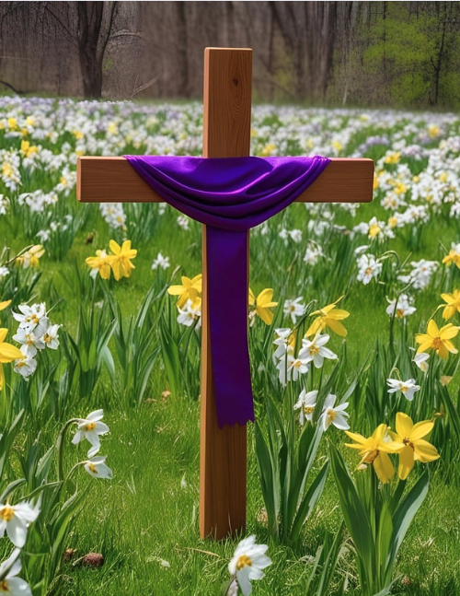

***Pastor****: TaeWon Kang*

*3049 Rectortown Road, Marshall, VA* 20115

*Pastor’s Cell Phone:* (470) 728 - 9060  
*Pastor’s E-mail:* pastortaewonkang@gmail.com

***Music Director****:* Karen Chase

***Ministers****: every member of the congregation*

Welcome to Rectortown UMC!

*“You are looking for Jesus the Nazarene, who was crucified. He has risen!”*

Mark 16:6 NIV

**\*** *Please Stand As You Are Able and Comfortable*

**PRELUDE** - *let us quiet our minds and hearts.*

**WELCOME, ANNOUNCEMENTS and CELEBRATIONS**

**\*BRINGING IN THE LIGHT OF CHRIST**

**\*CALL to WORSHIP**

Leader: Long ago, God rescued God’s people from

slavery.  
**People: We are enslaved today, in many**

**different ways.**Leader: God can and will rescue us. Place your trust

in God’s love.  
**People: Our hope is in the Lord who is our**

**refuge and our strength.**Leader: Even though temptations surround us,

drawing us away from God,  
**People: We will continue to follow God and**

**trust in God’s ways. AMEN.**

**\*OPENING PRAYER**

**In the quiet of this moment, in the stillness of this place, draw near to us, O God. As we seek the shelter of your refuge, as we celebrate the bounty of your provision, hearken to our need, Holy One. Transform this time and place into our land of milk and honey— a land where you are among us, a land where your mighty hand and your outstretched arm protect us, a land where you alone are worthy of our worship and service. We ask this in the saving name of Jesus, our Lord. Amen.**

**\* HYMN** “A Mighty Fortress Is Our God” UMH 110

**YOUNG DISCIPLES’ MESSAGE**

**\*PRAYER for ILLUMINATION** UMH 393

**Spirit of the living God, fall afresh on me.**

**Spirit of the living God, fall afresh on me.**

**Melt me, mold me, fill me, use me.**

**Spirit of the living God, fall afresh on me.**

**OLD TESTAMENT READING**

Deuteronomy 26: 1 -11

This is the word of God for the people of God.

**Thanks be to God.**

**RESPONSIVE READING**

Psalm 91; 1- 2, 9 -16 UMH 810

**\*GOSPEL READING** Luke 4: 1 - 13

**\*** Gloria Patri –“Glory Be to the Father” UMH 70

**SERMON** “Jesus in the Wilderness”

**\*RESPONDING HYMN** “Be Still, My Soul” UMH 534

**AFFIRMATION OF FAITH**

Apostles’ Creed (Traditional Version) UMH 881

**SHARING OUR JOYS and CONCERNS**

**PASTORAL PRAYER & LORD’S PRAYER**

**GIVING OUR GIFTS and TITHES**

Offertory:

Doxology UMH 94  
 “Praise God from Whom All Blessings Flow”

Offertory Prayer

**\*CLOSING HYMN**

“Lord, Who Throughout These Forty Days” UMH 269

**\*BENEDICTION**

**\* POSTLUDE**

* *Please stand as you are able and comfortable.*

|  |
| --- |
| ***This worship service has ended, and now your service begins.***  ***As you leave church today, you are entering the mission field.*** |

***PRAYERS FOR THE CHURCH AND FOR THE WORLD:***

|  |  |
| --- | --- |
| **For Family and Friends:** | |
| Linda Brown  Jim Caylen  Towny Lunsford  Christine Felts & Mother  Vickie Duff  The Reed Family | Shirley Embrey  Russ & Ethel Muter  Aiden Leake  Joann Garrett |
| **For the Family of those who grieve for:**  Laura Skirka  Judy Bailey | |
|  |  |

**For the Church and For the World:**

For those in need of healing, and their caretakers.

For first responders, the military, and their families.

For God’s People, The Church, and the World.

Prayers for national, state, and local leaders; and for our Nation.

**If you know someone you would like to add to our prayer list, please forward your request to the church office by email at: secretaryrumc@gmail.com, or by calling (540) 364-1066.**

**RUMC CELEBRATIONS**

|  |  |
| --- | --- |
| **Birthdays** | |
| Butch Yowell – 11th | Sara Hall – 12th |
| **Anniversaries** | |
| None | |

**UPCOMING MEETINGS AND EVENTS**

**Worship Meeting**

March 10th at 6pm, zoom & in person

**Bible Study**

March 11th at 10:30am, Fellowship Hall

**Trustees Meeting**

March 11th at 6pm, zoom & in person

**Rectortown United Methodist Church**

Location: 3049 Rectortown Road, Rectortown, VA

Mailing Address: PO Box 301, Rectortown, VA 20140

Email: [secretaryrumc@gmail.com](mailto:secretaryrumc@gmail.com) Phone: (540)364.1066