Crossword Puzzle

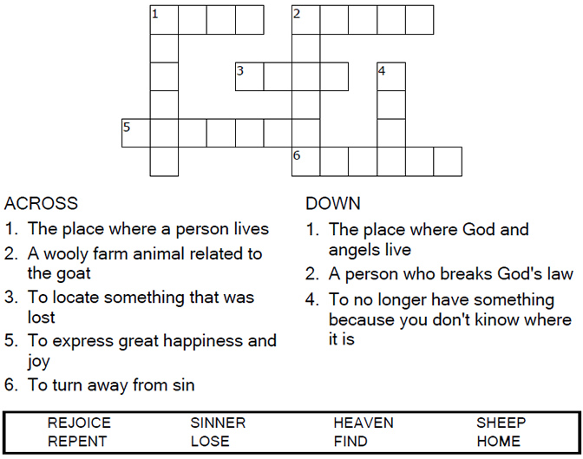

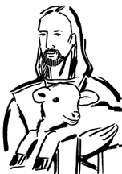

Copyright © Sermons4Kids, Inc.

May be reproduced for Ministry Use

**Children’s Worship Bulletin**



Luke 15:1-7

Word Search Puzzle

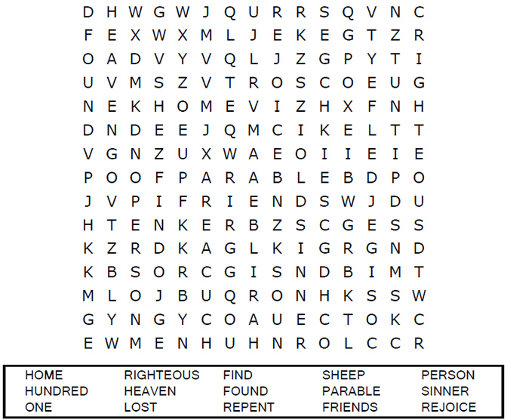

Coloring Page

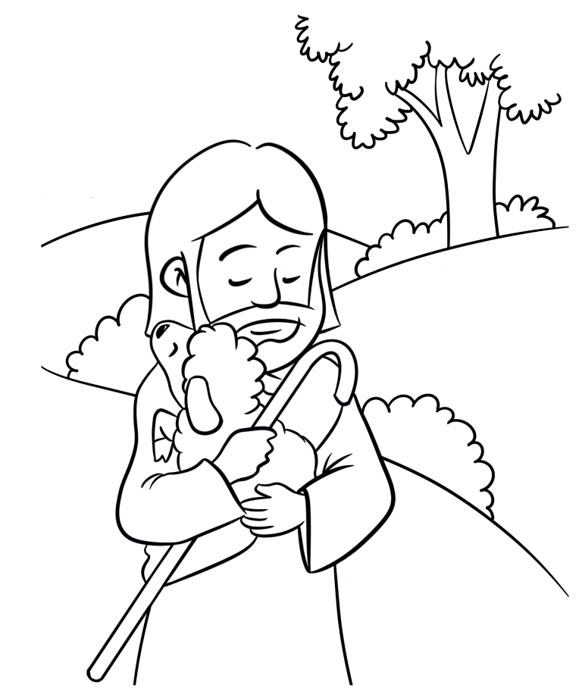

**The Parable of the Lost Sheep**

Decoder Puzzle

Each number represents a letter of the alphabet. Substitute  
the correct letter for the numbers to reveal the coded words.

