Rectortown United Methodist Church
September 27th, 2026 9:30 a.m.
Eighteenth Sunday after Pentecost


Pastor: Eduardo Carrillo
3049 Rectortown Road, Marshall, VA 20115
Pastor’s Cell Phone: (703) 967-4361
Pastor’s E-mail: eduardocarrillo@vaumc.org
Music Accompanist: Cheryl Kowalczyk
Ministers: every member of the congregation
Welcome to Rectortown UMC!

“This is the day that the Lord has made;
let us rejoice and be glad in it.” Psalm 118:24 NRSV

* Please Stand As You Are Able and Comfortable
PRELUDE - let us quiet our minds and hearts.
WELCOME, ANNOUNCEMENTS and CELEBRATIONS
GATHERING
*BRINGING IN THE LIGHT OF CHRIST

*CALL to WORSHIP
Leader: Is the Lord among us or not?
People: The Lord is here; God’s presence fills this place!
Leader: God brings water from the dry rock and life from unexpected places.
People: Let us come with humble hearts, ready not just to speak God’s will, but to do it.
Leader: Faith begets actions, the actions of Jesus Christ.
All: Let us live by faith today and always!

*OPENING PRAYER
Living God, whenever our faith grows dry and our trust wavers, you pour out living water. Pour out your Spirit upon us today. Give us the mindset of Christ, that our lives may be defined not merely by noble words, but by humble obedience and love. Let our actions mirror our faith. Transform us from hearers to doers. Amen.

* HYMN
“Jesu, Jesu” UMH 432

PROCLAMATION
*PRAYER for ILLUMINATION UMH 393
Spirit of the living God, fall afresh on me.
Spirit of the living God, fall afresh on me.
Melt me, mold me, fill me, use me.
Spirit of the living God, fall afresh on me.

FIRST READING
Exodus 17: 1 – 7
*SECOND READING
Matthew 21: 23 – 32
This is the word of God for the people of God.
Thanks be to God.

SERMON
“Water from the Rock, Faith in Action”

RESPONSE
*RESPONDING HYMN UMH 393
“Here I Am, Lord”

*AFFIRMATION OF FAITH UMH 881
Apostles’ Creed (Traditional Version)

GIVING OUR GIFTS and TITHES
Offertory:
Doxology UMH 94
“Praise God from Whom All Blessings Flow”
Offertory Prayer

SENDING FORTH

SHARING OUR JOYS & CONCERNS
PASTORAL PRAYER & LORD’S PRAYER
*BENEDICTION & POSTLUDE

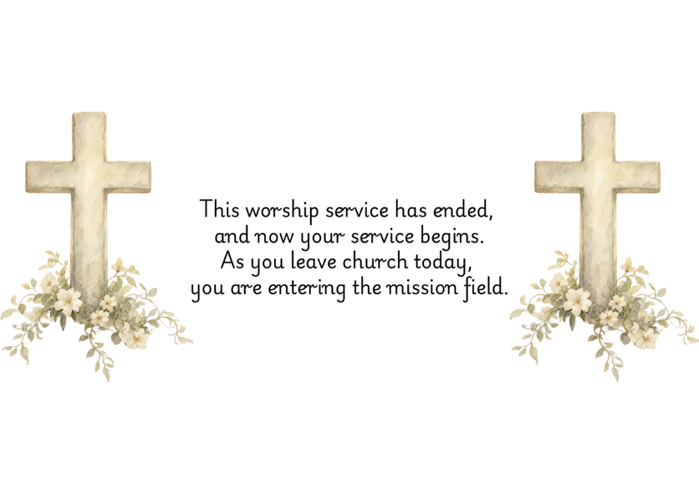

PRAYERS FOR THE CHURCH AND FOR THE WORLD:
For Family and Friends:
Russ & Ethel Muter  Gillian Payne  Billy Wines  Gloria Shelton  Joan Newsome  Keith Kuck  Don Williams | Kathleen Rhodes  Rick Willis  Austin  Shirley Embrey  Marline & Warren  Billy Wines
For the Family of those who grieve for:

For the Church and For the World:

For those in need of healing, and their caretakers.
For first responders, the military, and their families.
For God’s People, The Church, and the World.
Prayers for national, state, and local leaders; and for our Nation.
If you know someone you would like to add to our prayer list, please forward your request to the church office by email at: secretary@rectortownumc.org or by calling (540) 364-1066.

RUMC CELEBRATIONS
Birthdays
Jim Harrington – 30th

Anniversaries
None

UPCOMING MEETINGS AND EVENTS
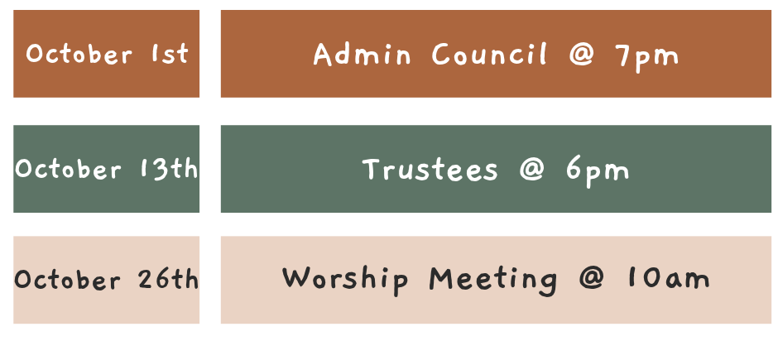



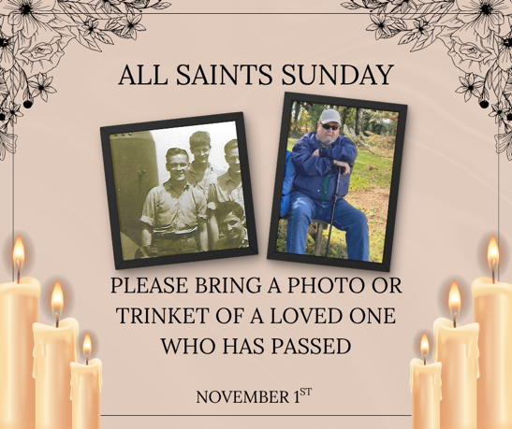

Rectortown United Methodist Church
  - Location: 3049 Rectortown Road, Rectortown, VA
Mailing Address: PO Box 301, Rectortown, VA 20140
Email: secretary@rectortownumc.org
Phone: (540)364.1066

