Rectortown United Methodist Church
April 13th, 2025 10:00 a.m.
Palm & Passion Sunday

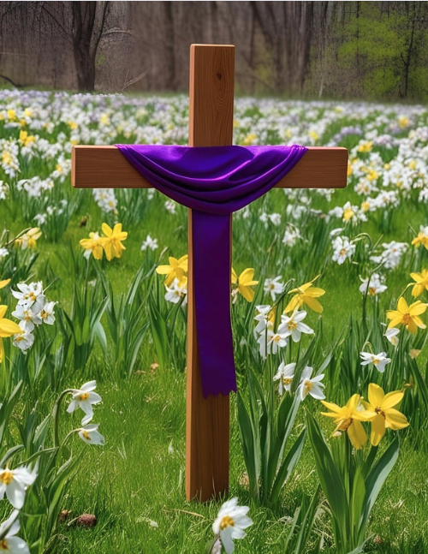

Pastor: TaeWon Kang
3049 Rectortown Road, Marshall, VA 20115
Pastor’s Cell Phone: (470) 728 - 9060
Pastor’s E-mail: pastortaewonkang@gmail.com
Music Director: Karen Chase
Ministers: every member of the congregation
Welcome to Rectortown UMC!

“You are looking for Jesus the Nazarene, who was crucified. He has risen!”
Mark 16:6 NIV

* Please Stand As You Are Able and Comfortable
PRELUDE - let us quiet our minds and hearts.

WELCOME, ANNOUNCEMENTS and CELEBRATIONS

*PLEASE GATHER IN THE CHURCHYARD OUTSIDE THE SANCTUARY*

Leader: Sing for joy! The Master comes!
People: Riding on a colt, he enters in victory!
Leader: If all shouting stopped, the rocks would
ring with joy.
People: But there will be some who will not
sing or shout.
Leader: There will be some who will cling to their
fear.
People: Be ready, O Jerusalem, for your king
truly is coming!
All: Hosanna in the highest! AMEN.

*PARADE INSIDE BEGINS*

*OPENING PRAYER
With great joy we welcome you, Lord Jesus! The journey has been long and we have longed to enter the Holy Place. You come into our hearts and our lives, humbly, patiently, encouraging us to learn and grow, to embark on journeys of hope and healing. Open our hearts today to hear your words, as we sing praise to you. Hosanna! Blessed is the One who comes in the Lord’s Name. AMEN.

* HYMN
“All Glory, Laud, and Honor” UMH 280 (v.1, 3, 5)

YOUNG DISCIPLES’ MESSAGE

*PRAYER for ILLUMINATION UMH 393
Spirit of the living God, fall afresh on me.
Spirit of the living God, fall afresh on me.
Melt me, mold me, fill me, use me.
Spirit of the living God, fall afresh on me.

EPISTLE READING
Philippians 2: 5 - 11
This is the word of God for the people of God.
Thanks be to God.

RESPONSIVE READING
Psalm 118:1-2, 19-29 UMH 839

*GOSPEL READING Luke 19: 28 - 40
* Gloria Patri –“Glory Be to the Father” UMH 70

SERMON “Jesus On a Colt.”

*RESPONDING HYMN
“When I Survey the Wondrous Cross” UMH 298

*AFFIRMATION OF FAITH UMH 881 Apostle’s Creed (Traditional Version)

SHARING OUR JOYS and CONCERNS

PASTORAL PRAYER & LORD’S PRAYER

GIVING OUR GIFTS and TITHES
Offertory:
Doxology UMH 94
“Praise God from Whom All Blessings Flow”
Offertory Prayer

*CLOSING HYMN
“Jesus, Keep Me Near the Cross” UMH 301

*BENEDICTION

* POSTLUDE
* Please stand as you are able and comfortable.
This worship service has ended, and now your service begins.
As you leave church today, you are entering the mission field.

PRAYERS FOR THE CHURCH AND FOR THE WORLD:
For Family and Friends:
Linda Brown  Jim Caylen  Towny Lunsford  Christine Felts & Mother  Paula Poston | Russ & Ethel Muter  Joann Garrett  Vickie Duff  The Reed Family  Tommy Ann
For the Family of those who grieve for:
Laura Skirka
Judy Bailey
LeAnn Scheuble
For the Church and For the World:

For those in need of healing, and their caretakers.
For first responders, the military, and their families.
For God’s People, The Church, and the World.
Prayers for national, state, and local leaders; and for our Nation.
If you know someone you would like to add to our prayer list, please forward your request to the church office by email at: secretaryrumc@gmail.com, or by calling (540) 364-1066.

RUMC CELEBRATIONS

Birthdays
Morgan Thomas – April 15th | Henry Symanski – April 17th
Eileen Miller – April 18th
Anniversaries
None

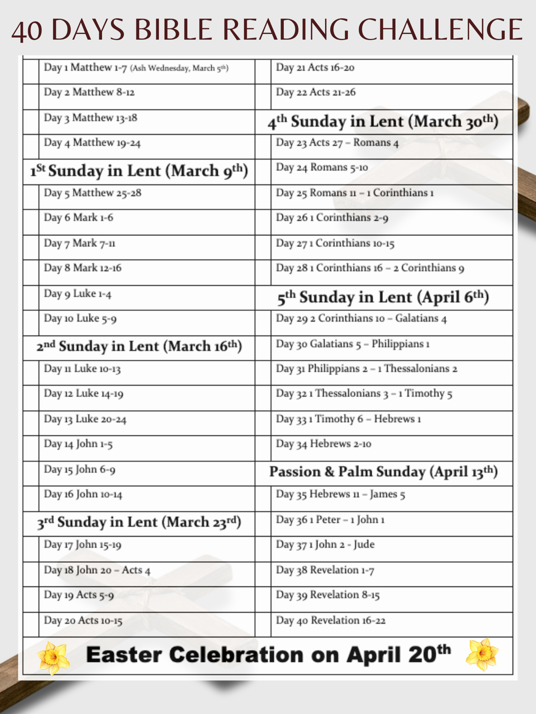

UPCOMING MEETINGS AND EVENTS

In Person Bible Study
Every Tuesday at 10:30am in the fellowship hall

Worship Meeting
Monday, April 14th at 6pm. In person and zoom.

Fig Leaf Meeting
Tuesday, April 15th at 10am. In person and zoom.

Good Friday
April 18th – MUMC service at Noon, RUMC service at 5:30pm
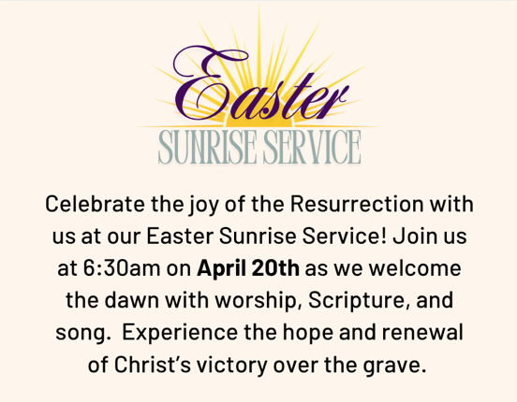

Rectortown United Methodist Church
  - Location: 3049 Rectortown Road, Rectortown, VA
Mailing Address: PO Box 301, Rectortown, VA 20140
Email: secretary@rectortownumc.org
Phone: (540)364.1066

