**Rectortown United Methodist Church**

July 27th, 2025 10:00 a.m.

*7th Sunday after Pentecost*

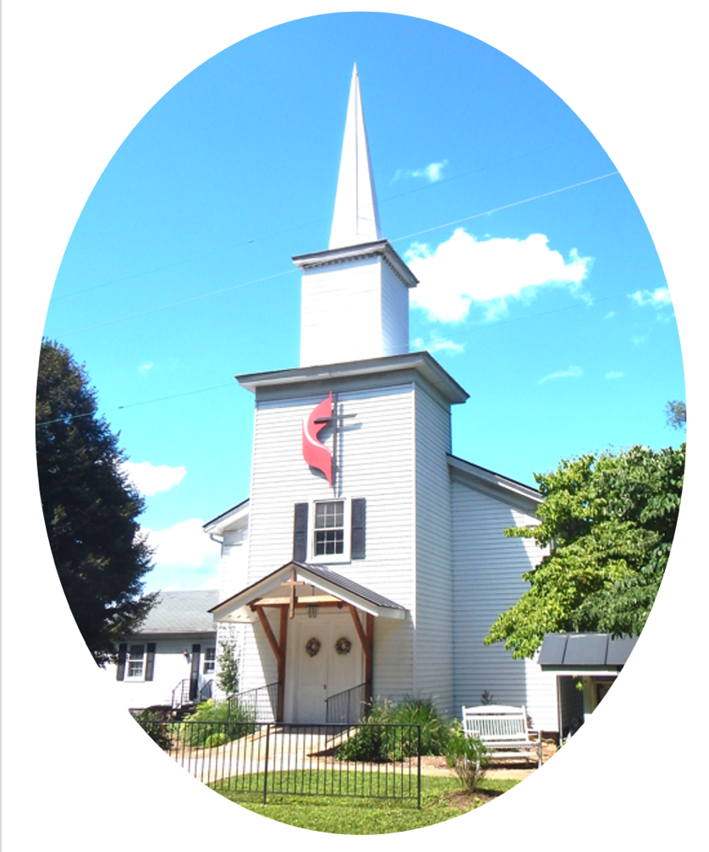

***Pastor****: Eduardo Carrillo*

*3049 Rectortown Road, Marshall, VA* 20115

*Pastor’s Cell Phone:* (703) 967-4361  
*Pastor’s E-mail:* pastor@rectortownumc.org

***Music Director****:* Karen Chase

***Ministers****: every member of the congregation*

Welcome to Rectortown UMC!

*“This is the day that the Lord has made;  
    let us rejoice and be glad in it.”* Psalm 118:24 NRSV

**\*** *Please Stand As You Are Able and Comfortable*

**PRELUDE** - *let us quiet our minds and hearts.*

**WELCOME, ANNOUNCEMENTS and CELEBRATIONS**

**\*BRINGING IN THE LIGHT OF CHRIST**

**\*CALL to WORSHIP**

Leader: Come, people of God—bring your

longings, your questions, your hope.

**People: We come seeking peace, revival,**

**and the presence of the Lord.**

Leader: The Lord has been faithful before, in

restoring, forgiving, and renewing.

**People: And we believe God is not done with**

**us yet.**

Leader: So we will ask. We will seek. We will

knock.

**All: Lord, teach us to pray. Speak peace to**

**us, your people, as we draw near in**

**worship.**

**\*OPENING PRAYER**

**Gracious God, You have been our help in ages past. You have been our healer, our restorer, our peace. Today we come with open hands and hopeful hearts, asking again: Teach us to pray. Revive us again. When we grow weary, renew us.**

**When we lose our way, guide us. When we cry out, hear us. Let your steadfast love meet us in this place and carry us forward in faith. In the name of Jesus, the one who taught us to ask, seek, and knock. Amen.**

**\* HYMN**

“It Is Well with My Soul” UMH 377

**YOUNG DISCIPLES’ MESSAGE**

**\*PRAYER for ILLUMINATION** UMH 393

**Spirit of the living God, fall afresh on me.**

**Spirit of the living God, fall afresh on me.**

**Melt me, mold me, fill me, use me.**

**Spirit of the living God, fall afresh on me.**

**RESPONSIVE READING**

Psalm 85

**\*NEW TESTAMENT READING**

Luke 11: 1 – 13

This is the word of God for the people of God.

**Thanks be to God.**

**SERMON**

“When You Knock, Grace Answers”

**\*RESPONDING HYMN**

“Close to Thee” UMH 407

**\*AFFIRMATION OF FAITH** UMH 881

Apostles’ Creed (Traditional Version)

**SHARING OUR JOYS and CONCERNS**

**PASTORAL PRAYER & LORD’S PRAYER**

**GIVING OUR GIFTS and TITHES**

Offertory:

Doxology UMH 94  
 “Praise God from Whom All Blessings Flow”

Offertory Prayer

**\*CLOSING HYMN**

“We Walk By Faith” TFWS 2196

**\*BENEDICTION**

**\* POSTLUDE**

* *Please stand as you are able and comfortable.*

|  |
| --- |
| ***This worship service has ended, and now your service begins.***  ***As you leave church today, you are entering the mission field.*** |

***PRAYERS FOR THE CHURCH AND FOR THE WORLD:***

|  |  |
| --- | --- |
| **For Family and Friends:** | |
| Russ & Ethel Muter  Peggy Rose Goldsmith  Nancy Glascock  Jeff Sisk  TommyAnn | Dusty, Warden in Texas  Priscilla Krick  John McGuinn & Sydney  Sandy Thomas |
| **For the Family of those who grieve for:**  Winnie  Anne Jackson  Texas & New Mexico Flood Victims | |
|  |  |

**For the Church and For the World:**

For those in need of healing, and their caretakers.

For first responders, the military, and their families.

For God’s People, The Church, and the World.

Prayers for national, state, and local leaders; and for our Nation.

**If you know someone you would like to add to our prayer list, please forward your request to the church office by email at: secretaryrumc@gmail.com, or by calling (540) 364-1066.**

**RUMC CELEBRATIONS**

|  |
| --- |
| **Birthdays** |
| None |
| **Anniversaries** |
| None |

**UPCOMING MEETINGS AND EVENTS**

**Admin Council**

Thursday, **August 7th at 7pm**. In person and zoom.

**Trustees Meeting**

Tuesday, **August 12th** at 6pm. In person and zoom.

**Worship Meeting**

TBD

**Fig Leaf**

Tuesday, **August 19th** at 10am. Zoom and in person.

**Reminder! Budget Drafts are due by Admin Meeting!**

**Back to School Supplies Needed!**

Please see the flyers or our website for supplies requested. Please consider donating!

**Offering Request**

Please consider donating towards purchasing fencing supplies for the parsonage.

**Rectortown United Methodist Church**

Location: 3049 Rectortown Road, Rectortown, VA

Mailing Address: PO Box 301, Rectortown, VA 20140

Email: secretary@rectortownumc.org

Phone: (540)364.1066