**Rectortown United Methodist Church**

August 3rd, 2025 10:00 a.m.

*8th Sunday after Pentecost*

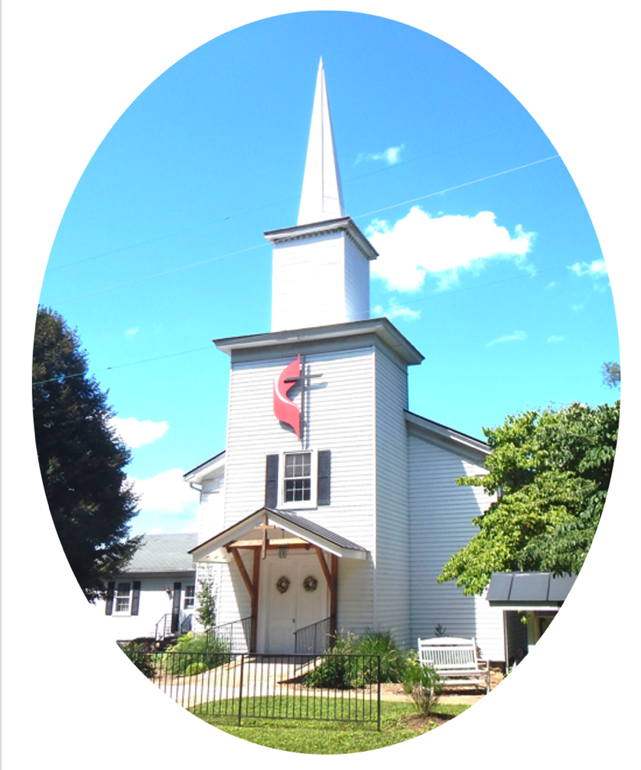

***Pastor****: Eduardo Carrillo*

*3049 Rectortown Road, Marshall, VA* 20115

*Pastor’s Cell Phone:* (703) 967-4361  
*Pastor’s E-mail:* pastor@rectortownumc.org

***Music Director****:* Karen Chase

***Ministers****: every member of the congregation*

Welcome to Rectortown UMC!

*“This is the day that the Lord has made;  
    let us rejoice and be glad in it.”* Psalm 118:24 NRSV

**\*** *Please Stand As You Are Able and Comfortable*

**PRELUDE** - *let us quiet our minds and hearts.*

**WELCOME, ANNOUNCEMENTS and CELEBRATIONS**

***GATHERING***

**\*BRINGING IN THE LIGHT OF CHRIST**

**\*CALL to WORSHIP**

Leader: Come, all who thirst for God's presence.  
**People: We come, longing for living water.**  
Leader: Come, all who hunger for truth and

mercy.  
**People: We come, seeking the Bread of Life.**  
Leader: Let us open our hearts and lift our

voices.  
**People: With gratitude and hope, we**

**worship the Lord**

**\*OPENING PRAYER**

**Loving God, you draw us in with gentle mercy and steadfast love. Gather us in this morning, the restless, weary, hopeful; and center us in your presence. Let your Spirit move among us and quiet our striving, that we may be renewed and refreshed to live as your people. Amen.**

**\* HYMN**

“Great Is Thy Faithfulness” UMH 140

***PROCLAMATION***

**YOUNG DISCIPLES’ MESSAGE**

**\*PRAYER for ILLUMINATION** UMH 393

**Spirit of the living God, fall afresh on me.**

**Spirit of the living God, fall afresh on me.**

**Melt me, mold me, fill me, use me.**

**Spirit of the living God, fall afresh on me.**

**OLD TESTAMENT READING**

Hosea 11: 1 – 11

**\*NEW TESTAMENT READING**

Luke 12: 13 – 21

This is the word of God for the people of God.

**Thanks be to God.**

**SERMON**

**“More Than Enough”**

***RESPONSE***

**\*RESPONDING HYMN**

“Take My Life and Let It Be” UMH 404

**INVITATION, CONFESSION, AND PARDON**

**INVITATION (UMH 12)**

Christ our Lord invites to his table all who

love him,

Who earnestly repent of their sin

And seek to live in peace with one another.

Therefore, let us confess our sin before God

and one another.

**CONFESSION (UMH 12)**

**Merciful God,**

**We confess that we have not loved you**

**with our whole heart.**

**We have failed to be an obedient church.**

**We have not done your will,**

**We have broken your law,**

**We have rebelled against your love,**

**We have not loved our neighbors,**

**And we have not heard the cry of the**

**needy.**

**Forgive us, we pray.**

**Free us for joyful obedience,**

**Through Jesus Christ our Lord. Amen.**

**PARDON (UMH 12)**

Hear the good news:

Christ died for us while we were yet sinners;

That proves God’s love toward us.

In the name of Jesus Christ, you are forgiven!

**PASSING OF THE PEACE**

**SHARING OUR JOYS and CONCERNS**

**PASTORAL PRAYER**

**GIVING OUR GIFTS and TITHES**

Offertory:

Doxology UMH 94  
 “Praise God from Whom All Blessings Flow”

Offertory Prayer

**GREAT THANKSGIVING** UMH 13

**LORD’S PRAYER, BREAKING THE BREAD, AND GIVING THE BREAD AND CUP** UMH 14

**\*PRAYER AFTER COMMUNION** UMH 11

***Eternal God, we give you thanks for this holy mystery in which you have given yourself to us. Grant that we may go into the world in the strength of your Spirit, to give ourselves for others, in the name of Jesus Christ our Lord, Amen.***

**\*CLOSING HYMN**

“Every Time I Feel the Spirit” UMH 404

***SENDING FORTH***

**\*BENEDICTION**

**\* POSTLUDE**

* *Please stand as you are able and comfortable.*

|  |
| --- |
| ***This worship service has ended, and now your service begins.***  ***As you leave church today, you are entering the mission field.*** |

***PRAYERS FOR THE CHURCH AND FOR THE WORLD:***

|  |  |
| --- | --- |
| **For Family and Friends:** | |
| Russ & Ethel Muter  Peggy Rose Goldsmith  Nancy Glascock  Jeff Sisk  TommyAnn | Dusty, Warden in Texas  Priscilla Krick  John McGuinn & Sydney  Sandy Thomas  Patsy Williams |
| **For the Family of those who grieve for:**  Winnie  Anne Jackson  Texas & New Mexico Flood Victims | |
|  |  |

**For the Church and For the World:**

For those in need of healing, and their caretakers.

For first responders, the military, and their families.

For God’s People, The Church, and the World.

Prayers for national, state, and local leaders; and for our Nation.

**If you know someone you would like to add to our prayer list, please forward your request to the church office by email at: secretaryrumc@gmail.com, or by calling (540) 364-1066.**

**RUMC CELEBRATIONS**

|  |
| --- |
| **Birthdays** |
| David Nall – August 3rd |
| Priscilla Krick – August 7th |
| Amy Riggio – August 9th |
| Jimmy Willis – August 9th |
| **Anniversaries** |
| None |

**UPCOMING MEETINGS AND EVENTS**

**Admin Council**

Thursday, **August 7th at 7pm**. In person and zoom.

**Trustees Meeting**

Tuesday, **August 12th** at 6pm. In person and zoom.

**Worship Meeting**

August 27th at 10am, in person and zoom.

**Fig Leaf**

Tuesday, **August 19th** at 10am. Zoom and in person.

**Back to School Supplies Needed!**

Please see the flyers or our website for supplies requested. Please consider donating!

**Cooperative Parish Meeting**

**August 16th at 10am, RUMC Fellowship Hall**

**Offering Request**

Please consider donating towards purchasing fencing supplies for the parsonage.

**Rectortown United Methodist Church**

Location: 3049 Rectortown Road, Rectortown, VA

Mailing Address: PO Box 301, Rectortown, VA 20140

Email: secretary@rectortownumc.org

Phone: (540)364.1066