Rectortown United Methodist Church
August 23rd, 2026 9:30 a.m.
Thirteenth Sunday after Pentecost


Pastor: Eduardo Carrillo
3049 Rectortown Road, Marshall, VA 20115
Pastor’s Cell Phone: (703) 967-4361
Pastor’s E-mail: eduardocarrillo@vaumc.org
Music Accompanist: Cheryl Kowalczyk
Ministers: every member of the congregation
Welcome to Rectortown UMC!

“This is the day that the Lord has made;
let us rejoice and be glad in it.” Psalm 118:24 NRSV

* Please Stand As You Are Able and Comfortable
PRELUDE - let us quiet our minds and hearts.
WELCOME, ANNOUNCEMENTS and CELEBRATIONS
GATHERING
*BRINGING IN THE LIGHT OF CHRIST

*CALL to WORSHIP
Leader: If the Lord had not been on our side when the world rose up against us,
People: The floods would have swept us away, and the torrent would have overwhelmed us.
Leader: But our help is in the name of the Lord, the maker of heaven and earth!
People: He is the Christ, the Son of the Living God!
Leader: Empires rise and fall, and the powers of fear try to silence our hope.
People: But the Lord is building a house that cannot be shaken.
All: Come, let us stand upon the Rock and praise our Deliverer!

*OPENING PRAYER
God of Shiphrah and Puah, God of Peter and Paul, you are the architect of a kingdom that outlasts every empire. We confess that we often freeze when we face the intimidating structures of this world. We let fear tell us that our faith is too small to matter. Remind us today that you use the ordinary to confound the mighty. Give us the courage of the midwives to protect life, and the clarity of Peter to speak truth to power. Present yourself to us anew today, so that we may confidently confess that you alone are Lord. Amen.

* HYMN
“A Mighty Fortress” UMH 110

PROCLAMATION
YOUNG DISCIPLES’ MESSAGE

*PRAYER for ILLUMINATION UMH 393
Spirit of the living God, fall afresh on me.
Spirit of the living God, fall afresh on me.
Melt me, mold me, fill me, use me.
Spirit of the living God, fall afresh on me.

FIRST READING
Exodus 1: 8 – 2: 10
*SECOND READING
Matthew 16: 13 – 20
This is the word of God for the people of God.
Thanks be to God.

SERMON
“Cracks in the Empire”

RESPONSE
*RESPONDING HYMN UMH 399
“Take My Life and Let It Be”

*AFFIRMATION OF FAITH UMH 881
Apostles’ Creed (Traditional Version)

GIVING OUR GIFTS and TITHES
Offertory:
Doxology UMH 94
“Praise God from Whom All Blessings Flow”
Offertory Prayer

SENDING FORTH
*CLOSING HYMN
“Sanctuary” TFWS 2164

SHARING OUR JOYS & CONCERNS
PASTORAL PRAYER & LORD’S PRAYER
*BENEDICTION & POSTLUDE
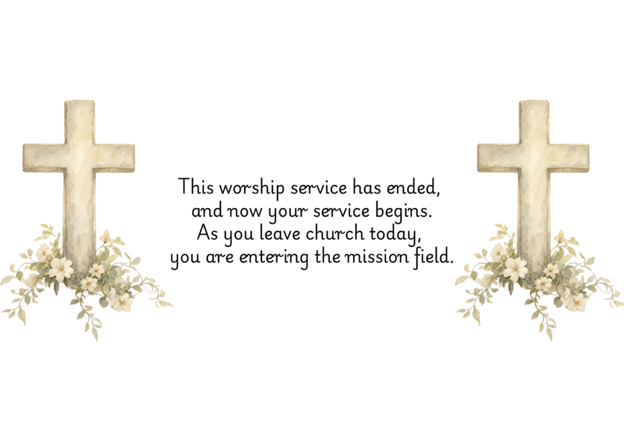

PRAYERS FOR THE CHURCH AND FOR THE WORLD:
For Family and Friends:
Russ & Ethel Muter  Gillian Payne  Billy Wines  Gloria Shelton  Joan Newsome | Kathleen Rhodes  Rick Willis  Austin  Shirley Embrey  Marline & Warren
For the Family of those who grieve for:
Butch Shelton
Ron May
Dennis Leohrs

For the Church and For the World:

For those in need of healing, and their caretakers. For first responders, the military, and their families. For God’s People, The Church, and the World. Prayers for national, state, and local leaders; and for our Nation.
If you know someone you would like to add to our prayer list, please forward your request to the church office by email at: secretary@rectortownumc.org or by calling (540) 364-1066.

RUMC CELEBRATIONS
Birthdays
Dawn Dye – 23rd
Joe Riggio – 25th
Muggie Grice – 27th
Dave Hall – 28th
Katie Carrillo – 28th
Laura Symanski – 29th

Anniversaries
Tara & Ben Wegdam – 23rd
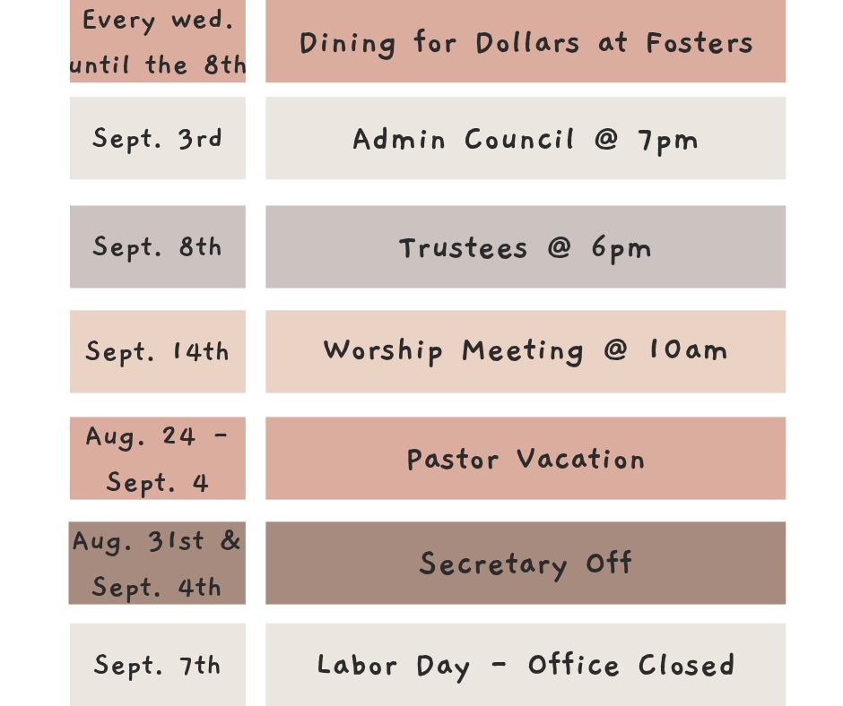
UPCOMING MEETINGS AND EVENTS

Rectortown United Methodist Church
  - Location: 3049 Rectortown Road, Rectortown, VA
Mailing Address: PO Box 301, Rectortown, VA 20140
Email: secretary@rectortownumc.org
Phone: (540)364.1066

