Rectortown United Methodist Church
March 2nd, 2025 10:00 a.m.
Transfiguration Sunday
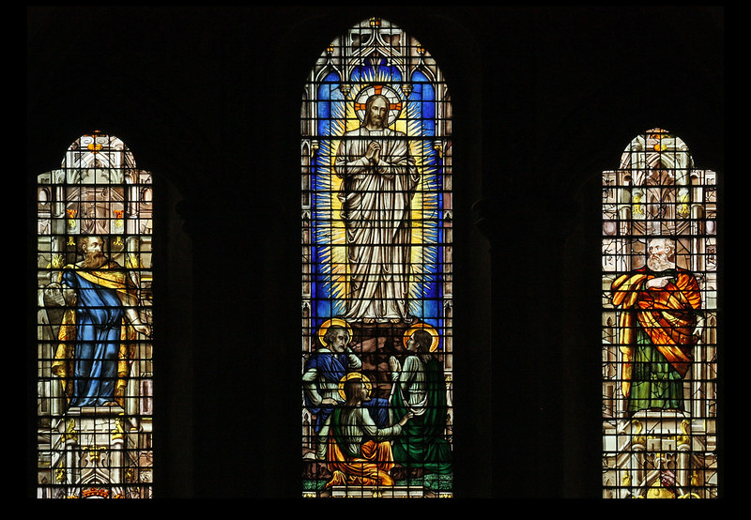

Pastor: TaeWon Kang
3049 Rectortown Road, Marshall, VA 20115
Pastor’s Cell Phone: (470) 728 - 9060
Pastor’s E-mail: pastortaewonkang@gmail.com
Music Director: Karen Chase
Ministers: every member of the congregation
Welcome to Rectortown UMC!

“You are looking for Jesus the Nazarene, who was crucified. He has risen!”
Mark 16:6 NIV

* Please Stand As You Are Able and Comfortable
PRELUDE - let us quiet our minds and hearts.
WELCOME, ANNOUNCEMENTS and CELEBRATIONS

*BRINGING IN THE LIGHT OF CHRIST

*CALL to WORSHIP
Leader: Lord, you have called us to the
mountaintop.
People: Help us to look forward to where you
would have us go.
Leader: Help us to listen carefully to the words of
your healing love.
People: Open our hearts and spirits to receive
your glorious directions.
Leader: Place your trust in the Lord in all your
ways.
People: Lord, we have come here to give our
lives to you. AMEN.

*OPENING PRAYER
Lord God, it seems so long ago that we heard your words at Jesus’ baptism. You reminded us that he is your beloved Son with whom you are well pleased. Again today we hear your words that we are to listen to him, to pay attention. Open our hearts this day, Lord, to hear the words of Jesus, to follow in his footsteps, and to serve You. For we ask this in Christ’s Name. AMEN.

* HYMN “O Wondrous Sight! O Vision Fair”
UMH 258 (verses 2 & 4)

YOUNG DISCIPLES’ MESSAGE

*PRAYER for ILLUMINATION UMH 393
Spirit of the living God, fall afresh on me.
Spirit of the living God, fall afresh on me.
Melt me, mold me, fill me, use me.
Spirit of the living God, fall afresh on me.

OLD TESTAMENT READING
Exodus 34: 29 - 35
This is the word of God for the people of God.
Thanks be to God.

RESPONSIVE READING Psalm 99 UMH 819

*GOSPEL READING Luke 9: 28 - 36
* Gloria Patri –“Glory Be to the Father” UMH 70

SERMON “Listen to Jesus”

*RESPONDING HYMN “Holy Ground” TFWS 2272

INVITATION, CONFESSION, AND PARDON
INVITATION (UMH 12)
Christ our Lord invites to his table all who
love him,
Who earnestly repent of their sin
And seek to live in peace with one another.
Therefore, let us confess our sin before God
and one another.

CONFESSION (UMH 12)
Merciful God,
We confess that we have not loved you
with our whole heart.
We have failed to be an obedient church.
We have not done your will,
We have broken your law,
We have rebelled against your love,
We have not loved our neighbors,
And we have not heard the cry of the
needy.
Forgive us, we pray.
Free us for joyful obedience,
Through Jesus Christ our Lord. Amen.

PARDON (UMH 12)
Hear the good news:
Christ died for us while we were yet sinners;
That proves God’s love toward us.
In the name of Jesus Christ, you are forgiven!

PASSING OF THE PEACE

SHARING OUR JOYS and CONCERNS

PASTORAL PRAYER

GIVING OUR GIFTS and TITHES
Offertory:
* Doxology UMH 94
“Praise God from Whom All Blessings Flow”
* Offertory Prayer

GREAT THANKSGIVING UMH 13

LORD’S PRAYER, BREAKING THE BREAD, AND GIVING THE BREAD AND CUP UMH 14

*PRAYER AFTER COMMUNION UMH 11
Eternal God, we give you thanks for this holy mystery in which you have given yourself to us. Grant that we may go into the world in the strength of your Spirit, to give ourselves for others, in the name of Jesus Christ our Lord, Amen.

*CLOSING HYMN “Be Though My Vision” UMH 451

*BENEDICTION

* POSTLUDE
* Please stand as you are able and comfortable.
This worship service has ended, and now your service begins.
As you leave church today, you are entering the mission field.

PRAYERS FOR THE CHURCH AND FOR THE WORLD:
For Family and Friends:
Linda Brown  Jim Caylen  Towny Lunsford  Christine Felts & Mother  Vickie Duff  The Reed Family | Shirley Embrey  Russ & Ethel Muter  Larry Underwood
For the Family of those who grieve for:
Laura Skirka
Elizabeth Payne
Hester Klemmer
Judy Bailey
For the Church and For the World:

For those in need of healing, and their caretakers.
For first responders, the military, and their families.
For God’s People, The Church, and the World.
Prayers for national, state, and local leaders; and for our Nation.
If you know someone you would like to add to our prayer list, please forward your request to the church office by email at: secretaryrumc@gmail.com, or by calling (540) 364-1066.

RUMC CELEBRATIONS

Birthdays
Jessica Lowry – March 3rd | Laura Thompson – March 4th
Yvie Frazier – March 4th | Eleanor Dove – March 5th
Jarod Hall – March 7th
Anniversaries
None

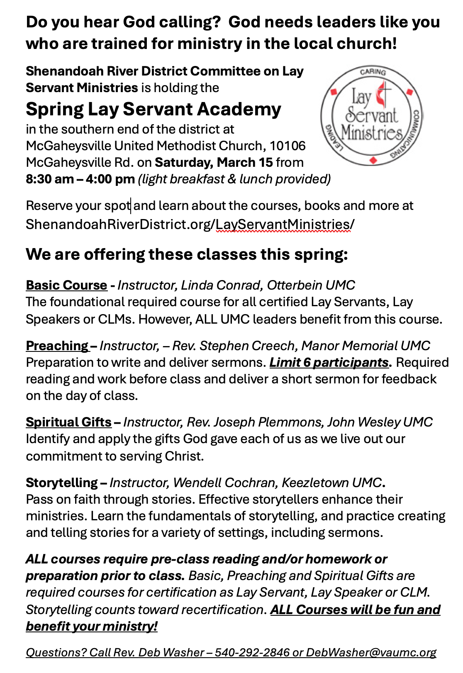

UPCOMING MEETINGS AND EVENTS

Admin Council
March 6th at 7pm, in person and zoom

Ash Wednesday Service
March 5th at 5:30 pm. Sanctuary

Rectortown United Methodist Church
Location: 3049 Rectortown Road, Rectortown, VA
Mailing Address: PO Box 301, Rectortown, VA 20140
Email: secretaryrumc@gmail.com Phone: (540)364.1066

