**Rectortown United Methodist Church**

July 13th, 2025 10:00 a.m.

*5th Sunday after Pentecost*

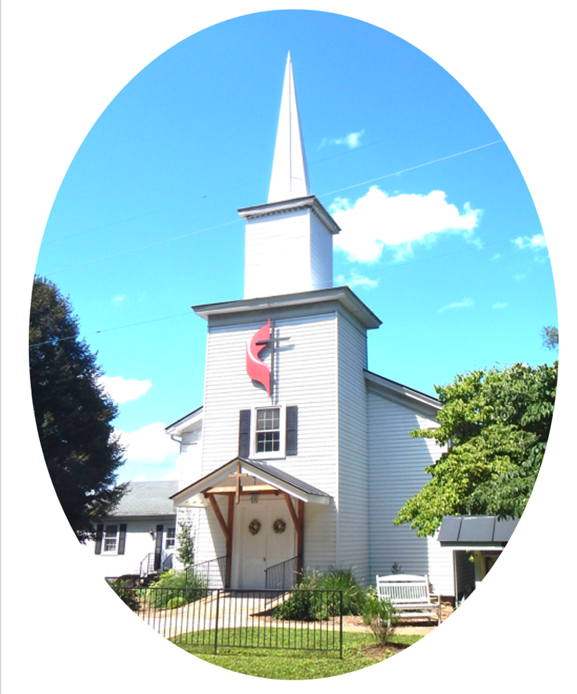

***Pastor****: Eduardo Carrillo*

*3049 Rectortown Road, Marshall, VA* 20115

*Pastor’s Cell Phone:* (703) 967-4361  
*Pastor’s E-mail:* pastor@rectortownumc.org

***Music Director****:* Karen Chase

***Ministers****: every member of the congregation*

Welcome to Rectortown UMC!

*“You are looking for Jesus the Nazarene, who was crucified. He has risen!”*

Mark 16:6 NIV

**\*** *Please Stand As You Are Able and Comfortable*

**PRELUDE** - *let us quiet our minds and hearts.*

**WELCOME, ANNOUNCEMENTS and CELEBRATIONS**

**\*BRINGING IN THE LIGHT OF CHRIST**

**\*CALL to WORSHIP**

Leader: God stands in the divine assembly,

calling for justice.

**People:** **We come, ready to listen, ready to**

**be challenged.**

Leader: The Lord says, “Rescue the weak and the

needy.”

**People:** **We come to worship the God who**

**sees injustice and demands mercy.**

Leader: Jesus shows us a Samaritan who crossed

the line.

**People:** **May we go and do likewise.**

**All:** **Come, let us worship the God of justice, compassion, and holy disruption!**

**\*OPENING PRAYER**

**God of justice and mercy, you do not stay silent while the powerful exploit the weak. You do not walk past the wounded lying by the roadside. You see what others ignore. You challenge what others accept. And through Christ, you call us to do the same. Forgive us when we do not see, hear, or follow you. Open our eyes this morning. Not just to hear your Word, but to live it. Give us courage to move with compassion, to love without borders, and to follow Jesus wherever mercy leads. Amen.**

**\* HYMN**

“O Master Let Me Walk with Thee” UMH 430

**YOUNG DISCIPLES’ MESSAGE**

**\*PRAYER for ILLUMINATION** UM Book of Worship

**Lord, open our hearts and minds by the power of your Holy Spirit, that as the Scriptures are read and your Word proclaimed, we may hear with joy what you say to us today. Amen.**

**OLD TESTAMENT READING**

Psalm 82 UMH 804

**\*NEW TESTAMENT READING**

Luke 10: 25 - 37

This is the word of God for the people of God.

**Thanks be to God.**

**SERMON**

“Crossing the Line”

**\*RESPONDING HYMN**

“Pass Me Not, O Gentle Savior” UMH 351

**\*AFFIRMATION OF FAITH** UMH 881

Apostles’ Creed (Traditional Version)

**SHARING OUR JOYS and CONCERNS**

**PASTORAL PRAYER & LORD’S PRAYER**

**GIVING OUR GIFTS and TITHES**

Offertory:

Doxology UMH 94  
 “Praise God from Whom All Blessings Flow”

Offertory Prayer

**\*CLOSING HYMN**

“Spirit of God, Descend upon My Heart” UMH 500

**\*BENEDICTION**

**\* POSTLUDE**

* *Please stand as you are able and comfortable.*

|  |
| --- |
| ***This worship service has ended, and now your service begins.***  ***As you leave church today, you are entering the mission field.*** |

***PRAYERS FOR THE CHURCH AND FOR THE WORLD:***

|  |  |
| --- | --- |
| **For Family and Friends:** | |
| Russ & Ethel Muter  Peggy Rose Goldsmith  Nancy Glascock  Jeff Sisk  TommyAnn  Dusty, Warden in Texas | |
| **For the Family of those who grieve for:**  Winnie  Anne Jackson  Texas Flood Victims | |
|  |  |

**For the Church and For the World:**

For those in need of healing, and their caretakers.

For first responders, the military, and their families.

For God’s People, The Church, and the World.

Prayers for national, state, and local leaders; and for our Nation.

**If you know someone you would like to add to our prayer list, please forward your request to the church office by email at: secretaryrumc@gmail.com, or by calling (540) 364-1066.**

**RUMC CELEBRATIONS**

|  |  |
| --- | --- |
| **Birthdays** | |
| Cindy Stolte -July 6th | Hazel Sisk – July 6th |
| Hunter Brown – July 7th | |
| **Anniversaries** | |
| Sue & Jess Lowry – July 10th | |

**UPCOMING MEETINGS AND EVENTS**

**Admin Council**

Thursday, **August 7th at 7pm**. In person and zoom.

**Trustees Meeting**

Tuesday, **July 8th** at 6pm. In person and zoom.

**Worship Meeting**

Cancelled

**Fig Leaf**

Tuesday, **July 15th** at 10am. Zoom and in person.

**Offering Request**

Please consider donating towards purchasing fencing supplies for the parsonage.

**Rectortown United Methodist Church**

Location: 3049 Rectortown Road, Rectortown, VA

Mailing Address: PO Box 301, Rectortown, VA 20140

Email: secretary@rectortownumc.org

Phone: (540)364.1066