Rectortown United Methodist Church
November 16th, 2025 10:00 a.m.
23rd Sunday after Pentecost

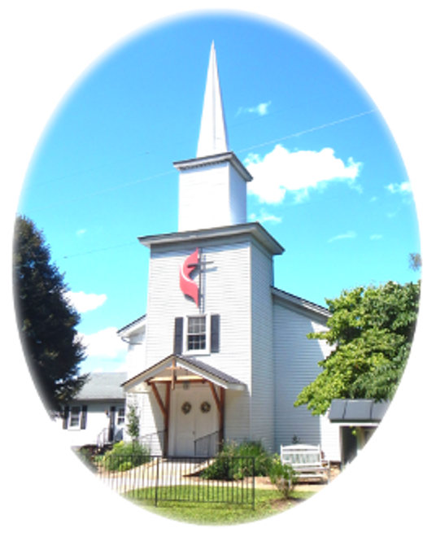

Pastor: Eduardo Carrillo
3049 Rectortown Road, Marshall, VA 20115
Pastor’s Cell Phone: (703) 967-4361
Pastor’s E-mail: pastor@rectortownumc.org
Music Director: Karen Chase
Ministers: every member of the congregation
Welcome to Rectortown UMC!

“This is the day that the Lord has made;
let us rejoice and be glad in it.” Psalm 118:24 NRSV

* Please Stand As You Are Able and Comfortable
PRELUDE - let us quiet our minds and hearts.
WELCOME, ANNOUNCEMENTS and CELEBRATIONS

GATHERING
*BRINGING IN THE LIGHT OF CHRIST

*CALL to WORSHIP
Leader: Behold, God is creating a new heaven
and a new earth.
People: A place where sorrow is no more.
Leader: Though trials may come, God holds us
fast.
People: We will not fear; our lives rest in
God's hands.
Leader: Let us worship the One who brings
beauty from brokenness.
People: Let us rejoice in the hope that
endures.

*OPENING PRAYER
God of all creation, when the world trembles, your love holds steady. When fear rises, your peace surrounds us. Speak into our chaos with your creative word. Help us live not in despair but in the deep trust that you are making all things new. Amen.

* HYMN
“On Jordan’s Stormy Banks I Stand” UMH 724

PROCLAMATION
YOUNG DISCIPLES’ MESSAGE

*PRAYER for ILLUMINATION UMH 393
Spirit of the living God, fall afresh on me.
Spirit of the living God, fall afresh on me.
Melt me, mold me, fill me, use me.
Spirit of the living God, fall afresh on me.

OLD TESTAMENT READING
Isaiah 65: 17 – 25

*NEW TESTAMENT READING
Luke 21: 5 – 19
This is the word of God for the people of God.
Thanks be to God.

SERMON “What Endures”
RESPONSE
*RESPONDING HYMN
“It is Well with My Soul” UMH 377

*AFFIRMATION OF FAITH UMH 881
Apostles’ Creed (Traditional Version)

SHARING OUR JOYS and CONCERNS

PASTORAL PRAYER & LORD’S PRAYER

GIVING OUR GIFTS and TITHES
Offertory:
Doxology UMH 94
“Praise God from Whom All Blessings Flow”
Offertory Prayer
*CLOSING HYMN
“I’ll Fly Away” TFWS 2282

SENDING FORTH
*BENEDICTION

* POSTLUDE
* Please stand as you are able and comfortable.
This worship service has ended, and now your service begins.
As you leave church today, you are entering the mission field.

PRAYERS FOR THE CHURCH AND FOR THE WORLD:
For Family and Friends:
Russ & Ethel Muter  Patsy Williams  Joan Newsome  Gillian Payne  Ernestine Hall  Sandra  Hall Family | John McGuinn & Sydney  Sandy Thomas  David Nalls  Kathleen Rhodes  Matt  Rick Willis
For the Family of those who grieve for:
Gaylen Ellison
Estelle Beach
Dottie Newman

For the Church and For the World:

For those in need of healing, and their caretakers.
For first responders, the military, and their families.
For God’s People, The Church, and the World.
Prayers for national, state, and local leaders; and for our Nation.

If you know someone you would like to add to our prayer list, please forward your request to the church office by email at: secretaryrumc@gmail.com, or by calling (540) 364-1066.

RUMC CELEBRATIONS

Birthdays
None
Anniversaries
None

UPCOMING MEETINGS AND EVENTS

Admin Council
Thursday, December 4th at 7pm. In person and zoom.

Trustees Meeting
Tuesday, December 9th at 6pm. In person and zoom.

Fig Leaf
Friday, November 21st at 10am.

Charge Conference
November 16th at Woodstock UMC

Veterans Day
November 11th

Rectortown United Methodist Church
  - Location: 3049 Rectortown Road, Rectortown, VA
Mailing Address: PO Box 301, Rectortown, VA 20140
Email: secretary@rectortownumc.org
Phone: (540)364.1066

