Rectortown United Methodist Church
July 26th, 2026 9:30 a.m.
Nineth Sunday after Pentecost


Pastor: Eduardo Carrillo
3049 Rectortown Road, Marshall, VA 20115
Pastor’s Cell Phone: (703) 967-4361
Pastor’s E-mail: eduardocarrillo@vaumc.org
Music Accompanist: Cheryl Kowalczyk
Ministers: every member of the congregation
Welcome to Rectortown UMC!

“This is the day that the Lord has made;
let us rejoice and be glad in it.” Psalm 118:24 NRSV

* Please Stand As You Are Able and Comfortable
PRELUDE - let us quiet our minds and hearts.
WELCOME, ANNOUNCEMENTS and CELEBRATIONS
GATHERING
*BRINGING IN THE LIGHT OF CHRIST

*CALL to WORSHIP
Leader: O give thanks to the Lord and call upon His holy name! Make known His deeds among the peoples!
People: We gather to sing to God, to tell of all His wonderful works, and to glory in His holy name.
Leader: We come seeking the Lord and His strength, remembering the covenant He made for a thousand generations.
People: Yet, we arrive knowing our own weakness. We come carrying burdens so heavy that we do not even know how to pray as we ought.
Leader: We worship with confidence today, resting in the promise that neither death, nor life, nor things present, nor things to come, nor anything else in all creation, will ever separate us from the love of God in Christ Jesus.
All: Let us rejoice in the God who holds us fast. Let us worship the Lord!

*OPENING PRAYER
Everlasting and Faithful God, We come before You today with hearts full of gratitude, remembering the wonderful works You have done. You are mindful of Your covenant forever, and You have proven Your faithfulness to us time and time again. Remind us today that we are more than conquerors through Him who loved us. Bind our wandering hearts to Your eternal promises. Assure us once again that absolutely nothing in all creation can sever us from Your love. We pray this in the strong and saving name of Jesus Christ, our Lord. Amen.

* HYMN
“Seek Ye First” UMH 405

PROCLAMATION
YOUNG DISCIPLES’ MESSAGE

*PRAYER for ILLUMINATION UMH 393
Spirit of the living God, fall afresh on me.
Spirit of the living God, fall afresh on me.
Melt me, mold me, fill me, use me.
Spirit of the living God, fall afresh on me.

FIRST READING
Psalm 105: 1 – 11
*SECOND READING
Romans 8: 26 – 39
This is the word of God for the people of God.
Thanks be to God.

SERMON
“When Words Fail, the Covenant Speaks”

RESPONSE
*RESPONDING HYMN UMH 480
“O Love That Wilt Not Let Me Go ”

*AFFIRMATION OF FAITH UMH 881
Apostles’ Creed (Traditional Version)

GIVING OUR GIFTS and TITHES
Offertory:
Doxology UMH 94
“Praise God from Whom All Blessings Flow”
Offertory Prayer

*CLOSING HYMN
“Since Jesus Came into My Heart” TFWS 2140

SENDING FORTH
SHARING OUR JOYS and CONCERNS
PASTORAL PRAYER & LORD’S PRAYER
*BENEDICTION
* POSTLUDE
* Please stand as you are able and comfortable.
This worship service has ended, and now your service begins.
As you leave church today, you are entering the mission field.

PRAYERS FOR THE CHURCH AND FOR THE WORLD:
For Family and Friends:
Russ & Ethel Muter  Gillian Payne  Billy Wines | Kathleen Rhodes  Rick Willis  Austin  Ronald Scheuble
For the Family of those who grieve for:
Tommy Krick
Sandy Beckham

For the Church and For the World:

For those in need of healing, and their caretakers.
For first responders, the military, and their families.
For God’s People, The Church, and the World.
Prayers for national, state, and local leaders; and for our Nation.
If you know someone you would like to add to our prayer list, please forward your request to the church office by email at: secretary@rectortownumc.org or by calling (540) 364-1066.

RUMC CELEBRATIONS
Birthdays
None

Anniversaries
None

UPCOMING MEETINGS AND EVENTS


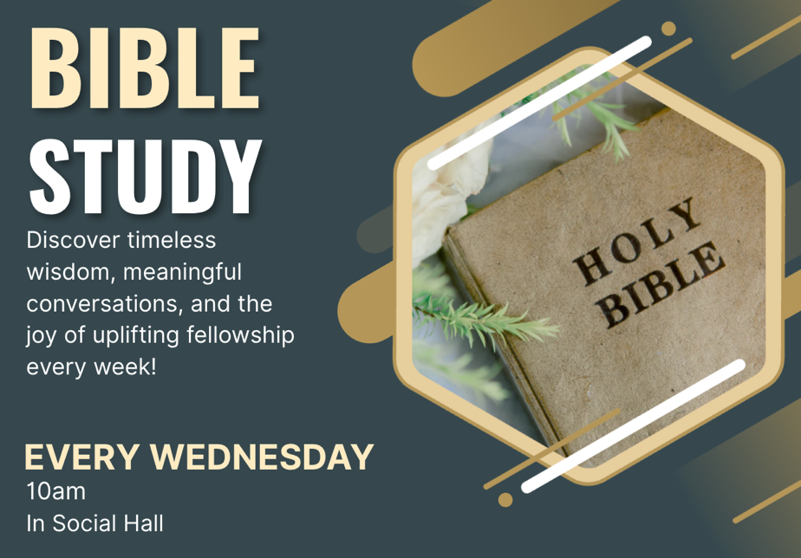

Rectortown United Methodist Church
  - Location: 3049 Rectortown Road, Rectortown, VA
Mailing Address: PO Box 301, Rectortown, VA 20140
Email: secretary@rectortownumc.org
Phone: (540)364.1066

