Rectortown United Methodist Church
July 19th, 2026 9:30 a.m.
Eighth Sunday after Pentecost


Pastor: Eduardo Carrillo
3049 Rectortown Road, Marshall, VA 20115
Pastor’s Cell Phone: (703) 967-4361
Pastor’s E-mail: eduardocarrillo@vaumc.org
Music Accompanist: Cheryl Kowalczyk
Ministers: every member of the congregation
Welcome to Rectortown UMC!

“This is the day that the Lord has made;
let us rejoice and be glad in it.” Psalm 118:24 NRSV

* Please Stand As You Are Able and Comfortable
PRELUDE - let us quiet our minds and hearts.
WELCOME, ANNOUNCEMENTS and CELEBRATIONS
GATHERING
*BRINGING IN THE LIGHT OF CHRIST

*CALL to WORSHIP
Leader: Lord, You have searched us and known us. You know when we sit down and when we
rise up; You discern our thoughts from far away.
People: There is nowhere we can flee from Your presence.
Leader: We gather today as a field planted by Your hand, yet we look around and see that the
field of our lives is a messy mix of wheat and weeds growing tightly together.
People: We confess our urge to judge quickly, to pull up what we think doesn't belong, and to act as the master of the harvest.
Leader: But the God who knitted us together in our mother's womb looks at our tangled fields
with absolute clarity and infinite patience.
All: We come to worship the One who knows us completely, handles us gently, and
promises that love will have the final word. Let us praise God together!

*OPENING PRAYER
Almighty God, Before a word is even on our tongues, You know it completely. You see
the hidden corners of our hearts, the parts of us that are bearing good fruit, and the
tangled, wild weeds of anxiety, doubt, and judgment that grow right alongside them.
Give us the courage today to stand in Your presence without hiding. Forgive our
impatience with ourselves, with our neighbors, and with the state of Your world. May Your Holy Spirit tend the good seed within us this hour, so that we might grow strong, secure in the knowledge that we are completely known and deeply loved. Amen.

* HYMN
“I Want to Walk as a Child of the Light” UMH 206

PROCLAMATION
YOUNG DISCIPLES’ MESSAGE

*PRAYER for ILLUMINATION UMH 393
Spirit of the living God, fall afresh on me.
Spirit of the living God, fall afresh on me.
Melt me, mold me, fill me, use me.
Spirit of the living God, fall afresh on me.

FIRST READING
Psalm 139: 1 – 12, 23 – 24
*SECOND READING
Matthew 13: 24 – 30, 36 – 43
This is the word of God for the people of God.
Thanks be to God.

SERMON
“Finding Grace in Our Imperfect Fields”

RESPONSE
*RESPONDING HYMN UMH 140
“Great is Thy Faithfulness”

*AFFIRMATION OF FAITH UMH 881
Apostles’ Creed (Traditional Version)

GIVING OUR GIFTS and TITHES
Offertory:
Doxology UMH 94
“Praise God from Whom All Blessings Flow”
Offertory Prayer

*CLOSING HYMN
“We’ve a Story to Tell to the Nations” UMH 569

SENDING FORTH
SHARING OUR JOYS and CONCERNS

PASTORAL PRAYER & LORD’S PRAYER

*BENEDICTION

* POSTLUDE
* Please stand as you are able and comfortable.
This worship service has ended, and now your service begins.
As you leave church today, you are entering the mission field.

PRAYERS FOR THE CHURCH AND FOR THE WORLD:
For Family and Friends:
Russ & Ethel Muter  Gillian Payne  Billy Wines | Kathleen Rhodes  Rick Willis  Austin  Ronald Scheuble
For the Family of those who grieve for:
Tommy Krick
Sandy Beckham

For the Church and For the World:

For those in need of healing, and their caretakers.
For first responders, the military, and their families.
For God’s People, The Church, and the World.
Prayers for national, state, and local leaders; and for our Nation.
If you know someone you would like to add to our prayer list, please forward your request to the church office by email at: secretary@rectortownumc.org or by calling (540) 364-1066.

RUMC CELEBRATIONS
Birthdays
Kiki Wegdam – 19th
Parker Hylton – 19th
Roxie Willis – 19th

Anniversaries
None

UPCOMING MEETINGS AND EVENTS

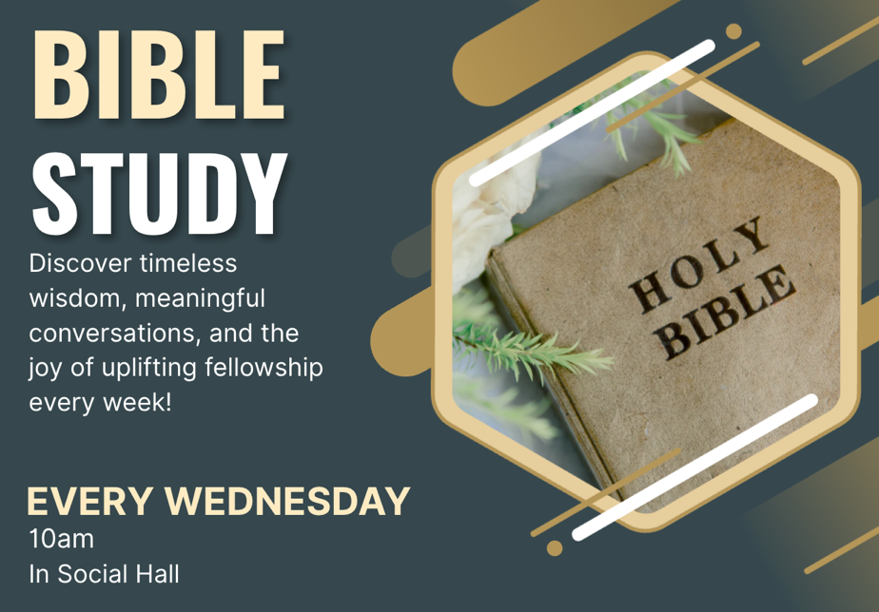

Rectortown United Methodist Church
  - Location: 3049 Rectortown Road, Rectortown, VA
Mailing Address: PO Box 301, Rectortown, VA 20140
Email: secretary@rectortownumc.org
Phone: (540)364.1066

