Rectortown United Methodist Church
April 5th, 2026 10:00 a.m.
Easter Sunday

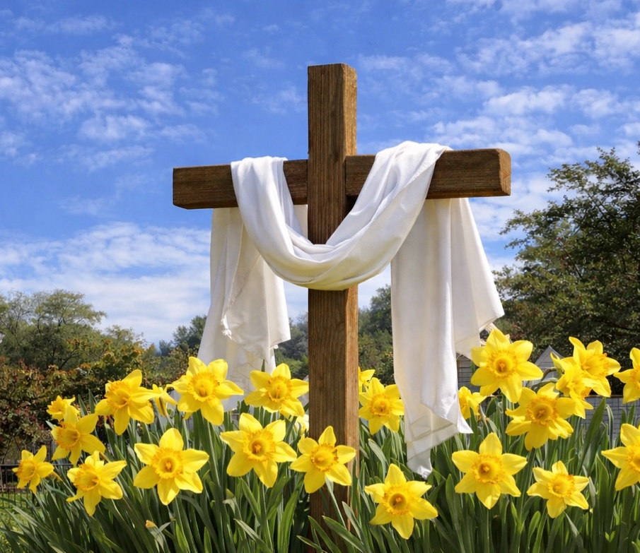

Pastor: Eduardo Carrillo
3049 Rectortown Road, Marshall, VA 20115
Pastor’s Cell Phone: (703) 967-4361
Pastor’s E-mail: eduardocarrillo@vaumc.org Music Director: Karen Chase
Ministers: every member of the congregation
Welcome to Rectortown UMC!

“This is the day that the Lord has made;
let us rejoice and be glad in it.” Psalm 118:24 NRSV

* Please Stand As You Are Able and Comfortable
PRELUDE - let us quiet our minds and hearts.
WELCOME, ANNOUNCEMENTS and CELEBRATIONS

GATHERING
*BRINGING IN THE LIGHT OF CHRIST

*CALL to WORSHIP
Leader: Christ is risen!
People: Christ is risen indeed!
Leader: The tomb is empty—death has not won.
People: It’s not too late for us.
Leader: It’s not too late for God.
People: It’s not too late for change.
All: Let us turn and follow the Risen One! Alleluia! Amen.

*PRAYER OF CONFESSION
Risen Lord, we praise you that it is never too late for us because you have already made your choice. You choose to love us, to break through the walls of sin and death, and call us back to you. We confess there are times when we get stuck—in our fear, in our doubt, in our sin, in hopelessness. We confess there are times we try to get unstuck on our own. Forgive us. We turn to you now, knowing that you are the one who brings new life.
You are the one who resurrects. We step forward with faith that with you, in you, and through you, it’s not too late. Amen.

* HYMN
“Christ the Lord is Risen Today” UMH 302

PROCLAMATION
YOUNG DISCIPLES’ MESSAGE

*PRAYER for ILLUMINATION UMH 393
Spirit of the living God, fall afresh on me.
Spirit of the living God, fall afresh on me.
Melt me, mold me, fill me, use me.
Spirit of the living God, fall afresh on me.

FIRST READING
Lamentations 3: 22 – 23

*SECOND READING
Matthew 28: 1 – 10
This is the word of God for the people of God.
Thanks be to God.

SERMON
“It’s Not Too Late for Us Because It’s Not Too Late for God”

RESPONSE
*RESPONDING HYMN
“He Lives” UMH 310

PASSING OF THE PEACE

LORD’S PRAYER, BREAKING THE BREAD, AND GIVING THE BREAD AND CUP UMH 14

*PRAYER AFTER COMMUNION UMH 11
Eternal God, we give you thanks for this holy mystery in which you have given yourself to us. Grant that we may go into the world in the strength of your Spirit, to give ourselves for others, in the name of Jesus Christ our Lord, Amen.

SHARING OUR JOYS and CONCERNS

PASTORAL PRAYER

GIVING OUR GIFTS and TITHES
Offertory:
Doxology UMH 94
“Praise God from Whom All Blessings Flow”
Offertory Prayer
*CLOSING HYMN
“Up From the Grave He Arose” UMH 322

SENDING FORTH
*BENEDICTION

* POSTLUDE
* Please stand as you are able and comfortable.
This worship service has ended, and now your service begins.
As you leave church today, you are entering the mission field.

PRAYERS FOR THE CHURCH AND FOR THE WORLD:
For Family and Friends:
Russ & Ethel Muter  Gillian Payne  Ernestine Hall  Sandra  Hall Family  Donna Olson  Joan Newsome | Russ & Ethel Muter  Gillian Payne  Ernestine Hall  Sandra  Hall Family  Donna Olson  Joan Newsome
For the Family of those who grieve for:
Larry Underwood
Georgie Ann Grimes
Katherine
For the Church and For the World:

For those in need of healing, and their caretakers. For first responders, the military, and their families. For God’s People, The Church, and the World. Prayers for national, state, and local leaders; and for our Nation.

If you know someone you would like to add to our prayer list, please forward your request to the church office by email at: secretary@rectortownumc.org, or by calling (540) 364-1066.

RUMC CELEBRATIONS

Birthdays
None
Anniversaries
Joann & Gary Garrett – 10th
Easter Lily Dedications

In Honor of:

Celeste & Heidi Bergeron

In Memory of:

Johnny Newsome

UPCOMING MEETINGS AND EVENTS
Admin Council
Thursday, April 9th at 7pm. In person & zoom.

Trustees Meeting
Tuesday, April 14th at 6 pm.
Zoom & In Person

Fig Leaf
Friday, April 17th at 10 am. Zoom & In Person

Worship Meeting
Wednesday, April 22nd at 10 am. Zoom & In Person

Rectortown United Methodist Church
  - Location: 3049 Rectortown Road, Rectortown, VA
Mailing Address: PO Box 301, Rectortown, VA 20140
Email: secretary@rectortownumc.org
Phone: (540)364.1066

