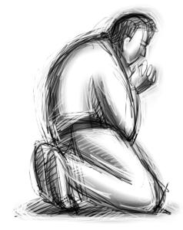

Copyright © Sermons4Kids, Inc.
May be reproduced for Ministry Use
Children’s Worship Bulletin

All Puffed Up

Luke 14:7-14




Happy are those people who are fair, who do what is right at all times.
Psalm 106:3
From Thru-the-Bible Coloring Pages for Ages 4-8. © Standard Publishing
Used by permission. Reproducible Coloring Books may be purchased from
Standard Publishing, www.standardpub.com,1-800-543-1301.



