Rectortown United Methodist Church
May 31st, 2026 10:00 a.m.
Trinity Sunday

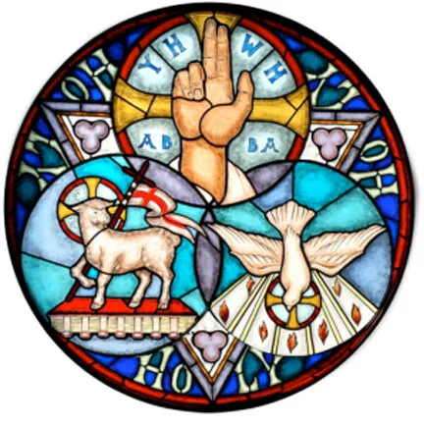

Pastor: Eduardo Carrillo
3049 Rectortown Road, Marshall, VA 20115
Pastor’s Cell Phone: (703) 967-4361
Pastor’s E-mail: eduardocarrillo@vaumc.org
Music Director: Karen Chase
Ministers: every member of the congregation
Welcome to Rectortown UMC!

“This is the day that the Lord has made;
let us rejoice and be glad in it.” Psalm 118:24 NRSV

* Please Stand As You Are Able and Comfortable
PRELUDE - let us quiet our minds and hearts.
WELCOME, ANNOUNCEMENTS and CELEBRATIONS
GATHERING
*BRINGING IN THE LIGHT OF CHRIST

*CALL to WORSHIP
Leader: On this Trinity Sunday, we come to praise the Triune God—Father, Son, and Holy Spirit!
People: We praise God who creates, redeems, and sustains all creation!
Leader: We come to wade into the depths of the divine mystery of God, the One-in-Three and Three-in-One.
People: We seek an ever-deepening faith in God who creates, redeems, and sustains all creation!
Leader: We come to witness the interconnectedness of the Triune God, to marvel at the divine dance of partnership and
cooperation
All: We receive the invitation to join the divine dance of God who creates, redeems, and sustains all creation!
Come, let us worship the Triune God who creates, redeems, and sustains all creation!

*OPENING PRAYER
Out of our ordinary, everyday lives, you have gathered us here, Holy God, to this time of worship, to this time of praise.
We join with angels and archangels and all the company of the saints to bless you, to listen for your Word, to immerse
ourselves in your grace, in your love. Open our hearts and our minds to your presence with us. Take our longings for your
goodness to shape our lives, this community, the hurting world, speak your Word and infuse us with your courage and
your hope and your love. Then, awaken us to your Holy Spirit who is making all things new, even us. Amen.
* HYMN
“Holy, Holy, Holy! Lord God Almighty” UMH 64

PROCLAMATION
YOUNG DISCIPLES’ MESSAGE

*PRAYER for ILLUMINATION UMH 393
Spirit of the living God, fall afresh on me.
Spirit of the living God, fall afresh on me.
Melt me, mold me, fill me, use me.
Spirit of the living God, fall afresh on me.

FIRST READING
Psalm 8

*SECOND READING
Matthew 28: 16 – 20
This is the word of God for the people of God.
Thanks be to God.

SERMON “Majestic Charge”

RESPONSE
*RESPONDING HYMN
“Morning Has Broken” UMH 145

*AFFIRMATION OF FAITH UMH 881
Apostles’ Creed (Traditional Version)

SHARING OUR JOYS and CONCERNS

PASTORAL PRAYER & LORD’S PRAYER

GIVING OUR GIFTS and TITHES
Offertory:
Doxology UMH 94
“Praise God from Whom All Blessings Flow”
Offertory Prayer

*CLOSING HYMN
“God Be With You till We Meet Again” UMH 672

SENDING FORTH
*BENEDICTION

* POSTLUDE
* Please stand as you are able and comfortable.
This worship service has ended, and now your service begins.
As you leave church today, you are entering the mission field.

PRAYERS FOR THE CHURCH AND FOR THE WORLD:
For Family and Friends:
Russ & Ethel Muter  Gillian Payne  Ernestine Hall  Hall Family | Kathleen Rhodes  Rick Willis  Austin  Ronald Scheuble
For the Family of those who grieve for:
Georgie Ann Grimes
Katherine
David Nalls
For the Church and For the World:

For those in need of healing, and their caretakers.
For first responders, the military, and their families.
For God’s People, The Church, and the World.
Prayers for national, state, and local leaders; and for our Nation.
If you know someone you would like to add to our prayer list, please forward your request to the church office by email at: secretary@rectortownumc.org or by calling (540) 364-1066.

RUMC CELEBRATIONS
Birthdays
None

Anniversaries
Diane & Jim Harrington – June 3rd

UPCOMING MEETINGS AND EVENTS

Admin Council – June 4th at 7pm.

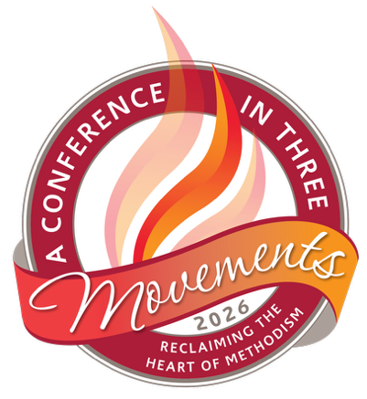
June 17 – 20
Harrisonburg VA

Rectortown United Methodist Church
  - Location: 3049 Rectortown Road, Rectortown, VA
Mailing Address: PO Box 301, Rectortown, VA 20140
Email: secretary@rectortownumc.org
Phone: (540)364.1066

