Rectortown United Methodist Church
April 2nd, 2026 6:00 p.m.
Holy Thursday



Pastor: Eduardo Carrillo
3049 Rectortown Road, Marshall, VA 20115
Pastor’s Cell Phone: (703) 967-4361
Pastor’s E-mail: eduardocarrillo@vaumc.org
Music Director: Karen Chase
Ministers: every member of the congregation
Welcome to Rectortown UMC!

“This is the day that the Lord has made;
let us rejoice and be glad in it.” Psalm 118:24 NRSV

* Please Stand As You Are Able and Comfortable

*PRELUDE

*CALL to WORSHIP
Leader: We gather on this holy night,
remembering how God brought his people
out of bondage into freedom.
People: We come as those still learning
what it means to be free.
Leader: On this night, Jesus rose from the table,
took up a towel, and knelt before those he
loved.
People: He gave us more than a meal. He
gave us a commandment.
Leader: It is not too late to receive it. It is not
too late to live it.
People: "Love one another as I have loved
you."
All: Lead us this night, O Lord. Teach us to
love as you have loved us. Amen.
*OPENING PRAYER
God on bended knee, we confess that we have all too often tried to stand over one another. We have been more concerned with power or propriety than with service and love. We have offered care only to those who can offer something in return.
In so doing, we have betrayed and denied the fullness of life you hold out to us. Forgive us, we pray. May we turn back to you by turning to one another and embracing your new commandment. May we love one another. Amen.

* HYMN
“What Wondrous Love Is This?” UMH 292

FIRST READING
Exodus 12: 1 – 14

*SECOND READING
John 13: 1 – 17, 31 – 35
This is the word of God for the people of God.
Thanks be to God.

SERMON
“It’s Not Too Late for a New Commandment”

*COMMUNION WITH HAND OR FOOT WASHING

*BENEDICTION

* CLOSING HYMN
“O Master Let Me Walk with Thee” UMH 430
* Please stand as you are able and comfortable.
This worship service has ended, and now your service begins.
As you leave church today, you are entering the mission field.

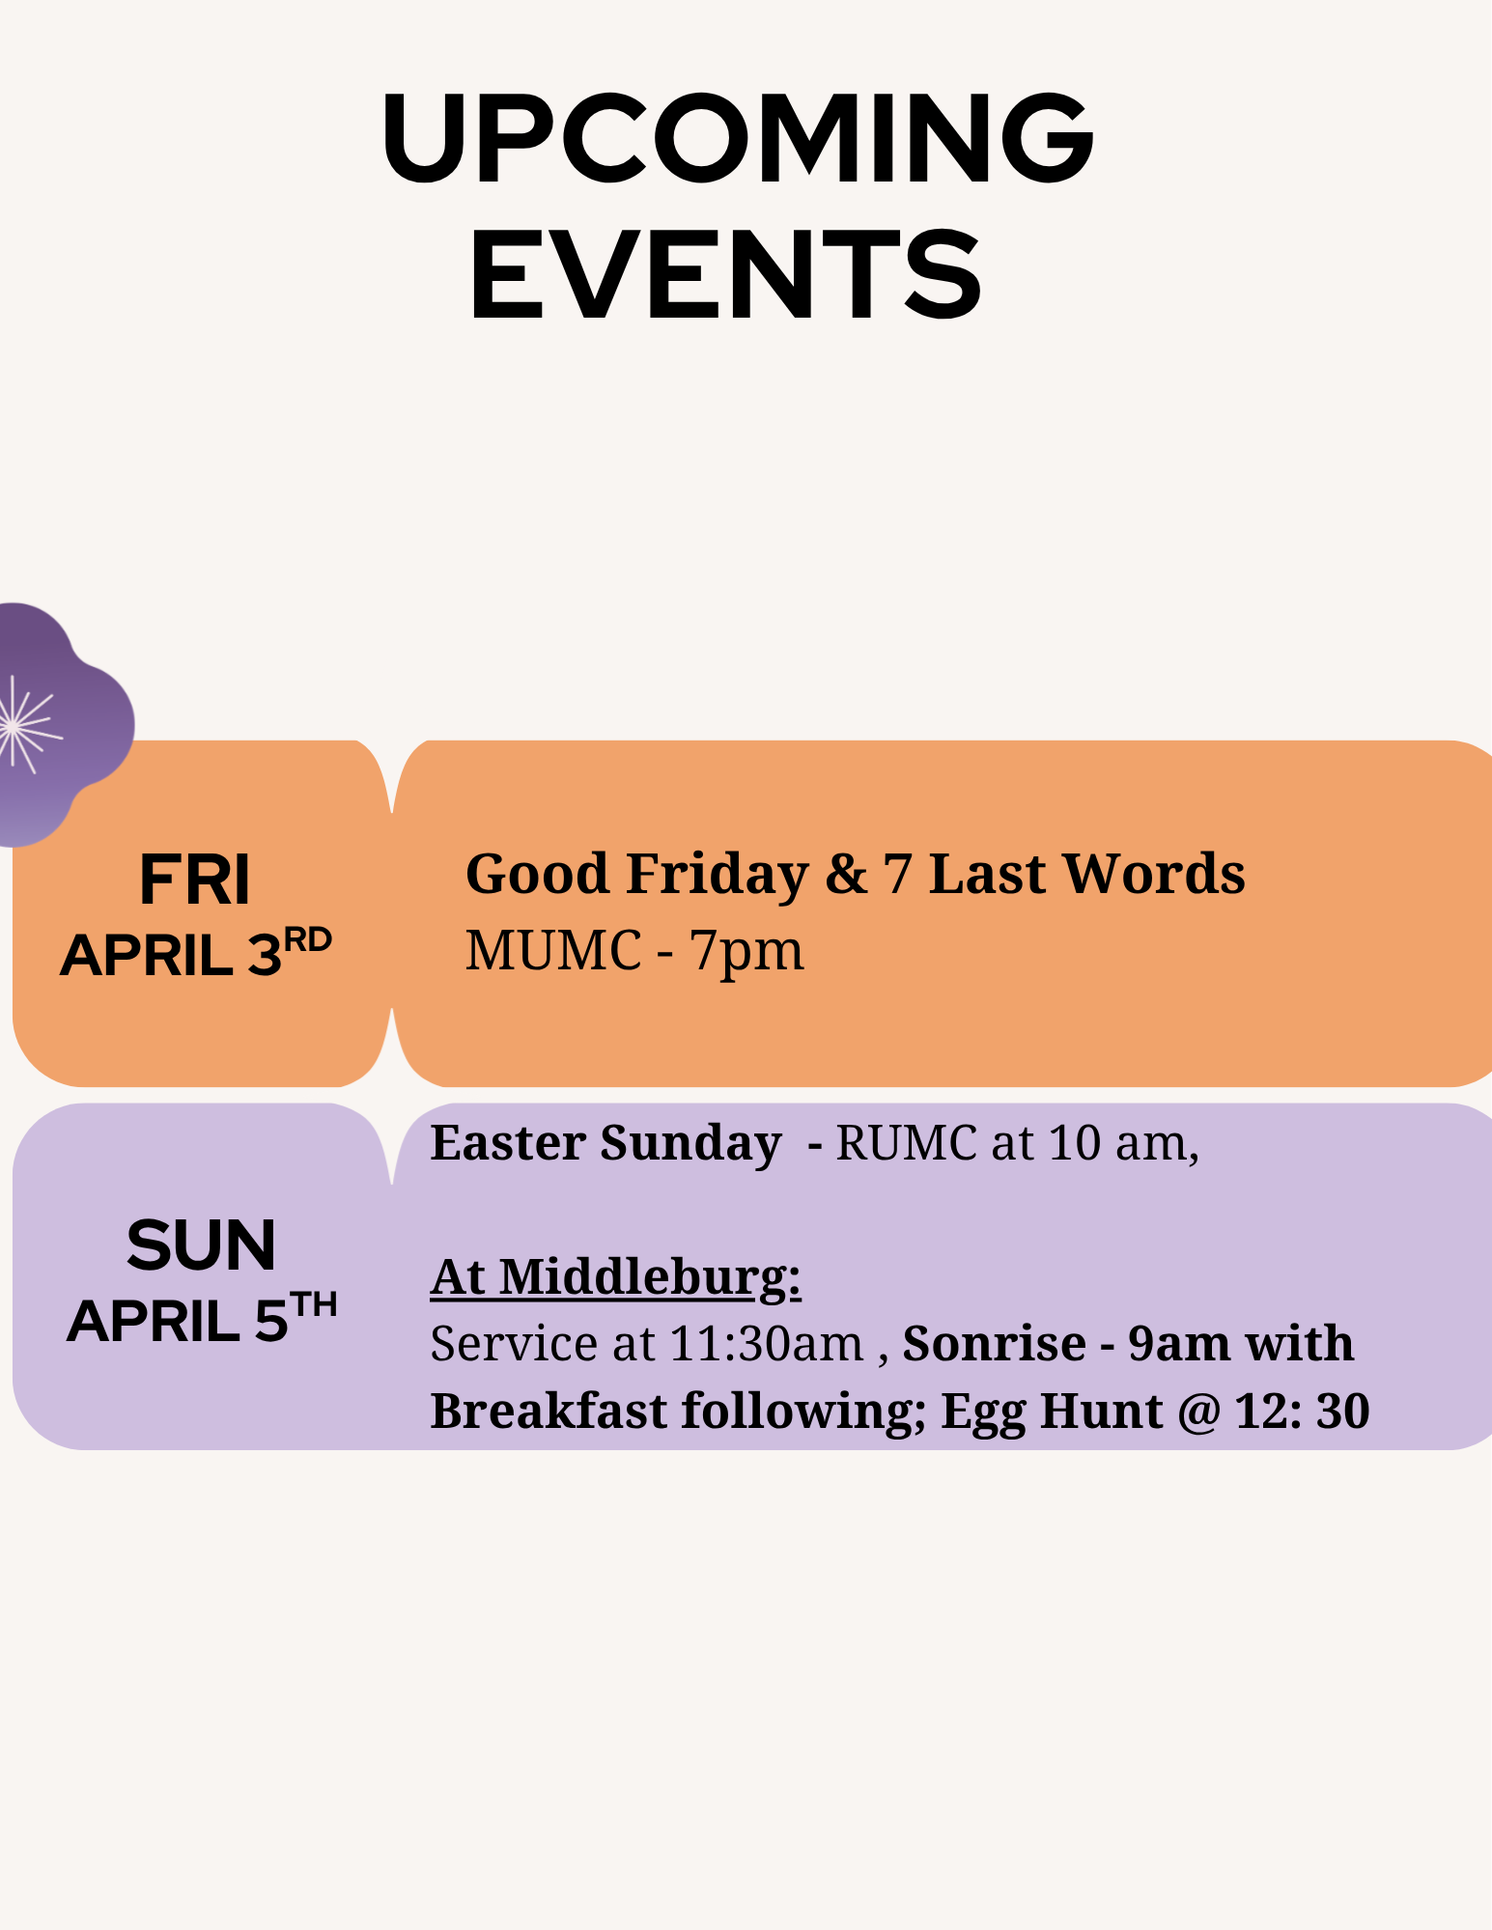

Rectortown United Methodist Church
  - Location: 3049 Rectortown Road, Rectortown, VA
Mailing Address: PO Box 301, Rectortown, VA 20140
Email: secretary@rectortownumc.org
Phone: (540)364.1066

