Rectortown United Methodist Church
August 30th, 2026 9:30 a.m.
Fourteenth Sunday after Pentecost


Pastor: Eduardo Carrillo
3049 Rectortown Road, Marshall, VA 20115
Pastor’s Cell Phone: (703) 967-4361
Pastor’s E-mail: eduardocarrillo@vaumc.org
Music Accompanist: Cheryl Kowalczyk
Ministers: every member of the congregation
Welcome to Rectortown UMC!

“This is the day that the Lord has made;
let us rejoice and be glad in it.” Psalm 118:24 NRSV

* Please Stand As You Are Able and Comfortable
PRELUDE - let us quiet our minds and hearts.
WELCOME, ANNOUNCEMENTS and CELEBRATIONS
GATHERING
*BRINGING IN THE LIGHT OF CHRIST

*CALL to WORSHIP
Leader: We gather together not as strangers, but as one family in Christ.
People: Bound together in love, united in praise.
Leader: Let us bring our whole lives to God.
People: Our joys, our needs, and our shared purpose.
Leader: We are here seeking, searching, answering.
All: With glad and sincere hearts, let us worship the Lord!

*OPENING PRAYER
Gracious and Loving God, we draw near to You today, giving thanks for the gift of community. Thank You for gathering us into one body, calling us to walk alongside one another in joy, generosity, and peace. Open our hearts during this time together. Melt away any division, quiet our distractions, and unite our spirits in Your presence. May our worship reflect the beauty of Your love, and may our fellowship shine as a light of hope to the world around us.
We ask for Your Holy Spirit to move freely among us today. In Jesus' name, Amen.

* HYMN Congregation Choice

PROCLAMATION
YOUNG DISCIPLES’ MESSAGE

*PRAYER for ILLUMINATION UMH 393
Spirit of the living God, fall afresh on me.
Spirit of the living God, fall afresh on me.
Melt me, mold me, fill me, use me.
Spirit of the living God, fall afresh on me.

READING
Acts 2: 44 – 47

This is the word of God for the people of God.
Thanks be to God.

SERMON Wayne Frick

RESPONSE
*RESPONDING HYMN Congregation Choice

*AFFIRMATION OF FAITH UMH 881
Apostles’ Creed (Traditional Version)

GIVING OUR GIFTS and TITHES
Offertory:
Doxology UMH 94
“Praise God from Whom All Blessings Flow”
Offertory Prayer

SENDING FORTH
*CLOSING HYMN Congregation Choice

SHARING OUR JOYS & CONCERNS
PASTORAL PRAYER & LORD’S PRAYER
*BENEDICTION & POSTLUDE
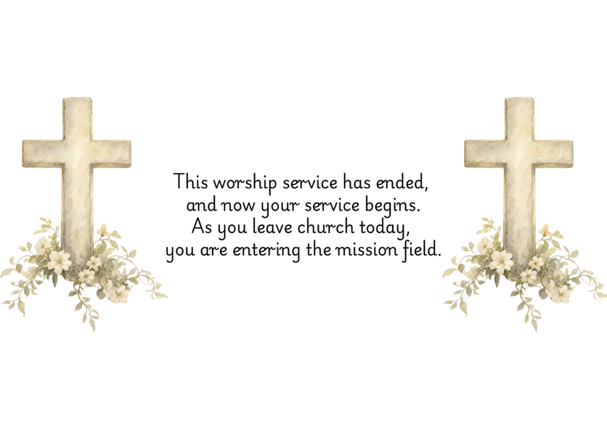

PRAYERS FOR THE CHURCH AND FOR THE WORLD:
For Family and Friends:
Russ & Ethel Muter  Gillian Payne  Billy Wines  Gloria Shelton  Joan Newsome | Kathleen Rhodes  Rick Willis  Austin  Shirley Embrey  Marline & Warren
For the Family of those who grieve for:
Butch Shelton
Ron May
Dennis Leohrs

For the Church and For the World:

For those in need of healing, and their caretakers. For first responders, the military, and their families. For God’s People, The Church, and the World. Prayers for national, state, and local leaders; and for our Nation.
If you know someone you would like to add to our prayer list, please forward your request to the church office by email at: secretary@rectortownumc.org or by calling (540) 364-1066.

RUMC CELEBRATIONS
Birthdays
Emma Symanski – Sept. 2nd

Anniversaries
None
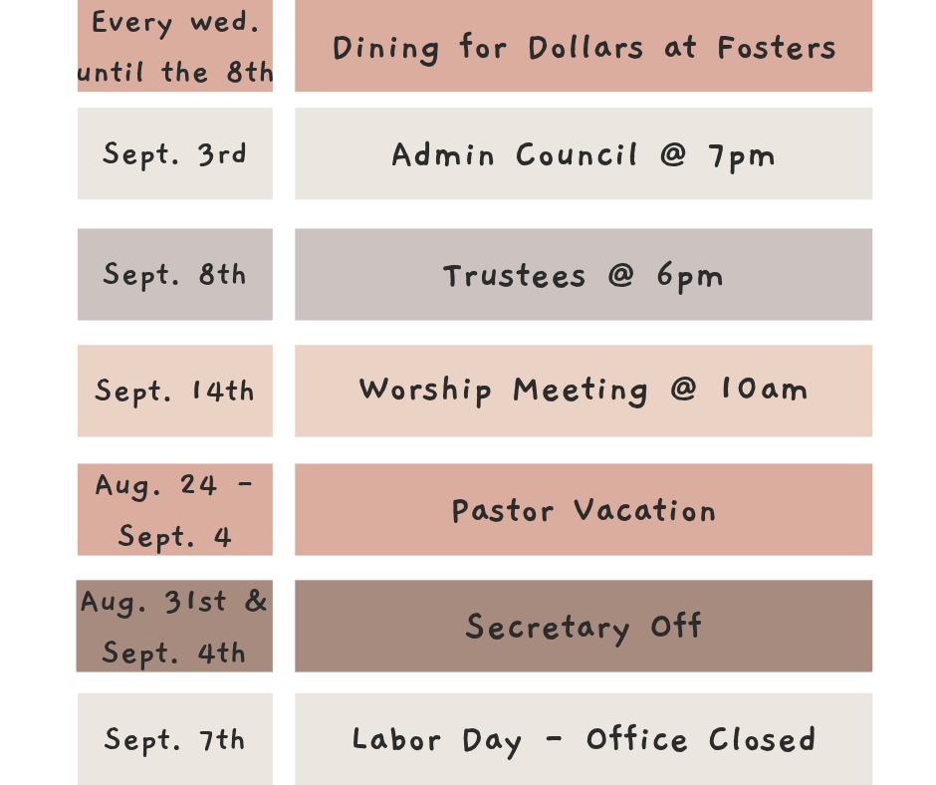
UPCOMING MEETINGS AND EVENTS

Rectortown United Methodist Church
  - Location: 3049 Rectortown Road, Rectortown, VA
Mailing Address: PO Box 301, Rectortown, VA 20140
Email: secretary@rectortownumc.org
Phone: (540)364.1066

