Rectortown United Methodist Church
September 20th, 2026 9:30 a.m.
Seventeenth Sunday after Pentecost


Pastor: Eduardo Carrillo
3049 Rectortown Road, Marshall, VA 20115
Pastor’s Cell Phone: (703) 967-4361
Pastor’s E-mail: eduardocarrillo@vaumc.org
Music Accompanist: Cheryl Kowalczyk
Ministers: every member of the congregation
Welcome to Rectortown UMC!

“This is the day that the Lord has made;
let us rejoice and be glad in it.” Psalm 118:24 NRSV

* Please Stand As You Are Able and Comfortable
PRELUDE - let us quiet our minds and hearts.
WELCOME, ANNOUNCEMENTS and CELEBRATIONS
GATHERING
*BRINGING IN THE LIGHT OF CHRIST

*CALL to WORSHIP
Leader: Praise the Lord! Give thanks to God, for God is good.
People: God’s steadfast love endures forever!
Leader: In our hunger and anxiety,
People: God opens the heavens and provides daily bread.
Leader: In our striving and score-keeping,
People: God offers grace beyond measure.
All: Let us worship our generous God!

*OPENING PRAYER
Provider God, you hear our grumbling and meet our deepest needs with unexpected grace. Overturn our notions of fairness with your vast and equal love. Feed us with the heavenly manna of your Word today, that we may learn to live with grateful and contented hearts. Continue to meet us in the wilderness, in our hunger and in our time of need. We lift up these moments in worship, Amen.
* HYMN
“Guide Me, O Thou Great Jehovah” UMH 127

PROCLAMATION
*PRAYER for ILLUMINATION UMH 393
Spirit of the living God, fall afresh on me.
Spirit of the living God, fall afresh on me.
Melt me, mold me, fill me, use me.
Spirit of the living God, fall afresh on me.

FIRST READING
Exodus 16: 2 – 15
*SECOND READING
Matthew 20: 1 – 16
This is the word of God for the people of God.
Thanks be to God.

SERMON
“Bread in the Wilderness, Grace Beyond Merit”

RESPONSE
*RESPONDING HYMN UMH 98
“To God Be the Glory”

*AFFIRMATION OF FAITH UMH 881
Apostles’ Creed (Traditional Version)

GIVING OUR GIFTS and TITHES
Offertory:
Doxology UMH 94
“Praise God from Whom All Blessings Flow”
Offertory Prayer

SENDING FORTH
*CLOSING HYMN UMH 378
“Amazing Grace”

SHARING OUR JOYS & CONCERNS
PASTORAL PRAYER & LORD’S PRAYER
*BENEDICTION & POSTLUDE

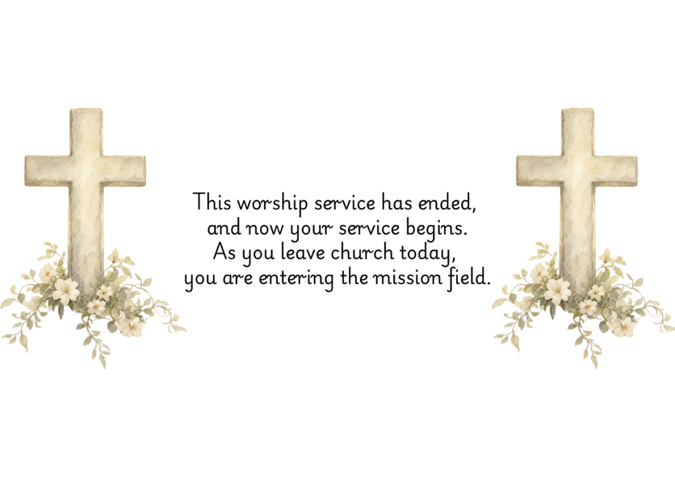

PRAYERS FOR THE CHURCH AND FOR THE WORLD:
For Family and Friends:
Russ & Ethel Muter  Gillian Payne  Billy Wines  Gloria Shelton  Joan Newsome  Keith Kuck  Don Williams | Kathleen Rhodes  Rick Willis  Austin  Shirley Embrey  Marline & Warren  Billy Wines
For the Family of those who grieve for:

For the Church and For the World:

For those in need of healing, and their caretakers.
For first responders, the military, and their families.
For God’s People, The Church, and the World.
Prayers for national, state, and local leaders; and for our Nation.
If you know someone you would like to add to our prayer list, please forward your request to the church office by email at: secretary@rectortownumc.org or by calling (540) 364-1066.

RUMC CELEBRATIONS
Birthdays
None

Anniversaries
None

UPCOMING MEETINGS AND EVENTS
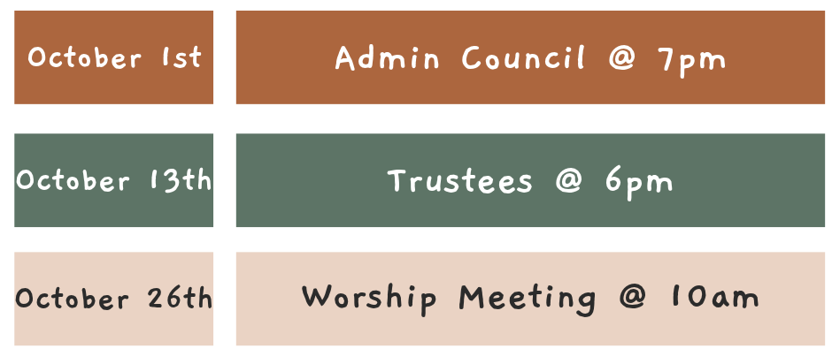



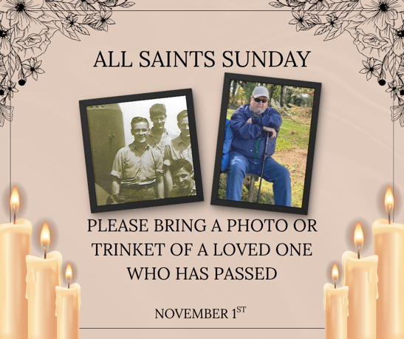

Rectortown United Methodist Church
  - Location: 3049 Rectortown Road, Rectortown, VA
Mailing Address: PO Box 301, Rectortown, VA 20140
Email: secretary@rectortownumc.org
Phone: (540)364.1066

