Rectortown United Methodist Church

March 16th, 2025 10:00 a.m.

*2nd Sunday in Lent*

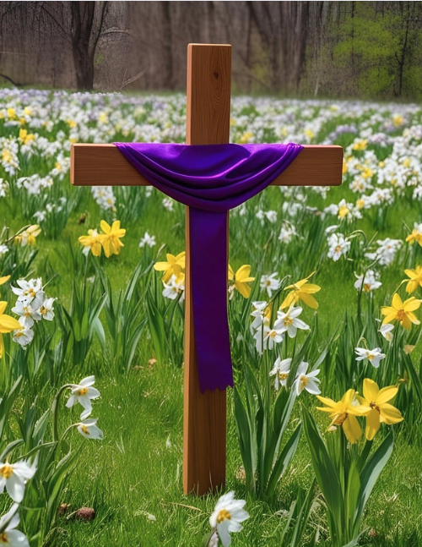

***Pastor****: TaeWon Kang*

*3049 Rectortown Road, Marshall, VA* 20115

*Pastor’s Cell Phone:* (470) 728 - 9060  
*Pastor’s E-mail:* pastortaewonkang@gmail.com

***Music Director****:* Karen Chase

***Ministers****: every member of the congregation*

Welcome to Rectortown UMC!

*“You are looking for Jesus the Nazarene, who was crucified. He has risen!”*

Mark 16:6 NIV

**\*** *Please Stand As You Are Able and Comfortable*

**PRELUDE** - *let us quiet our minds and hearts.*

**WELCOME, ANNOUNCEMENTS and CELEBRATIONS**

**\*BRINGING IN THE LIGHT OF CHRIST**

**\*CALL to WORSHIP**

Leader: We are on a journey of faith. Jesus is our

leader and our guide.  
**People: We place our trust in him.**Leader: As the daylight hours grow longer, our

journey takes on an urgency.  
**People: We must prepare our hearts for**

**Jerusalem**Leader: Do not fear! God goes before us, into

Jerusalem, into the world.  
**People: Amen!**

**\*OPENING PRAYER**

**Lord, we come to you this morning with so many concerns and issues that demand our attention. Our lives are burdened; our spirits are tired. Guide our lives and our steps as we walk this Lenten journey, inward and outward. Help us to discern what you would have us do, that others may be healed. In Jesus’ name, we pray. AMEN.**

**\* HYMN** “Fairest Lord Jesus” UMH 189

**YOUNG DISCIPLES’ MESSAGE**

**\*PRAYER for ILLUMINATION** UMH 393

**Spirit of the living God, fall afresh on me.**

**Spirit of the living God, fall afresh on me.**

**Melt me, mold me, fill me, use me.**

**Spirit of the living God, fall afresh on me.**

**OLD TESTAMENT READING**

Deuteronomy 26: 1 -11

This is the word of God for the people of God.

**Thanks be to God.**

**EPISTLE READING** Philippians 3: 17 – 4:1

**RESPONSIVE READING** Psalm 27 UMH 758

**\*GOSPEL READING** Luke 13: 31 - 35

**\*** Gloria Patri –“Glory Be to the Father” UMH 70

**SERMON** “Imitate Jesus’ Persistence”

**\*RESPONDING HYMN**

“I Am Thine, O Lord” UMH 419 (v.1,2,&4)

**AFFIRMATION OF FAITH**

Apostles’ Creed (Traditional Version) UMH 881

**SHARING OUR JOYS and CONCERNS**

**PASTORAL PRAYER & LORD’S PRAYER**

**GIVING OUR GIFTS and TITHES**

Offertory:

Doxology UMH 94  
 “Praise God from Whom All Blessings Flow”

Offertory Prayer

**\*CLOSING HYMN**

“In the Cross of Christ, I Glory” UMH 295 (v.1,3,&5)

**\*BENEDICTION**

**\* POSTLUDE**

* *Please stand as you are able and comfortable.*

|  |
| --- |
| ***This worship service has ended, and now your service begins.***  ***As you leave church today, you are entering the mission field.*** |

***PRAYERS FOR THE CHURCH AND FOR THE WORLD:***

|  |  |
| --- | --- |
| **For Family and Friends:** | |
| Linda Brown  Jim Caylen  Towny Lunsford  Christine Felts & Mother  Vickie Duff  The Reed Family | Shirley Embrey  Russ & Ethel Muter  Aiden Leake  Joann Garrett  Ann Woodward  Jean Fontana |
| **For the Family of those who grieve for:**  Laura Skirka  Judy Bailey  Colonel Jim Dismukes (Tara’s father) | |
|  |  |

**For the Church and For the World:**

For those in need of healing, and their caretakers.

For first responders, the military, and their families.

For God’s People, The Church, and the World.

Prayers for national, state, and local leaders; and for our Nation.

**If you know someone you would like to add to our prayer list, please forward your request to the church office by email at: secretaryrumc@gmail.com, or by calling (540) 364-1066.**

**RUMC CELEBRATIONS**

|  |  |
| --- | --- |
| **Birthdays** | |
| Madeline Thompson – 21st | Noah Cooper – 21st |
| **Anniversaries** | |
| None | |

**UPCOMING MEETINGS AND EVENTS**

**St. Patrick’s Day**

March 17th

**Fig Leaf Meeting**

March 18th at 10am, in person and zoom

**In Person Bible Study**

Every Tuesday at 10:30am in the fellowship hall

**Rectortown United Methodist Church**

Location: 3049 Rectortown Road, Rectortown, VA

Mailing Address: PO Box 301, Rectortown, VA 20140

Email: secretary@rectortownumc.org

Phone: (540)364.1066