Rectortown United Methodist Church
February 9th, 2025 10:00 a.m.
5th Sunday after Epiphany

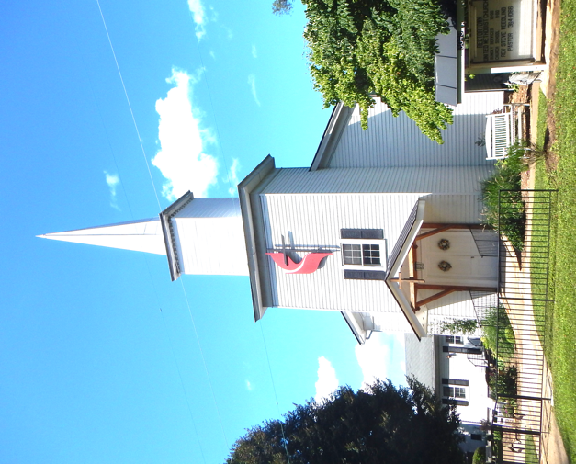

Pastor: TaeWon Kang
3049 Rectortown Road, Marshall, VA 20115
Pastor’s Cell Phone: (470) 728 - 9060
Pastor’s E-mail: pastortaewonkang@gmail.com
Music Director: Karen Chase
Ministers: every member of the congregation
Welcome to Rectortown UMC!

“You are looking for Jesus the Nazarene, who was crucified. He has risen!”
Mark 16:6 NIV

* Please Stand As You Are Able and Comfortable
PRELUDE - let us quiet our minds and hearts.

WELCOME, ANNOUNCEMENTS and CELEBRATIONS

*BRINGING IN THE LIGHT OF CHRIST

*CALL to WORSHIP
Leader: Great is the Lord!
People: God’s greatness is beyond our
understanding.
Leader: Yet God has revealed God’s self in Jesus
Christ.
People: Through Jesus we have come to know
the absolute love of God.
Leader: Lift up your hearts and praise the Lord!
People: May God continue to bless God’s
people with peace. AMEN.

*OPENING PRAYER
O Holy God, you call us to follow your voice. “Whom shall I send?” you asked us. With hearts of hope and souls filled with courage, we respond, “Here I am. Send me.” You evaporate our shame, and joyously embrace our authentic selves. May we continue to open ourselves to you, and may we embrace our full humanity as you do. In Christ’s name, we pray. Amen.

* HYMN “Holy, Holy, Holy! Lord God Almighty” UMH 64

YOUNG DISCIPLES’ MESSAGE

*PRAYER for ILLUMINATION UMH 393
Spirit of the living God, fall afresh on me.
Spirit of the living God, fall afresh on me.
Melt me, mold me, fill me, use me.
Spirit of the living God, fall afresh on me.

OLD TESTAMENT READING
Isaiah 6: 1 - 8
This is the word of God for the people of God.
Thanks be to God.

RESPONSIVE READING Psalm 138 UMH 853

*GOSPEL READING Luke 5: 1 -11
* Gloria Patri –“Glory Be to the Father” UMH 70

SERMON “Into the Deep Water”

*RESPONDING HYMN
“I Have Decided to Follow Jesus” TFWS 2129

*AFFIRMATION OF FAITH UMH 881
Apostles’ Creed (Traditional version)

SHARING OUR JOYS and CONCERNS

PASTORAL PRAYER & LORD’S PRAYER

GIVING OUR GIFTS and TITHES
Offertory:
* Doxology UMH 94
“Praise God from Whom All Blessings Flow”
* Offertory Prayer

*CLOSING HYMN “Here I Am, Lord” UMH 593

*BENEDICTION

* POSTLUDE
* Please stand as you are able and comfortable.
This worship service has ended, and now your service begins.
As you leave church today, you are entering the mission field.

PRAYERS FOR THE CHURCH AND FOR THE WORLD:
For Family and Friends:
Linda Brown  Jim Caylen  Towny Lunsford  Christine Felts & Mother  Vickie Duff  Jane Thomas  The Reed Family | Russ & Ethel Muter
For the Family of those who grieve for:
Laura Skirka
Elizabeth Payne
Hester Klemmer
Norma Jean Thorpe (Yowell)
Judy Bailey
For the Church and For the World:

For those in need of healing, and their caretakers.
For first responders, the military, and their families.
For God’s People, The Church, and the World.
Prayers for national, state, and local leaders; and for our Nation.
If you know someone you would like to add to our prayer list, please forward your request to the church office by email at: secretaryrumc@gmail.com, or by calling (540) 364-1066.

RUMC CELEBRATIONS

Birthdays
Greg Kroes – February 15th | Kattie Ferrebee – February 15th
Anniversaries
Sheila & Todd Kridler – February 14th

UPCOMING MEETINGS AND EVENTS

*Question for Congregation*
Would you prefer a 6:30 or an earlier Ash Wednesday Service?

Please let Larry or the secretary know.

Worship Committee
February 10th at 6pm

Trustees Committee
February 11th at 6pm

Valentine’s Day
February 14th

Rectortown United Methodist Church
Location: 3049 Rectortown Road, Rectortown, VA
Mailing Address: PO Box 301, Rectortown, VA 20140
Email: secretaryrumc@gmail.com Phone: (540)364.1066

