**Rectortown United Methodist Church**

June 8th, 2025 10:00 a.m.

*Pentecost Sunday*

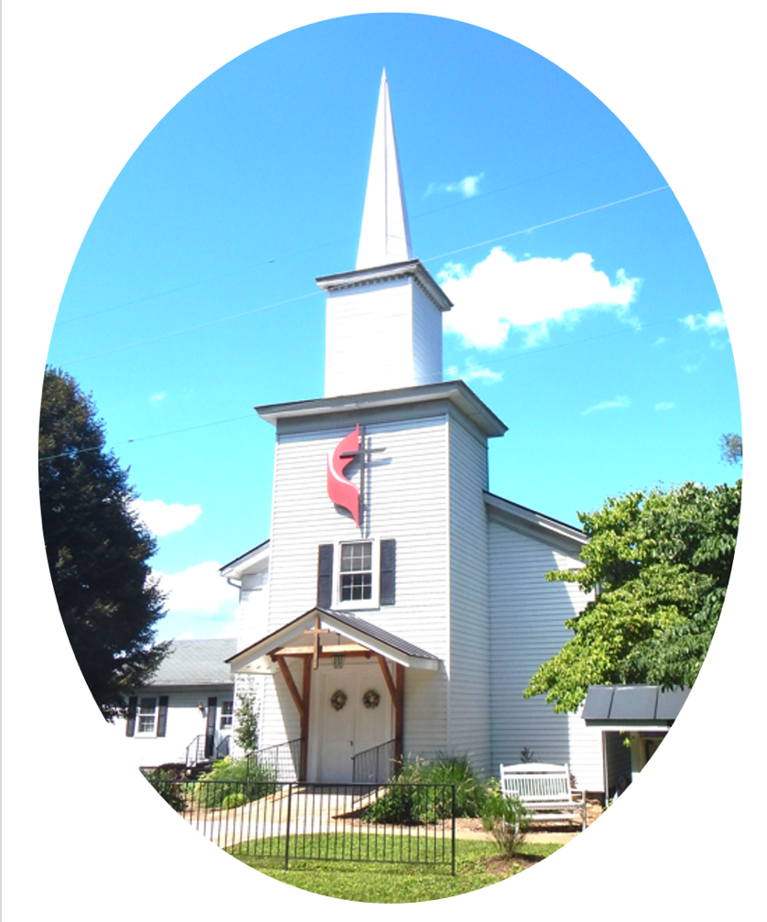

***Pastor****: TaeWon Kang*

*3049 Rectortown Road, Marshall, VA* 20115

*Pastor’s Cell Phone:* (470) 728 - 9060  
*Pastor’s E-mail:* pastortaewonkang@gmail.com

***Music Director****:* Karen Chase

***Ministers****: every member of the congregation*

Welcome to Rectortown UMC!

*“You are looking for Jesus the Nazarene, who was crucified. He has risen!”*

Mark 16:6 NIV

**\*** *Please Stand As You Are Able and Comfortable*

**PRELUDE** - *let us quiet our minds and hearts.*

**WELCOME, ANNOUNCEMENTS and CELEBRATIONS**

**\*BRINGING IN THE LIGHT OF CHRIST**

**\*CALL to WORSHIP**

Leader: We are the Easter people!  
**People: We have witnessed the Resurrection**

**of our Lord.**Leader: We are now called to be people of the

Pentecost.  
**People: We are called to boldly share the**

**good news of God’s love!**Leader: Open your hearts, O people, to God’s

great power and love.  
**People: We open our hearts to hear God’s**

**word for us and to joyfully proclaim**

**Jesus Christ as our Savior. AMEN.**

**\*OPENING PRAYER**

**God of wind and fire, embolden us this day to receive your power. Help us to proclaim the wondrous things that you have done and continue to do in our lives. Give us strength and courage to share the Good News of your love and your presence. For we ask this in Jesus’ Name. AMEN.**

**\* HYMN**

“Come, Christians, Join to Sing” UMH 158

**YOUNG DISCIPLES’ MESSAGE**

**\*PRAYER for ILLUMINATION** UMH 393

**Spirit of the living God, fall afresh on me.**

**Spirit of the living God, fall afresh on me.**

**Melt me, mold me, fill me, use me.**

**Spirit of the living God, fall afresh on me.**

**FIRST READING**

Acts 2: 1 - 21

This is the word of God for the people of God.

**Thanks be to God.**

**RESPONSIVE READING**

Psalm 105: 1 - 11 UMH 828

**\*GOSPEL READING** John 14: 8 – 17, 25 - 27

**\*** Gloria Patri –“Glory Be to the Father” UMH 70

**SERMON**

“God Is With You”

**\*RESPONDING HYMN**

“We Are the Church” UMH 558 (1,2,4& 5)

**\*AFFIRMATION OF FAITH** UMH 881

Apostles’ Creed (Traditional Version)

**SHARING OUR JOYS and CONCERNS**

**PASTORAL PRAYER & LORD’S PRAYER**

**GIVING OUR GIFTS and TITHES**

Offertory:

Doxology UMH 94  
 “Praise God from Whom All Blessings Flow”

Offertory Prayer

**\*CLOSING HYMN**

“Let There Be Peace on Earth” UMH 431

**\*BENEDICTION**

**\* POSTLUDE**

* *Please stand as you are able and comfortable.*

|  |
| --- |
| ***This worship service has ended, and now your service begins.***  ***As you leave church today, you are entering the mission field.*** |

***PRAYERS FOR THE CHURCH AND FOR THE WORLD:***

|  |  |
| --- | --- |
| **For Family and Friends:** | |
| Jim Caylen  Towny Lunsford  Christine Felts & Mother | Russ & Ethel Muter  The Reed Family |
| **For the Family of those who grieve for:**  Laura Skirka  Judy Bailey  Winnie | |
|  |  |

**For the Church and For the World:**

For those in need of healing, and their caretakers.

For first responders, the military, and their families.

For God’s People, The Church, and the World.

Prayers for national, state, and local leaders; and for our Nation.

**If you know someone you would like to add to our prayer list, please forward your request to the church office by email at: secretaryrumc@gmail.com, or by calling (540) 364-1066.**

**RUMC CELEBRATIONS**

|  |  |
| --- | --- |
| **Birthdays** | |
| Johvan Hackley – June 9th | Colin Hall – June 13th |
| **Anniversaries** | |
| Tammy & Todd Frazier – June 12th | |

**UPCOMING MEETINGS AND EVENTS**

**Admin Council**

Thursday, **July 3rd at 7pm**. In person and zoom.

**Trustees Meeting**

Tuesday, June 10th at 6pm. In person and zoom.

**Fig Leaf**

Tuesday, June 17th at 10am. Zoom and in person.



**Father’s Day**

June 15th

**Rectortown United Methodist Church**

Location: 3049 Rectortown Road, Rectortown, VA

Mailing Address: PO Box 301, Rectortown, VA 20140

Email: secretary@rectortownumc.org

Phone: (540)364.1066