Rectortown United Methodist Church
September 13th, 2026 9:30 a.m.
Sixteenth Sunday after Pentecost


Pastor: Eduardo Carrillo
3049 Rectortown Road, Marshall, VA 20115
Pastor’s Cell Phone: (703) 967-4361
Pastor’s E-mail: eduardocarrillo@vaumc.org
Music Accompanist: Cheryl Kowalczyk
Ministers: every member of the congregation
Welcome to Rectortown UMC!

“This is the day that the Lord has made;
let us rejoice and be glad in it.” Psalm 118:24 NRSV

* Please Stand As You Are Able and Comfortable
PRELUDE - let us quiet our minds and hearts.
WELCOME, ANNOUNCEMENTS and CELEBRATIONS
GATHERING
*BRINGING IN THE LIGHT OF CHRIST

*CALL to WORSHIP
Leader: Sing to the Lord, for God has triumphed gloriously!
People: God is our strength, our song, and our salvation.
Leader: How many times shall we extend God’s mercy to others?
People: Not seven times, but seventy-seven times.
Leader: Just as God is merciful, we, who are God’s children, have to be merciful.
People: With humble hearts we receive and give.
All: Let us worship the God of endless grace!

*OPENING PRAYER
O God, who parted the waters of the Red Sea and made a path through the wilderness: liberate us today from the burden of unforgiveness. Teach us to extend the same extravagant mercy that you have poured out on us to our neighbors. Forgive us we pray, when we hoard your forgiveness. Equip us to part the sea that divides us, and find that all of us are worthy of your mercy. This we pray through Jesus Christ our Lord. Amen.

* HYMN
“Joyful, Joyful, We Adore Thee” UMH 89

PROCLAMATION
YOUNG DISCIPLES’ MESSAGE

*PRAYER for ILLUMINATION UMH 393
Spirit of the living God, fall afresh on me.
Spirit of the living God, fall afresh on me.
Melt me, mold me, fill me, use me.
Spirit of the living God, fall afresh on me.

FIRST READING
Exodus 14: 19 – 31
*SECOND READING
Matthew 18: 21 – 35
This is the word of God for the people of God.
Thanks be to God.

SERMON
“The Way Through and the Grace to Forgive”

RESPONSE
*RESPONDING HYMN UMH 365
“Grace Greater Than All Our Sin”

*AFFIRMATION OF FAITH UMH 881
Apostles’ Creed (Traditional Version)

GIVING OUR GIFTS and TITHES
Offertory:
Doxology UMH 94
“Praise God from Whom All Blessings Flow”
Offertory Prayer

SENDING FORTH
*CLOSING HYMN UMH 389
“Freely, Freely”

SHARING OUR JOYS & CONCERNS
PASTORAL PRAYER & LORD’S PRAYER
*BENEDICTION & POSTLUDE

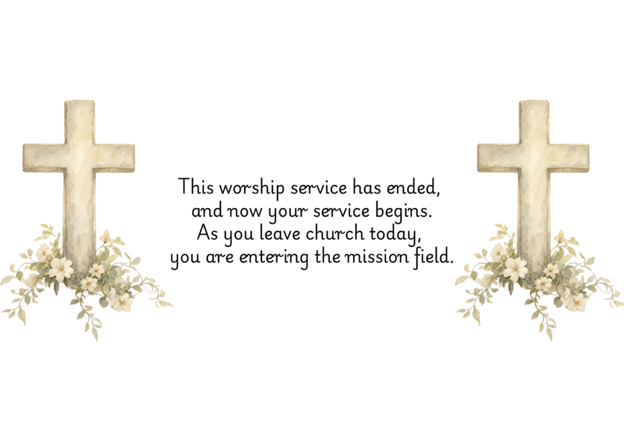

PRAYERS FOR THE CHURCH AND FOR THE WORLD:
For Family and Friends:
Russ & Ethel Muter  Gillian Payne  Billy Wines  Gloria Shelton  Joan Newsome  Keith Kuck | Kathleen Rhodes  Rick Willis  Austin  Shirley Embrey  Marline & Warren  Billy Wines
For the Family of those who grieve for:
Butch Shelton
Ron May
Dennis Leohrs
For the Church and For the World:

For those in need of healing, and their caretakers.
For first responders, the military, and their families.
For God’s People, The Church, and the World.
Prayers for national, state, and local leaders; and for our Nation.
If you know someone you would like to add to our prayer list, please forward your request to the church office by email at: secretary@rectortownumc.org or by calling (540) 364-1066.

RUMC CELEBRATIONS
Birthdays
None

Anniversaries
None

UPCOMING MEETINGS AND EVENTS
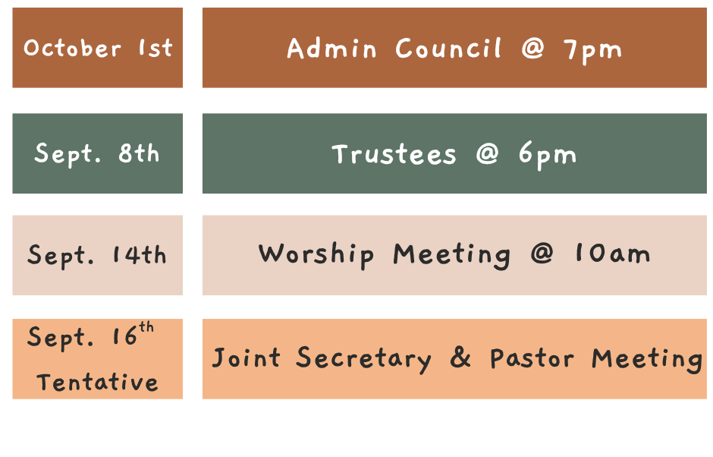

Rectortown United Methodist Church
  - Location: 3049 Rectortown Road, Rectortown, VA
Mailing Address: PO Box 301, Rectortown, VA 20140
Email: secretary@rectortownumc.org
Phone: (540)364.1066

