**Rectortown United Methodist Church**

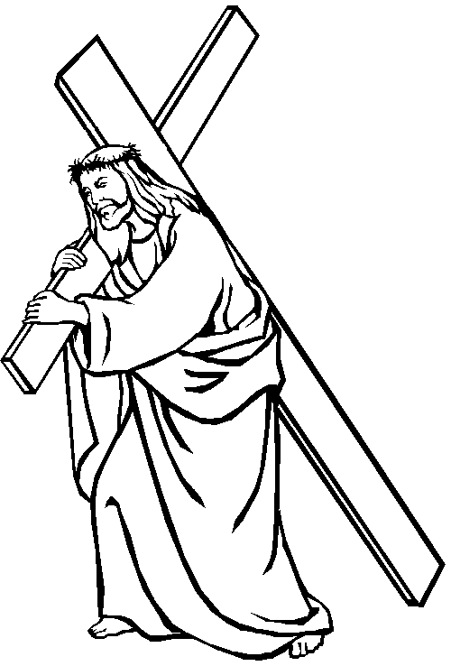

*“All who want to come after me must say no to themselves, take up their cross, and follow me” (Mark 8:34b, CEB).*

**Take Up Your Cross**

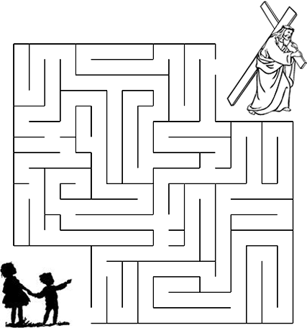

Can you find the path to Jesus?