RUMC PRAYER LIST:

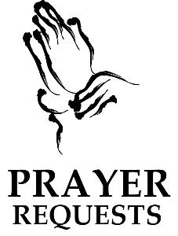
Larry Underwood Roy Sisk
Hazel Sisk Zulla Russell the Lenzen family Avis Kessler Roger Daniels Linda Rose Mac Kirkpatrick Dougie Thompson James Matthew Russell Campbell Wanda Hanna David Hickey Earline Hickey the Brown Family the Scheuble family

Continuing Prayers:
All those with COVID-19
All those caring for COVID-19 patients
For the sick. For those who grieve.
For all who serve and their families.
For God’s People, The Church, and the World.
Prayers for our Nation.

If you know someone you would like to add to our prayer list, please forward your request to Judy Scheuble by email at: ljscheuble@aol.com, or by calling her at home.

RUMC CELEBRATIONS

Birthdays

David Weedling, Sunday, February 28th
Yvie Frazier, Thursday, March 4th

Anniversaries

Larry & Judy Scheuble, Thursday, March 4th

UPCOMING MEETINGS and EVENTS
Administrative Council – Thursday, March 4th at 7:00 pm
Worship Committee – Tuesday, March 9th at 10:00 am
Trustees – Wednesday, March 10th at 6:00 pm
SPRC – Thursday, March 18th at 7:00 pm

