Rectortown United Methodist Church
August 16th, 2026 9:30 a.m.
Twelfth Sunday after Pentecost


Pastor: Eduardo Carrillo
3049 Rectortown Road, Marshall, VA 20115
Pastor’s Cell Phone: (703) 967-4361
Pastor’s E-mail: eduardocarrillo@vaumc.org
Music Accompanist: Cheryl Kowalczyk
Ministers: every member of the congregation
Welcome to Rectortown UMC!

“This is the day that the Lord has made;
let us rejoice and be glad in it.” Psalm 118:24 NRSV

* Please Stand As You Are Able and Comfortable
PRELUDE - let us quiet our minds and hearts.
WELCOME, ANNOUNCEMENTS and CELEBRATIONS
GATHERING
*BRINGING IN THE LIGHT OF CHRIST

*CALL to WORSHIP
Leader: How pleasant it is when God's people dwell together in unity!
People: But our worlds are deeply divided, fractured by hurt and old walls.
Leader: The Lord is expanding the borders of the house, calling those who were far off to come near.
People: We come seeking a mercy that is wider than our minds can measure.
Leader: Do not be afraid, for the one who healed the outsider and forgave the brother is in this place.
People: Let us open our hearts to the radical, boundary-breaking grace of God.
All: Come, let us worship together!

*OPENING PRAYER
God of unsearchable mercy, you refuse to be contained by the walls we build or the boundaries we draw. We come before you today acknowledging our own tendency to keep people out, and our own desperate need to be let in. Like Joseph’s brothers, we need your forgiveness. Like the Canaanite woman, we cry out from the margins for your healing touch. Break down the barriers in our hearts this morning. Pour out your grace upon us, heal our broken relationships, and teach us to marvel at a faith that refuses to give up on you. In Jesus’ name, Amen.

* HYMN
“I Want a Principle Within” UMH 410

PROCLAMATION
YOUNG DISCIPLES’ MESSAGE

*PRAYER for ILLUMINATION UMH 393
Spirit of the living God, fall afresh on me.
Spirit of the living God, fall afresh on me.
Melt me, mold me, fill me, use me.
Spirit of the living God, fall afresh on me.

FIRST READING
Genesis 45: 1 – 15
*SECOND READING
Matthew 15: 21 – 28
This is the word of God for the people of God.
Thanks be to God.

SERMON
“Mercy Makes Room”

RESPONSE
*RESPONDING HYMN UMH 140
“Great is Thy Faithfullness”

*AFFIRMATION OF FAITH UMH 881
Apostles’ Creed (Traditional Version)

GIVING OUR GIFTS and TITHES
Offertory:
Doxology UMH 94
“Praise God from Whom All Blessings Flow”
Offertory Prayer

SENDING FORTH
*CLOSING HYMN
“Bind Us Together” TFWS 2226

SHARING OUR JOYS & CONCERNS
PASTORAL PRAYER & LORD’S PRAYER
*BENEDICTION & POSTLUDE
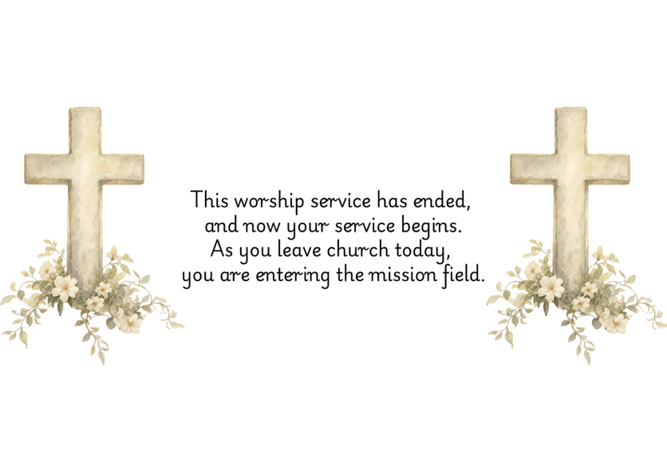

PRAYERS FOR THE CHURCH AND FOR THE WORLD:
For Family and Friends:
Russ & Ethel Muter  Gillian Payne  Billy Wines  Gloria Shelton  Joan Newsome | Kathleen Rhodes  Rick Willis  Austin  Shirley Embrey
For the Family of those who grieve for:
Butch Shelton
Ron May
Dennis Leohrs

For the Church and For the World:

For those in need of healing, and their caretakers. For first responders, the military, and their families. For God’s People, The Church, and the World. Prayers for national, state, and local leaders; and for our Nation.
If you know someone you would like to add to our prayer list, please forward your request to the church office by email at: secretary@rectortownumc.org or by calling (540) 364-1066.

RUMC CELEBRATIONS
Birthdays
Todd Frazier – 16th
Dawn Brown – 17th
Elena Cooper – 22nd

Anniversaries
Pastor Eduardo & Katie Carrillo – 17th

UPCOMING MEETINGS AND EVENTS
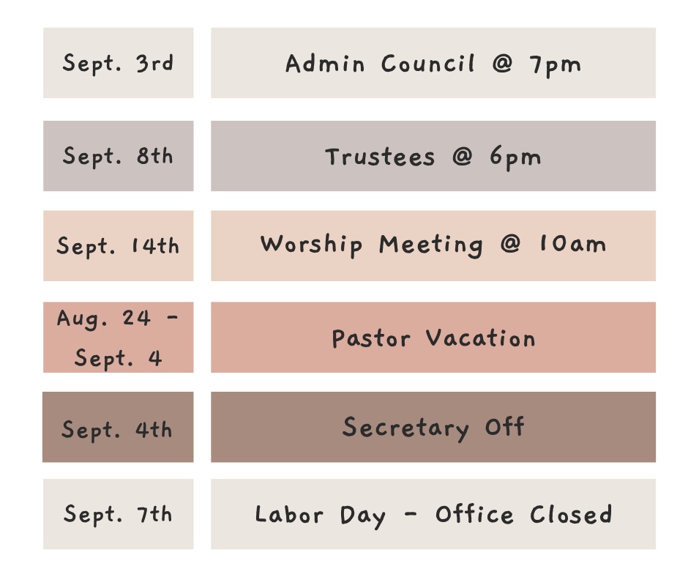

Rectortown United Methodist Church
  - Location: 3049 Rectortown Road, Rectortown, VA
Mailing Address: PO Box 301, Rectortown, VA 20140
Email: secretary@rectortownumc.org
Phone: (540)364.1066

