Rectortown United Methodist Church
October 25th, 2026 9:30 a.m.
Reformation Sunday

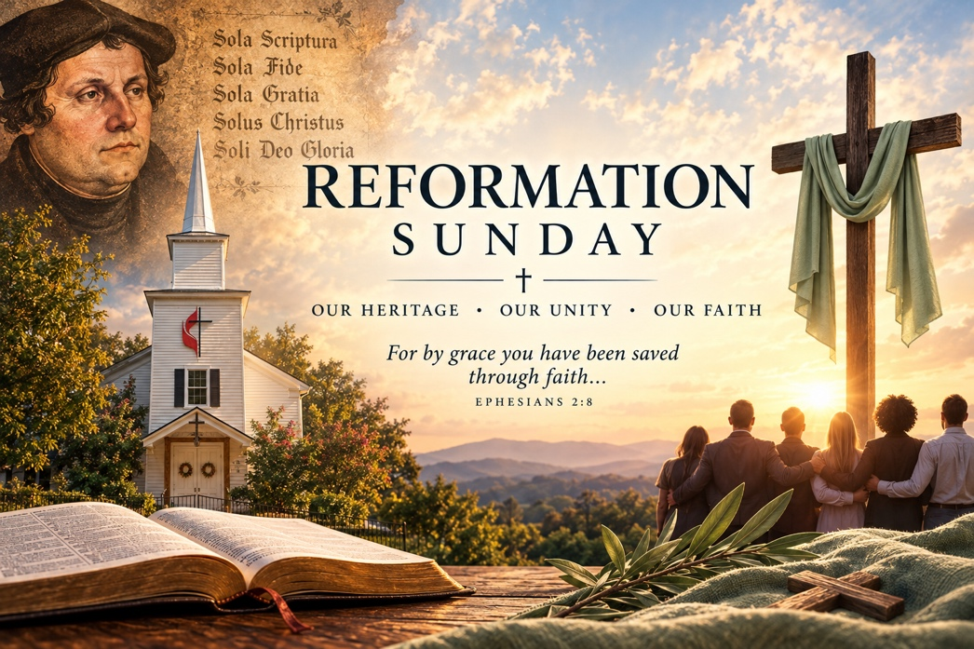

Pastor: Eduardo Carrillo
3049 Rectortown Road, Marshall, VA 20115
Pastor’s Cell Phone: (703) 967-4361
Pastor’s E-mail: eduardocarrillo@vaumc.org
Music Accompanist: Cheryl Kowalczyk
Ministers: every member of the congregation
Welcome to Rectortown UMC!

“This is the day that the Lord has made;
let us rejoice and be glad in it.” Psalm 118:24 NRSV

* Please Stand As You Are Able and Comfortable
PRELUDE - let us quiet our minds and hearts.
WELCOME, ANNOUNCEMENTS and CELEBRATIONS
GATHERING
*BRINGING IN THE LIGHT OF CHRIST

*CALL to WORSHIP
Leader: Moses saw the Promised Land from afar, yet died before stepping onto its soil.
People: Our earthly dreams may fail, but God’s covenant endures forever.
Leader: What is the greatest commandment in the Law?
People: To love the Lord our God with all our heart, soul, and mind.
Leader: What is the second?
People: To love our neighbor as ourselves.
Leader: Though leaders fall and seasons end, the Son of David reigns eternally.
All: Let us worship God!

*OPENING PRAYER
Eternal God, You bring our earthly labors to a close and remind us that we are pilgrims passing through. Forgive us for measuring Your faithfulness by whether we reach our personal Promised Lands.
When our earthly hopes fall short, ground us in the ultimate command: to love You wholeheartedly and our neighbors selflessly. Fix our eyes on David’s Lord, Jesus Christ, who completed the work we could never finish. Teach us to rest in Your enduring promise, knowing that death itself is not the end of Your grace. Amen.

* HYMN UMH 384
“Love Divine, All Loves Excelling”

PROCLAMATION
*PRAYER for ILLUMINATION UMH 393
Spirit of the living God, fall afresh on me.
Spirit of the living God, fall afresh on me.
Melt me, mold me, fill me, use me.
Spirit of the living God, fall afresh on me.

FIRST READING
Deuteronomy 34: 1 – 12
*SECOND READING
Matthew 22: 34 – 46
This is the word of God for the people of God.
Thanks be to God.

SERMON
“Looking at Canaan, Loving the Lord”

RESPONSE
*RESPONDING HYMN UMH 117
“O God Our Help in Ages Past”

*AFFIRMATION OF FAITH UMH 881
Apostles’ Creed (Traditional Version)

GIVING OUR GIFTS and TITHES
Offertory:
Doxology UMH 94
“Praise God from Whom All Blessings Flow”
Offertory Prayer

SENDING FORTH
SHARING OUR JOYS & CONCERNS
PASTORAL PRAYER & LORD’S PRAYER
*BENEDICTION & POSTLUDE

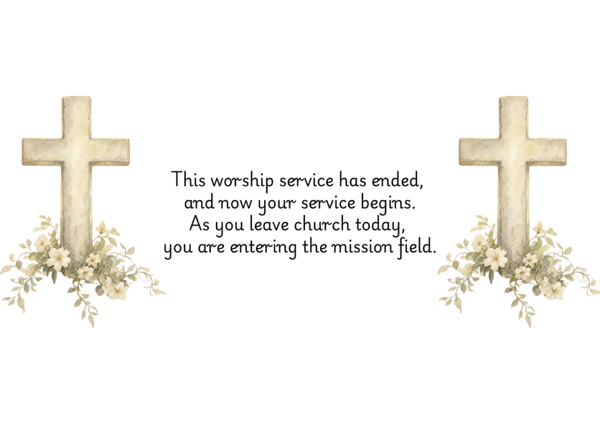

PRAYERS FOR THE CHURCH AND FOR THE WORLD:
For Family and Friends:
Russ & Ethel Muter  Gillian Payne  Billy Wines  Gloria Shelton  Joan Newsome  Keith Kuck  Don Williams | Kathleen Rhodes  Rick Willis  Austin  Shirley Embrey  Marline & Warren  Billy Wines
For the Family of those who grieve for:
Teddy Saunders
For the Church and For the World:

For those in need of healing, and their caretakers.
For first responders, the military, and their families.
For God’s People, The Church, and the World.
Prayers for national, state, and local leaders; and for our Nation.
If you know someone you would like to add to our prayer list, please forward your request to the church office by email at: secretary@rectortownumc.org or by calling (540) 364-1066.

RUMC CELEBRATIONS
Birthdays
Thurston Willis – 30th

Anniversaries
None

UPCOMING MEETINGS AND EVENTS
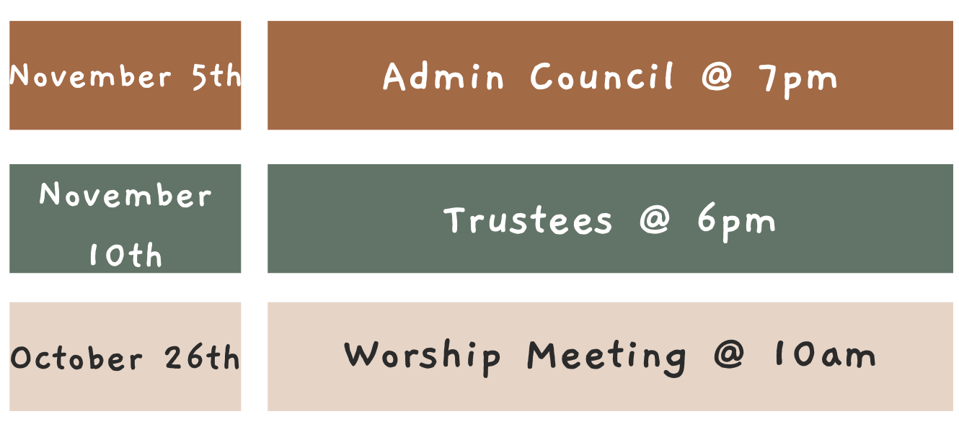

Please send the secretary a remembrance story of our members that have passed to be published into the November Newsletter.
Thank you.

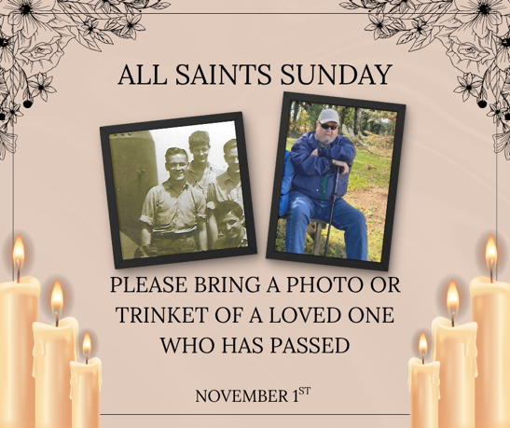

Rectortown United Methodist Church
  - Location: 3049 Rectortown Road, Rectortown, VA
Mailing Address: PO Box 301, Rectortown, VA 20140
Email: secretary@rectortownumc.org
Phone: (540)364.1066

