**Rectortown United Methodist Church**

August 10th, 2025 10:00 a.m.

*9th Sunday after Pentecost/*

*Back to School Blessing*

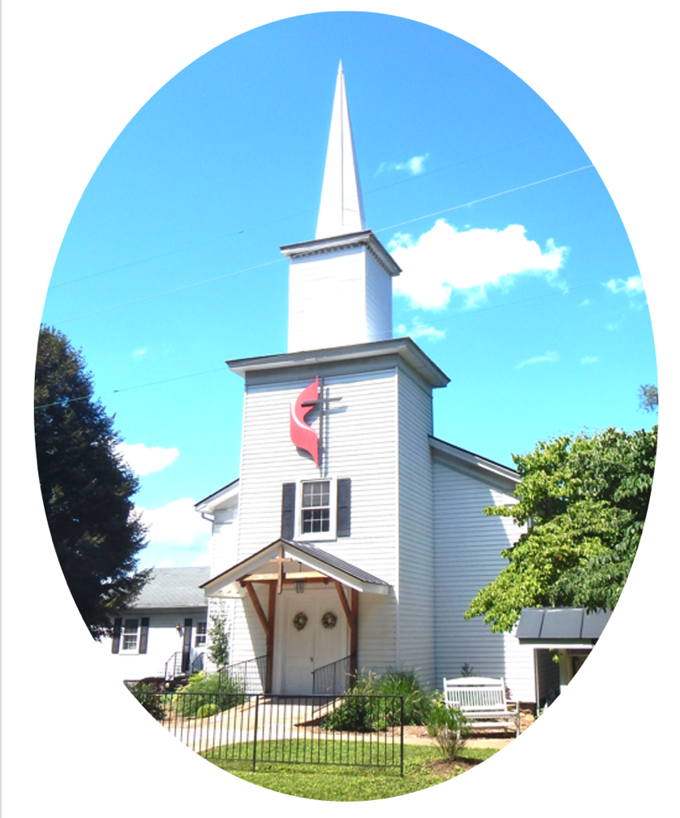

***Pastor****: Eduardo Carrillo*

*3049 Rectortown Road, Marshall, VA* 20115

*Pastor’s Cell Phone:* (703) 967-4361  
*Pastor’s E-mail:* pastor@rectortownumc.org

***Music Director****:* Karen Chase

***Ministers****: every member of the congregation*

Welcome to Rectortown UMC!

*“This is the day that the Lord has made;  
    let us rejoice and be glad in it.”* Psalm 118:24 NRSV

**\*** *Please Stand As You Are Able and Comfortable*

**PRELUDE** - *let us quiet our minds and hearts.*

**WELCOME, ANNOUNCEMENTS and CELEBRATIONS**

***GATHERING***

**\*BRINGING IN THE LIGHT OF CHRIST**

**\*CALL to WORSHIP**

Leader: The Lord is our light and our salvation.  
**People: Whom shall we fear?**  
Leader: The Lord is the strength of our lives.  
**People: In God, we place our trust.**  
Leader: Come, let us walk by faith.  
**People: With confidence and praise, we**

**worship God together.**

**\*OPENING PRAYER**

**Faithful God, you are present in what we can see and in what we cannot. You lead us forward even when the path is uncertain. In this time of worship, calm our fears and strengthen our trust. Help us to hear your voice and respond with joy. Amen.**

**\* HYMN**

“Faith of Our Fathers” UMH 710

***PROCLAMATION***

**YOUNG DISCIPLES’ MESSAGE**

**BLESSING FOR THE SCHOOL YEAR**

**Loving God, as the school year begins, we lift to you all the backpacks before us and more importantly, those who carry them.**

**Bless our students with open minds, kind hearts, and a hunger to grow. Bless our teachers with patience, creativity, and wisdom as they guide and inspire. Bless every staff member who keeps our schools safe, clean, and running smoothly. Bless our bus drivers who carry our precious ones to and from their learning each day. May every zipper zip with purpose, every strap be light with your grace, and every pocket be filled with the tools they need to thrive.  
Surround them all with your protection, fill them with your peace, and remind them daily: they are loved by you. Amen.**

**\*PRAYER for ILLUMINATION** UMH 393

**Spirit of the living God, fall afresh on me.**

**Spirit of the living God, fall afresh on me.**

**Melt me, mold me, fill me, use me.**

**Spirit of the living God, fall afresh on me.**

**OLD TESTAMENT READING**

Isaiah 1: 10 – 20

**\*NEW TESTAMENT READING**

Hebrews 11: 1 – 3, 8 – 16

This is the word of God for the people of God.

**Thanks be to God.**

**SERMON**

**“Do Not Be Afraid, Little Flock”**

***RESPONSE***

**\*RESPONDING HYMN**

“Immortal, Invisible, God Only Wise” UMH 103

**\*AFFIRMATION OF FAITH** UMH 881

Apostles’ Creed (Traditional Version)

**SHARING OUR JOYS and CONCERNS**

**PASTORAL PRAYER & LORD’S PRAYER**

**GIVING OUR GIFTS and TITHES**

Offertory:

Doxology UMH 94  
 “Praise God from Whom All Blessings Flow”

Offertory Prayer

**\*CLOSING HYMN**

“We’ll Understand It Better By & By” UMH 525

***SENDING FORTH***

**\*BENEDICTION**

**\* POSTLUDE**

* *Please stand as you are able and comfortable.*

|  |
| --- |
| ***This worship service has ended, and now your service begins.***  ***As you leave church today, you are entering the mission field.*** |

***PRAYERS FOR THE CHURCH AND FOR THE WORLD:***

|  |  |
| --- | --- |
| **For Family and Friends:** | |
| Russ & Ethel Muter  Peggy Rose Goldsmith  Nancy Glascock  Jeff Sisk  TommyAnn | Dusty, Warden in Texas  Priscilla Krick  John McGuinn & Sydney  Sandy Thomas  Patsy Williams |
| **For the Family of those who grieve for:**  Winnie  Anne Jackson  Texas & New Mexico Flood Victims | |
|  |  |

**For the Church and For the World:**

For those in need of healing, and their caretakers.

For first responders, the military, and their families.

For God’s People, The Church, and the World.

Prayers for national, state, and local leaders; and for our Nation.

**If you know someone you would like to add to our prayer list, please forward your request to the church office by email at: secretaryrumc@gmail.com, or by calling (540) 364-1066.**

**RUMC CELEBRATIONS**

|  |
| --- |
| **Birthdays** |
| Carl Carter – August 11th |
| Courtney Harrington – August 11th |
| Todd Frazier – August 16th |
|  |
| **Anniversaries** |
| Katie & Eduardo Carrillo – August 17th |

**UPCOMING MEETINGS AND EVENTS**

**Admin Council**

Thursday, **September 4th at 7pm**. In person and zoom.

**Trustees Meeting**

Tuesday, **August 12th** at 6pm. In person and zoom.

**Worship Meeting**

**August 27th** at 10am, in person and zoom.

**Fig Leaf**

Tuesday, **August 19th** at 10am. Zoom and in person.

**Cooperative Parish Meeting**

**August 17th at 1:45pm, RUMC Fellowship Hall**

**Offering Request**

Please consider donating towards purchasing fencing supplies for the parsonage.

**Rectortown United Methodist Church**

Location: 3049 Rectortown Road, Rectortown, VA

Mailing Address: PO Box 301, Rectortown, VA 20140

Email: secretary@rectortownumc.org

Phone: (540)364.1066