Rectortown United Methodist Church
February 16th, 2025 10:00 a.m.
6th Sunday after Epiphany

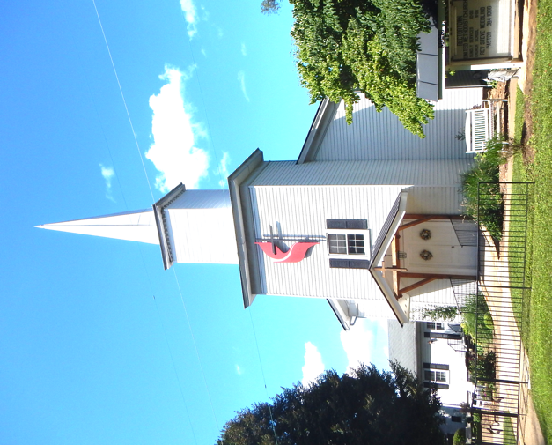

Pastor: TaeWon Kang
3049 Rectortown Road, Marshall, VA 20115
Pastor’s Cell Phone: (470) 728 - 9060
Pastor’s E-mail: pastortaewonkang@gmail.com
Music Director: Karen Chase
Ministers: every member of the congregation
Welcome to Rectortown UMC!

“You are looking for Jesus the Nazarene, who was crucified. He has risen!”
Mark 16:6 NIV

* Please Stand As You Are Able and Comfortable
PRELUDE - let us quiet our minds and hearts.
WELCOME, ANNOUNCEMENTS and CELEBRATIONS

*BRINGING IN THE LIGHT OF CHRIST

*CALL to WORSHIP
Leader: Happy are those who walk in God’s ways.
People: Blessed are those who observe God’s
commandments.
Leader: Faithful are those whose eyes are fixed on
righteousness.
People: Joyful are those whose hearts are
filled with praise.
Leader: Come, let us love the Lord our God.
People: We come to worship the One who
leads us in the ways of life.

*OPENING PRAYER
Come, Holy One: teach us your ways, lead us in your paths, guide us on our journey. Speak to us your words of life, for you offer us direction and wholeness when we hear your voice and follow. You bless us with your love, shower us with your grace, and help us grow in faith. We seek you, O God, with all our hearts. Be with us in this time of worship. We Glorify you, and Love you, O good and gracious Lord. In the name of Jesus Christ, we pray. Amen.

* HYMN “My Jesus, I Love Thee” UMH 172

YOUNG DISCIPLES’ MESSAGE

*PRAYER for ILLUMINATION UMH 393
Spirit of the living God, fall afresh on me.
Spirit of the living God, fall afresh on me.
Melt me, mold me, fill me, use me.
Spirit of the living God, fall afresh on me.

OLD TESTAMENT READING
Jeremiah 17: 5 -10
This is the word of God for the people of God.
Thanks be to God.

RESPONSIVE READING Psalm 1 UMH 738

*GOSPEL READING Luke 6: 17 - 26
* Gloria Patri –“Glory Be to the Father” UMH 70

SERMON “Those Who Are Blessed”

*RESPONDING HYMN “Marching to Zion” UMH 733

*AFFIRMATION OF FAITH UMH 881
Apostles’ Creed (Traditional version)

SHARING OUR JOYS and CONCERNS

PASTORAL PRAYER & LORD’S PRAYER

GIVING OUR GIFTS and TITHES
Offertory:
* Doxology UMH 94
“Praise God from Whom All Blessings Flow”
* Offertory Prayer

*CLOSING HYMN “Guide My Feet” TFWS 2208

*BENEDICTION

* POSTLUDE
* Please stand as you are able and comfortable.
This worship service has ended, and now your service begins.
As you leave church today, you are entering the mission field.

PRAYERS FOR THE CHURCH AND FOR THE WORLD:
For Family and Friends:
Linda Brown  Jim Caylen  Towny Lunsford  Christine Felts & Mother  Vickie Duff  Jane Thomas  The Reed Family | Shirley Embrey  Russ & Ethel Muter  Larry Underwood
For the Family of those who grieve for:
Laura Skirka
Elizabeth Payne
Hester Klemmer
Norma Jean Thorpe (Yowell)
Judy Bailey
For the Church and For the World:

For those in need of healing, and their caretakers.
For first responders, the military, and their families.
For God’s People, The Church, and the World.
Prayers for national, state, and local leaders; and for our Nation.
If you know someone you would like to add to our prayer list, please forward your request to the church office by email at: secretaryrumc@gmail.com, or by calling (540) 364-1066.

RUMC CELEBRATIONS

Birthdays
Kim Kroes – February 16th | Nelson Warfield – February 16th
Anniversaries
None

UPCOMING MEETINGS AND EVENTS

President’s Day
February 17th
Offices Closed

Fig Leaf
February 18th at 10 am

Rectortown United Methodist Church
Location: 3049 Rectortown Road, Rectortown, VA
Mailing Address: PO Box 301, Rectortown, VA 20140
Email: secretaryrumc@gmail.com Phone: (540)364.1066

