Rectortown United Methodist Church
October 18th, 2026 9:30 a.m.
Twenty-First Sunday after Pentecost


Pastor: Eduardo Carrillo
3049 Rectortown Road, Marshall, VA 20115
Pastor’s Cell Phone: (703) 967-4361
Pastor’s E-mail: eduardocarrillo@vaumc.org
Music Accompanist: Cheryl Kowalczyk
Ministers: every member of the congregation
Welcome to Rectortown UMC!

“This is the day that the Lord has made;
let us rejoice and be glad in it.” Psalm 118:24 NRSV

* Please Stand As You Are Able and Comfortable
PRELUDE - let us quiet our minds and hearts.
WELCOME, ANNOUNCEMENTS and CELEBRATIONS
GATHERING
*BRINGING IN THE LIGHT OF CHRIST

*CALL to WORSHIP
Leader: Caesar demands his coin, and the world claims its share of our allegiance.
People: But we bear the image of the God whose glory passes before us.
Leader: No one can see God's face and live, yet He hides us in the cleft of the rock.
People: He covers us with His hand and reveals His goodness in our midst.
Leader: Render to the world what belongs to the world, but give your soul to God.
All: We give ourselves entirely to the One who knows us by name.

*OPENING PRAYER
Sovereign Lord, You hold the nations in Your hands, and earthly powers are but a drop in the bucket before You. We confess how easily we divide our loyalty, giving our passions to worldly kingdoms while offering You only leftover devotion.
Hide us today in the cleft of the rock, Christ Jesus, and let Your divine goodness pass before us. Remind us that we bear Your image, not the world’s. Take our hearts, our lives, and our worship, and anchor us in Your glory. Amen.

* HYMN UMH 103
“Immortal, Invisible, God Only Wise”

PROCLAMATION
*PRAYER for ILLUMINATION UMH 393
Spirit of the living God, fall afresh on me.
Spirit of the living God, fall afresh on me.
Melt me, mold me, fill me, use me.
Spirit of the living God, fall afresh on me.

FIRST READING
Exodus 33: 12 – 23
*SECOND READING
Matthew 22: 15 – 22
This is the word of God for the people of God.
Thanks be to God.

SERMON
“Stamped with God’s Image”

RESPONSE
*RESPONDING HYMN UMH 396
“O Jesus, I have Promised”

*AFFIRMATION OF FAITH UMH 881
Apostles’ Creed (Traditional Version)

GIVING OUR GIFTS and TITHES
Offertory:
Doxology UMH 94
“Praise God from Whom All Blessings Flow”
Offertory Prayer

SENDING FORTH
SHARING OUR JOYS & CONCERNS
PASTORAL PRAYER & LORD’S PRAYER
*BENEDICTION & POSTLUDE

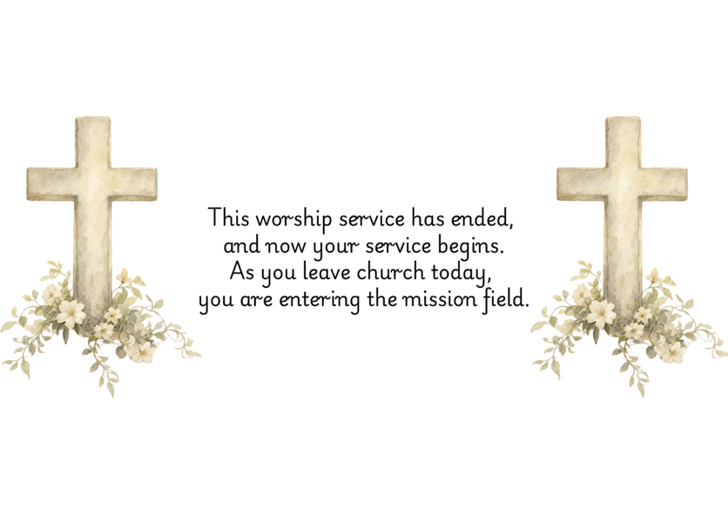

PRAYERS FOR THE CHURCH AND FOR THE WORLD:
For Family and Friends:
Russ & Ethel Muter  Gillian Payne  Billy Wines  Gloria Shelton  Joan Newsome  Keith Kuck  Don Williams | Kathleen Rhodes  Rick Willis  Austin  Shirley Embrey  Marline & Warren  Billy Wines  Tammy Frazier
For the Family of those who grieve for:
Teddy Saunders
For the Church and For the World:

For those in need of healing, and their caretakers.
For first responders, the military, and their families.
For God’s People, The Church, and the World.
Prayers for national, state, and local leaders; and for our Nation.
If you know someone you would like to add to our prayer list, please forward your request to the church office by email at: secretary@rectortownumc.org or by calling (540) 364-1066.

RUMC CELEBRATIONS
Birthdays
April Gannon – 20th

Anniversaries
Vicki & Jimmy Willis – 18th

UPCOMING MEETINGS AND EVENTS
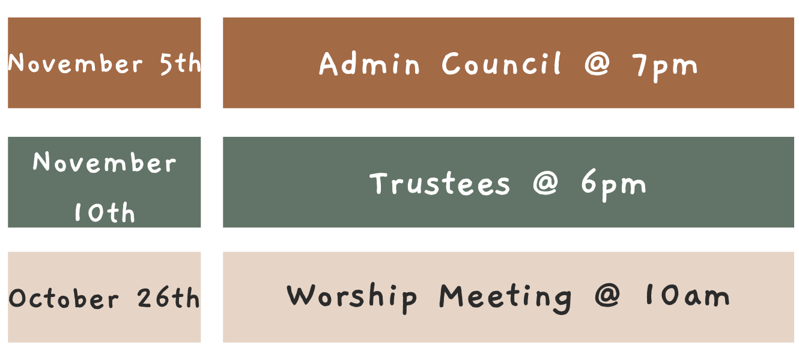

Please send the secretary a remembrance story of our members that have passed to be published into the November Newsletter.
Thank you.

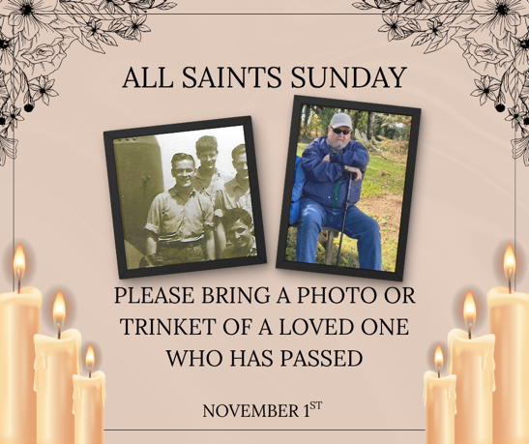

Rectortown United Methodist Church
  - Location: 3049 Rectortown Road, Rectortown, VA
Mailing Address: PO Box 301, Rectortown, VA 20140
Email: secretary@rectortownumc.org
Phone: (540)364.1066

