Rectortown United Methodist Church
May 24th, 2026 10:00 a.m.
Pentecost

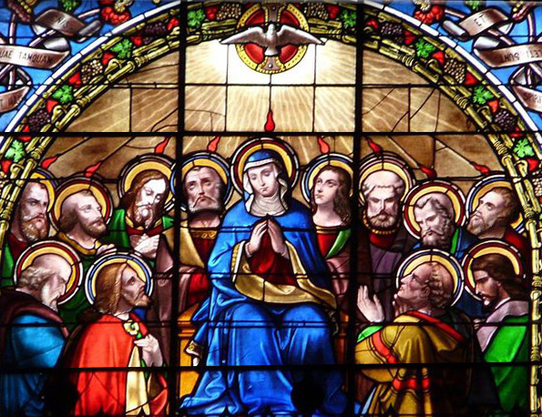

Pastor: Eduardo Carrillo
3049 Rectortown Road, Marshall, VA 20115
Pastor’s Cell Phone: (703) 967-4361
Pastor’s E-mail: eduardocarrillo@vaumc.org
Music Director: Karen Chase
Ministers: every member of the congregation
Welcome to Rectortown UMC!

“This is the day that the Lord has made;
let us rejoice and be glad in it.” Psalm 118:24 NRSV

* Please Stand As You Are Able and Comfortable
PRELUDE - let us quiet our minds and hearts.
WELCOME, ANNOUNCEMENTS and CELEBRATIONS
GATHERING
*BRINGING IN THE LIGHT OF CHRIST

*CALL to WORSHIP
Leader: The Spirit of the Living God has been poured out on all flesh, this is that day!
People: We declare it boldly, the Holy Spirit is here and He is moving!
Leader: From the rushing wind of creation to the fire of Pentecost, God has never stopped breathing life!
People: Send Your Spirit, Lord, renew us, revive us, set us ablaze!
Leader: Young and old, sons and daughters, all shall prophesy, all shall be filled!
All: We will not be silent! The Spirit of God is upon us, let us worship with everything we have!

*OPENING PRAYER
Holy Spirit, we welcome You boldly into this place today! You hovered over creation, You fell like fire at Pentecost, You breathed life into dry bones and scared disciples. Do it again, Lord, right here, right now. Fill every corner of this room and every corner of our hearts. We are not here for a quiet, comfortable Sunday, we are here for an encounter. Pour Yourself out upon us. Renew us like the face of the earth. Make us witnesses we were born to be. Come, Holy Spirit. We are ready. In Jesus' name, Amen!

* HYMN
“Spirit of God, Descend upon My Heart” UMH 500

PROCLAMATION
YOUNG DISCIPLES’ MESSAGE

*PRAYER for ILLUMINATION UMH 393
Spirit of the living God, fall afresh on me.
Spirit of the living God, fall afresh on me.
Melt me, mold me, fill me, use me.
Spirit of the living God, fall afresh on me.

FIRST READING
Psalm 104: 24 – 32, 35

*SECOND READING
Acts 2: 1 – 21
This is the word of God for the people of God.
Thanks be to God.

SERMON “The Wind Still Moving”

RESPONSE
*RESPONDING HYMN
“Spirit Song” UMH 347

*AFFIRMATION OF FAITH UMH 881
Apostles’ Creed (Traditional Version)

SHARING OUR JOYS and CONCERNS

PASTORAL PRAYER & LORD’S PRAYER

GIVING OUR GIFTS and TITHES
Offertory:
Doxology UMH 94
“Praise God from Whom All Blessings Flow”
Offertory Prayer

*CLOSING HYMN
“Every Time I Feel the Spirit” UMH 404

SENDING FORTH
*BENEDICTION

* POSTLUDE
* Please stand as you are able and comfortable.
This worship service has ended, and now your service begins.
As you leave church today, you are entering the mission field.

PRAYERS FOR THE CHURCH AND FOR THE WORLD:
For Family and Friends:
Russ & Ethel Muter  Gillian Payne  Ernestine Hall  Hall Family  David Nalls | Kathleen Rhodes  Rick Willis  Austin  Ronald Scheuble
For the Family of those who grieve for:
Georgie Ann Grimes
Katherine
For the Church and For the World:

For those in need of healing, and their caretakers.
For first responders, the military, and their families.
For God’s People, The Church, and the World.
Prayers for national, state, and local leaders; and for our Nation.
If you know someone you would like to add to our prayer list, please forward your request to the church office by email at: secretary@rectortownumc.org or by calling (540) 364-1066.

RUMC CELEBRATIONS
Birthdays
None

Anniversaries
Russ & Ethel Muter – May 25th

UPCOMING MEETINGS AND EVENTS

Worship Meeting
May 27th at 10pm. In person & zoom

5TH Sunday – May 31st

Join us for Bring Your Family Sunday as we celebrate faith, fellowship, and the joy of worshiping together across generations. Invite your loved ones and come experience the warmth of church family and community together! Want to make it extra fun? Wear 3 of something for Trinity Sunday!

Memorial Day
May 25th, 2026 – Offices Closed



Rectortown United Methodist Church
  - Location: 3049 Rectortown Road, Rectortown, VA
Mailing Address: PO Box 301, Rectortown, VA 20140
Email: secretary@rectortownumc.org
Phone: (540)364.1066

