**Rectortown United Methodist Church**

August 17th, 2025 10:00 a.m.

*10th Sunday after Pentecost*

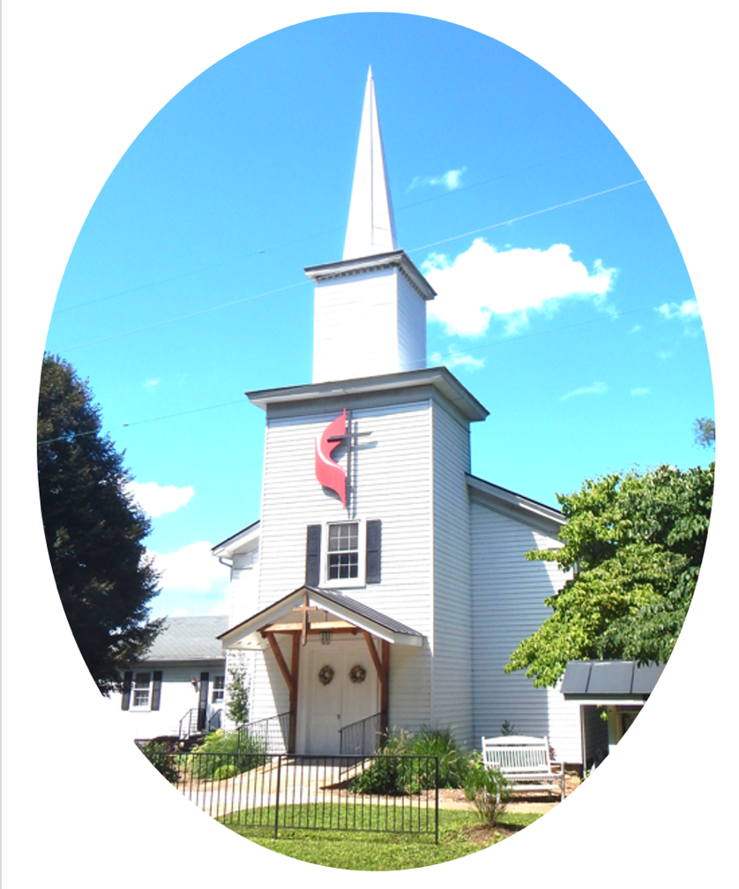

***Pastor****: Eduardo Carrillo*

*3049 Rectortown Road, Marshall, VA* 20115

*Pastor’s Cell Phone:* (703) 967-4361  
*Pastor’s E-mail:* pastor@rectortownumc.org

***Music Director****:* Karen Chase

***Ministers****: every member of the congregation*

Welcome to Rectortown UMC!

*“This is the day that the Lord has made;  
    let us rejoice and be glad in it.”* Psalm 118:24 NRSV

**\*** *Please Stand As You Are Able and Comfortable*

**PRELUDE** - *let us quiet our minds and hearts.*

**WELCOME, ANNOUNCEMENTS and CELEBRATIONS**

***GATHERING***

**\*BRINGING IN THE LIGHT OF CHRIST**

**\*CALL to WORSHIP**

Leader: The God of justice and mercy calls us to

gather.  
**People: We come, listening for the Word of**

**life.**  
Leader: The Spirit stirs our hearts with courage.  
**People: We come, ready to be moved and**

**renewed.**  
Leader: Let us worship with reverence and hope.  
**People: Let us worship the Lord with open**

**hearts.**

**\*OPENING PRAYER**

**Holy and Living God, we come before you seeking more than comfort, we long for your truth. Surprise us with your presence and shake us from routine, so that we may be open to all you are doing in and through us. Make us attentive, willing, and awake in this hour. Amen.**

**\* HYMN**

“Standing on the Promises” UMH 374

***PROCLAMATION***

**YOUNG DISCIPLES’ MESSAGE**

**\*PRAYER for ILLUMINATION** UMH 393

**Spirit of the living God, fall afresh on me.**

**Spirit of the living God, fall afresh on me.**

**Melt me, mold me, fill me, use me.**

**Spirit of the living God, fall afresh on me.**

**OLD TESTAMENT READING**

Isaiah 5: 1 – 7

**\*NEW TESTAMENT READING**

Luke 12: 49 – 56

This is the word of God for the people of God.

**Thanks be to God.**

**SERMON**  “Set the World on Fire”

***RESPONSE***

**\*RESPONDING HYMN**

“Guide My Feet” TFWS 2208

**\*AFFIRMATION OF FAITH** UMH 881

Apostles’ Creed (Traditional Version)

**SHARING OUR JOYS and CONCERNS**

**PASTORAL PRAYER & LORD’S PRAYER**

**GIVING OUR GIFTS and TITHES**

Offertory:

Doxology UMH 94  
 “Praise God from Whom All Blessings Flow”

Offertory Prayer

**\*CLOSING HYMN**

“Abide With Me” UMH 700

***SENDING FORTH***

**\*BENEDICTION**

**\* POSTLUDE**

* *Please stand as you are able and comfortable.*

|  |
| --- |
| ***This worship service has ended, and now your service begins.***  ***As you leave church today, you are entering the mission field.*** |

***PRAYERS FOR THE CHURCH AND FOR THE WORLD:***

|  |  |
| --- | --- |
| **For Family and Friends:** | |
| Russ & Ethel Muter  Nancy Glascock  Jeff Sisk  TommyAnn | Priscilla Krick  John McGuinn & Sydney  Sandy Thomas  Patsy Williams |
| **For the Family of those who grieve for:**  Winnie  Anne Jackson  Texas & New Mexico Flood Victims  Peggy Rose Goldsmith  Bobby Williams  Jerry Yowell | |
|  |  |

**For the Church and For the World:**

For those in need of healing, and their caretakers.

For first responders, the military, and their families.

For God’s People, The Church, and the World.

Prayers for national, state, and local leaders; and for our Nation.

**If you know someone you would like to add to our prayer list, please forward your request to the church office by email at: secretaryrumc@gmail.com, or by calling (540) 364-1066.**

**RUMC CELEBRATIONS**

|  |
| --- |
| **Birthdays** |
| Dawn Brown – August 17th |
| Elena Cooper – August 22nd |
| Dawn Dye – August 23rd |
| **Anniversaries** |
| Katie & Eduardo Carrillo – August 17th  Tara & Ben Wegdam – August 23rd |

**UPCOMING MEETINGS AND EVENTS**

**Admin Council**

Thursday, **September 4th at 7pm**. In person and zoom.

**Trustees Meeting**

Tuesday, **September 9th** at 6pm. In person and zoom.

**Worship Meeting**

**August 26th** at 10am, in person and zoom.

**Fig Leaf**

Tuesday, **August 19th** at 10am. Zoom and in person.

**Cooperative Parish Meeting**

**August 17th at 1:45 pm, RUMC Fellowship Hall**

**Offering Request**

Please consider donating towards purchasing fencing supplies for the parsonage.

**Rectortown United Methodist Church**

Location: 3049 Rectortown Road, Rectortown, VA

Mailing Address: PO Box 301, Rectortown, VA 20140

Email: secretary@rectortownumc.org

Phone: (540)364.1066